Student Name……………………………………………………………………………….……….Date…………………………
My Rights | My Responsibilities | My Rewards
I have the right to be safe within my school  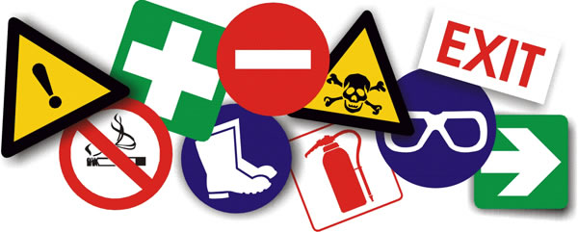 | I will follow all Health and Safety instructions and I will not bring any banned substances into school, including weapons, cigarettes and any illegal substances  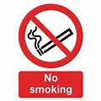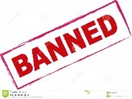 | I will be rewarded for the valued student I am    
I have the right to use ICT services at my school appropriately   | I will hand my mobile phone in when I come to school  I will not use headphones during lessons unless as part of the lesson  I will not drink or eat in the ICT suite  I will use ICT school equipment safely and as directed  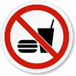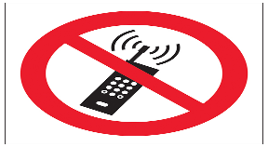 | I will be rewarded for the valued student I am
I have the right to be taught in a healthy and safe environment  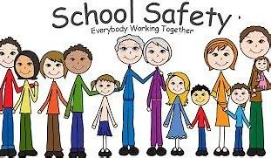 | I will not bring energy drinks into school  I will follow all Health and Safety rules  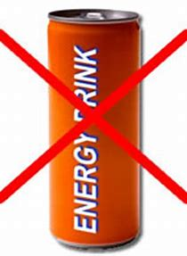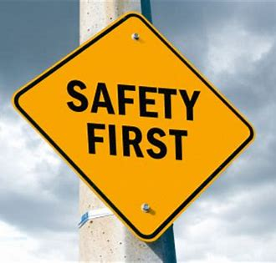 | I will be rewarded for the valued student I am
I have the right to be respected by staff and students at my school  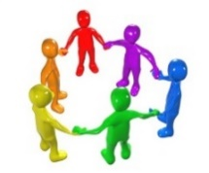 | I will respect everyone and not use any inappropriate language, or be nasty or bully anyone  I will not be physically violent to anyone 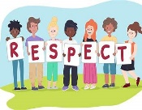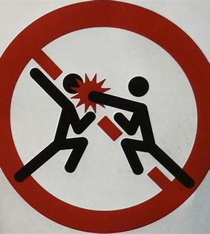 | I will be rewarded for the valued student I am
I have the right to use meaningful and interesting equipment and resources  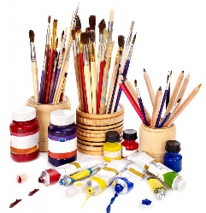 | I will use all equipment and resources with respect, and I will not deliberately damage anything  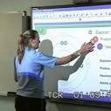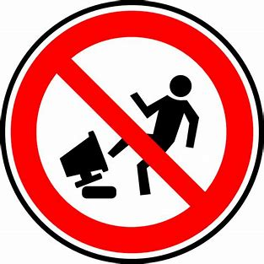 | I will be rewarded for the valued student I am
I have the right to be taught by qualified staff  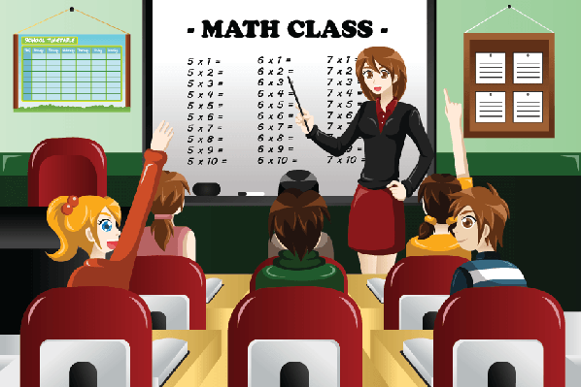 | I will arrive on time, follow any instructions and complete my work as directed by my staff  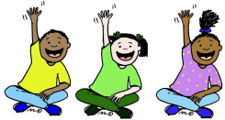 | I will be rewarded for the valued student I am

This is so that we can keep everyone safe and happy. I understand that failure to follow rules will result in sanctions.
Signed Student Date
Signed Teacher Date
Signed Head of School Date

