XML and Databases

by

Hugh Lafferty
Table of Contents

1. Introduction 1
1.1. Send some XML from the server to the client 2
1.2. Send a little more XML from the server to the client 3
1.3. Display the XML on the client using an XSL stylesheet on the server 5
1.4. Get the data from a database, transform it into XML, send the XML to the client and display it on the client using XSL 6
1.5. Refer to a DTD 7
1.6. Save the XML on the server in a flat file 8
1.7. Use the XML DOM on the client to load the XML from a flat file on the server and then transform the XML using XSL(that is on the server) 10
2. Summary 12
3. Self-Test 12
4. Resources 12
4.1. Books 12
4.2. Web sites 12
5. Research Ideas 12
6. TUTORIAL 13

XML and Databases

Introduction

We are gradually going to increase the complexity of what we can achieve, by starting off with sending the simplest XML from a server to a client and end up with XML encapsulating data from a database on the server and displaying it on the client using an XSL stylesheet.

In Activity 1 we produce some XML ‘on the fly’ on the server and send it to the client. We send the absolute minimum that qualifies as an XML document viz.
<?xml version='1.0'?><Catalogue></Catalogue>.
This is to show that we can send XML from the server to a client. The client browser has not been sent an XSL stylesheet, so uses its default.

In Activity 2 we create a bit more meaningful xml document, that corresponds to the following data
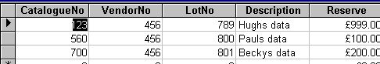

Again we leave it to the browser to use its default stylesheet

In Activity 3 we create a stylesheet on the server and get the browser on the client to use it in order to display the data ‘nicely’.

In Activity 4 we build on the above but get the data from a database on the server.

In Activity 5 we refer to a DTD but we know that is pretty pointless because IE5 is not a validating parser. In order to validate the XML we should save it on the server and run it against validate.htm.

In Activity 6 we show how to save the XML to a flat file on the server.

In Activity 7 we show how to send a little HTML to the client that locates the XML and XSL from the server and on the client uses the XML DOM to transform the XML using the XSL.

Send some XML from the server to the client

ACTIVITY 1. Copy the following and save it on the server as FirstXML.asp
Run it from a browser by typing something like
Use your own student number in stuxx
http://vespasian.cms.shu.ac.uk/pg/students1/stuxx/FirstXML.asp

<%
Response.write("<?xml version='1.0'?>")
Response.write("<Catalogue>")
Response.write("</Catalogue>")

%>

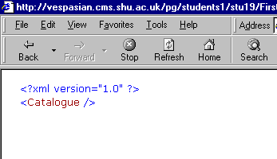
This what you should see

If you View the Source this is what you should see

<?xml version='1.0'?><Catalogue></Catalogue>

So, what we have done is to use VBScript inside an asp file to generate XML on the client. The browser on the client uses a default XSL stylesheet to produce the above.

Send a little more XML from the server to the client

ACTIVITY 2. Copy the following and save it on the server as SecondXML.asp and then call it from a browser on the client
<%
Response.write("<?xml version='1.0'?>")
Response.write("<Catalogue>")
Response.write("<Row>")
Response.write("<CatalogueNo>")
Response.write("123")
Response.write("</CatalogueNo>")
Response.write("<VendorNo>")
Response.write("456")
Response.write("</VendorNo>")
Response.write("<LotNo>")
Response.write("789")
Response.write("</LotNo>")
Response.write("<Description>")
Response.write("Hughs data")
Response.write("</Description>")
Response.write("<Reserve>")
Response.write("999.00")
Response.write("</Reserve>")
Response.write("</Row>")

Response.write("<Row>")
Response.write("<CatalogueNo>")
Response.write("560")
Response.write("</CatalogueNo>")
Response.write("<VendorNo>")
Response.write("456")
Response.write("</VendorNo>")
Response.write("<LotNo>")
Response.write("800")
Response.write("</LotNo>")
Response.write("<Description>")
Response.write("Pauls data")
Response.write("</Description>")
Response.write("<Reserve>")
Response.write("100.00")
Response.write("</Reserve>")
Response.write("</Row>")

Response.write("<Row>")
Response.write("<CatalogueNo>")
Response.write("700")
Response.write("</CatalogueNo>")
Response.write("<VendorNo>")
Response.write("456")
Response.write("</VendorNo>")
Response.write("<LotNo>")
Response.write("801")
Response.write("</LotNo>")
Response.write("<Description>")
Response.write("Beckys data")
Response.write("</Description>")
Response.write("<Reserve>")
Response.write("200.00")
Response.write("</Reserve>")
Response.write("</Row>")
Response.write("</Catalogue>")
%>
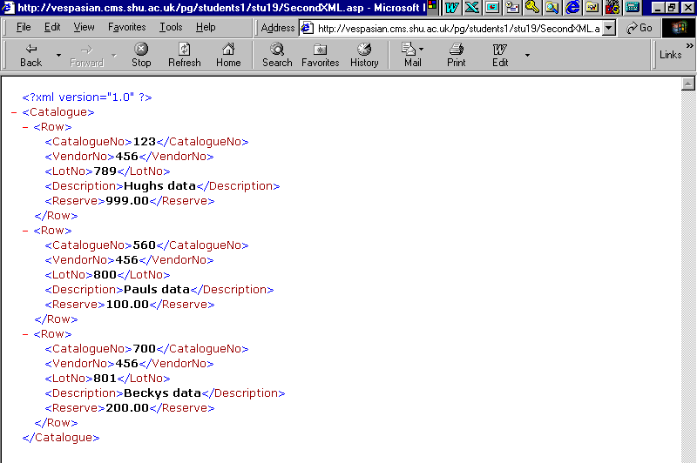
This is what you should see

Display the XML on the client using an XSL stylesheet on the server

ACTIVITY 3. a) Create the following and save it on the server in Catalogue.xsl

<?xml version="1.0"?>
<xsl:stylesheet xmlns:xsl="http://www.w3.org/TR/WD-xsl">
<xsl:template>
<TABLE BORDER="1">
<THEAD>
<TH>Catalogue No</TH>
<TH>Vendor No</TH>
<TH>Lot No</TH>
<TH>Description</TH>
<TH>Reserve</TH>
</THEAD>
<xsl:for-each select="Catalogue/Row">
<TR>
<TD><xsl:value-of select="CatalogueNo"/></TD>
<TD><xsl:value-of select="VendorNo"/></TD>
<TD><xsl:value-of select="LotNo"/></TD>
<TD><xsl:value-of select="Description"/></TD>
<TD><xsl:value-of select="Reserve"/></TD>
</TR>
</xsl:for-each>
</TABLE>
</xsl:template>

b) Modify SecondXML.asp to include the highlighted line shown below and save it on the server as ThirdXML.asp

Response.write("<?xml version='1.0'?>")
Response.write("<?xml:stylesheet type='text/xsl' href='catalogue.xsl'?>")
Response.write("<Catalogue>")

c) call ThirdXML.asp from a browser on the client, and this is what you should see
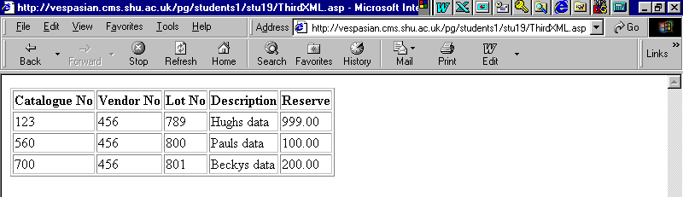

Get the data from a database, transform it into XML, send the XML to the client and display it on the client using XSL

ACTIVITY 4.

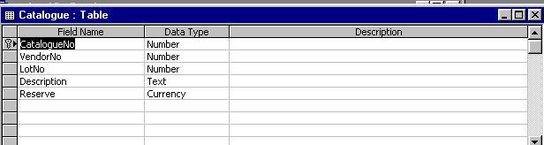
a) Create the Catalogue Table in your database on the server. It should have the following structure

and the data shown in Activity 3 above.

b) Copy the following in FourthXML.asp on the server, and call it from a browser on the client.

<%
Option Explicit makes sure that all variables are declared before they are used
Option Explicit
Dim Rs
Dim MyConn
Dim i

Set MyConn=Server.CreateObject("ADODB.Connection")
Set Rs=Server.CreateObject("ADODB.RecordSet")
Use your own DSN
MyConn.Open("pg1stuxx")
Rs.Open "SELECT * From Catalogue", MyConn, 1, 2

Response.write("<?xml version='1.0'?>")
Response.write("<?xml:stylesheet type='text/xsl' href='catalogue.xsl'?>")
Response.write("<Catalogue>")

While NOT Rs.EOF
Response.write("<Row>")
FOR i=0 TO Rs.Fields.Count-1
Response.write("<" & Rs(i).Name & ">" & Rs(i) & "</" & Rs(i).Name & ">")
NEXT
Response.write("</Row>")
Rs(i).Name holds the name of the ith field
Rs(i) holds the contents of the ith field

Rs.MoveNext
WEND

Response.write("</Catalogue>")
%>

You should see exactly what you saw in Activity 3, but now the data is coming from a database.

Refer to a DTD

ACTIVITY 5.
a) Create the following DTD and save it on the server in Catalogue.dtd

<!ELEMENT Catalogue (Row)+>

<!ELEMENT Row (CatalogueNo, VendorNo, LotNo, Description, Reserve)>

<!ELEMENT CatalogueNo (#PCDATA)>
It is left as an exercise for the reader to achieve the equivalent using an XML Schema (c.f. The Tutorial below)
<!ELEMENT VendorNo (#PCDATA)>
<!ELEMENT LotNo (#PCDATA)>
<!ELEMENT Description (#PCDATA)>
<!ELEMENT Reserve (#PCDATA)>

b) Modify FourthXML.asp to include the line highlighted below and save on the server as FifthXML.asp

Response.write("<?xml version='1.0'?>")
Response.write("<?xml:stylesheet type='text/xsl' href='catalogue.xsl'?>")
Response.write("<!DOCTYPE Catalogue SYSTEM 'Catalogue.dtd'>")
Response.write("<Catalogue>")

You should see exactly what you saw in Activities 3 & 4. The DTD is actually ignored (unless it contains syntax errors) as we know that IE5 is not a validating parser.

Save the XML on the server in a flat file

ACTIVITY 6.
a) Copy the following into SixthXML.asp on the server. Run it from a browser on a client

<%
Option Explicit
Dim Rs
Dim MyConn
Dim i
Dim MyObject
Dim MyFlatFile

Set MyConn=Server.CreateObject("ADODB.Connection")
Set Rs=Server.CreateObject("ADODB.RecordSet")
The next two lines simply create a text file on the server, to which we are going to write the XML

Set MyObject=Server.CreateObject("Scripting.FileSystemObject")
Set MyFlatFile=MyObject.CreateTextFile("c:\inetpub\wwwroot\pg\students1\stuxx\Catalogue.xml")
Use your own number
MyConn.Open("pg1stuxx")
Rs.Open "SELECT * From Catalogue", MyConn, 1, 2

MyFlatFile.WriteLine("<?xml version='1.0'?>")
MyFlatFile.WriteLine("<?xml:stylesheet type='text/xsl' href='catalogue.xsl'?>")
MyFlatFile.WriteLine("<!DOCTYPE Catalogue SYSTEM 'Catalogue.dtd'>")
MyFlatFile.WriteLine("<Catalogue>")

While NOT Rs.EOF
MyFlatFile.WriteLine("<Row>")
FOR i=0 TO Rs.Fields.Count-1
MyFlatFile.WriteLine("<" & Rs(i).Name & ">" & Rs(i) & "</" & Rs(i).Name & ">")
NEXT
MyFlatFile.WriteLine("</Row>")
Basically, all we have done is to replace Response.write with MyFlatFile.WriteLine
Rs.MoveNext
WEND

MyFlatFile.WriteLine("</Catalogue>")

Rs.Close
Set Rs=Nothing
MyFlatFile.Close
Set MyFlatFile=Nothing

%>

b) You should see that there is file called Catalogue.xml on the server that contains the following

<?xml version='1.0'?>
<?xml:stylesheet type='text/xsl' href='catalogue.xsl'?>
<!DOCTYPE Catalogue SYSTEM 'Catalogue.dtd'>
<Catalogue>
<Row>
<CatalogueNo>123</CatalogueNo>
<VendorNo>456</VendorNo>
<LotNo>789</LotNo>
<Description>Hughs data</Description>
<Reserve>999</Reserve>
</Row>
<Row>
<CatalogueNo>560</CatalogueNo>
<VendorNo>456</VendorNo>
<LotNo>800</LotNo>
<Description>Pauls data</Description>
<Reserve>100</Reserve>
</Row>
<Row>
<CatalogueNo>700</CatalogueNo>
<VendorNo>456</VendorNo>
<LotNo>801</LotNo>
<Description>Beckys data</Description>
<Reserve>200</Reserve>
</Row>
</Catalogue>

c) The books say that there is an even simpler way to do this whereby we say that we are going to use a file by saying e.g.

szFile=Server.MapPath(“Catalogue2.xml")

Then without going round a loop as above we simply say

Rs.Save szFile, adPersistXML

If this works it will be a miracle!!

Copy the following into SixthXMLa.asp on the server. Run it from a browser on a client

<%
Option Explicit
Dim Rs
Dim MyConn
Dim szFile

Set MyConn=Server.CreateObject("ADODB.Connection")
Set Rs=Server.CreateObject("ADODB.RecordSet")
Use your own number
MyConn.Open("pg1stuxx")
Rs.Open "SELECT * From Catalogue", MyConn, 1, 2

szFile=Server.MapPath(“Catalogue2.xml")
Rs.Save szFile, adPersistXML

Rs.Close
Set Rs=Nothing

%>

NOTE. This only works in ADO 2.5. I was right about the miracle!

Use the XML DOM on the client to load the XML from a flat file on the server and then transform the XML using XSL(that is on the server)

ACTIVITY 7.

Copy the following into SeventhXML.asp on the server, and run it from a browser on the client.

<%
Option Explicit
Dim Rs
Dim MyConn
Dim i
Dim MyObject
Dim MyFlatFile

Set MyConn=Server.CreateObject("ADODB.Connection")
Set Rs=Server.CreateObject("ADODB.RecordSet")
Set MyObject=Server.CreateObject("Scripting.FileSystemObject")
Set MyFlatFile=MyObject.CreateTextFile("c:\inetpub\wwwroot\pg\students1\stu19\Catalogue.xml")

MyConn.Open("pg1stu19")
Rs.Open "SELECT * From Catalogue", MyConn, 1, 2

MyFlatFile.WriteLine("<?xml version='1.0'?>")
MyFlatFile.WriteLine("<?xml:stylesheet type='text/xsl' href='catalogue.xsl'?>")
MyFlatFile.WriteLine("<!DOCTYPE Catalogue SYSTEM 'Catalogue.dtd'>")
MyFlatFile.WriteLine("<Catalogue>")

While NOT Rs.EOF
MyFlatFile.WriteLine("<Row>")
FOR i=0 TO Rs.Fields.Count-1
MyFlatFile.WriteLine("<" & Rs(i).Name & ">" & Rs(i) & "</" & Rs(i).Name & ">")
NEXT
MyFlatFile.WriteLine("</Row>")
Rs.MoveNext
WEND

MyFlatFile.WriteLine("</Catalogue>")

Rs.Close
Set Rs=Nothing
MyFlatFile.Close
Set MyFlatFile=Nothing

%>

This is the new stuff.
This gets sent to the client.
This script runs on the client

The logic is
Create 2 DOM Document objects
xml, xsl
Load the relevant files into them
Write the xsl transformed xml to the client browser window that is currently open.
<HTML>
<BODY>
<SCRIPT Language="Javascript">
var xml=new ActiveXObject("Microsoft.XMLDOM")
xml.async=false
xml.load("Catalogue.xml")

var xsl=new ActiveXObject("Microsoft.XMLDOM")
xsl.async=false
xsl.load("Catalogue.xsl")

document.write(xml.transformNode(xsl))
</SCRIPT>
</BODY>
</HTML>

Summary

There is something that I do not understand. How does the client know that the XSL is on the server?

There appears to be no point in saving the XML in a flat file on the server.

There are a number of logical tasks that I have omitted here

Sending XML back to the server
Saving the XML data onto a database on the client

Self-Test

Resources

Books

Web sites

Research Ideas

1.

TUTORIAL

1. Repeat Activity 5 but create an equivalent XML Schema instead of the DTD.
2.

