DREAMWEAVER 4
Timelines

by

Hugh Lafferty

Table of Contents

1. Timelines 1
2. Opening the Timelines Inspector 1
3. Adding motion to a timeline 2
4. Modifying a timeline by adding a key frame 3
5. Recording a layer’s path 4
6. Summary 4
7. Ideas for experiments with layers 5

DREAMWEAVER. Timelines

Timelines

Timelines are a way of adding animation to a layer.
If you already know Flash or Director 7 then the following will be very easy.

YOU CAN ONLY ANIMATE LAYERS. So, if you want to animate some text, then put it in a layer.

Opening the Timelines Inspector
ACTIVITY 1. Open up the Timelines Inspector from Window→Timelines

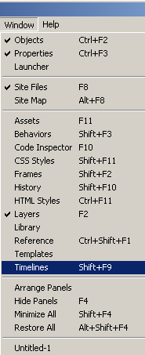

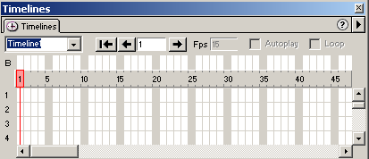

Drag the BlueLayer to the Timeline as shown below
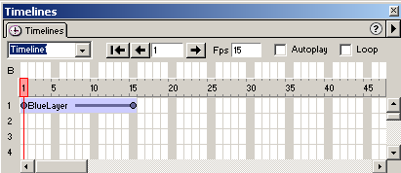

Adding motion to a timeline
ACTIVITY 2.

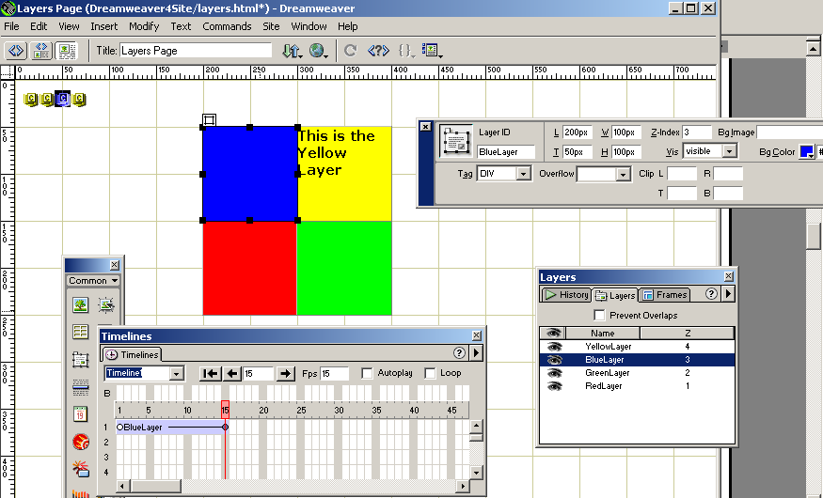

Select the end frame

Move the layer by grabbing its selection handle and moving it to where you want the layer to end.
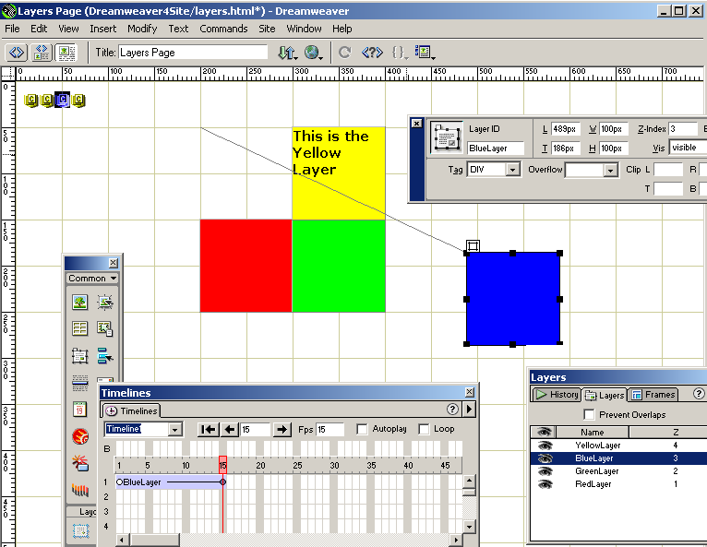

Tick Autoplay and Loop and then
save (File →Save) and then preview in the browser (F12)

Now, do the same for the other layers.

To play the animation a) Press the Rewind button,
This is Autoplay
and b) Press and hold down the Play button

Modifying a timeline by adding a key frame

ACTIVITY 3. We will add a keyframe to show an intermediate point on the path, and then drag the layer to that point.

In the Timelines Inspector choose the object whose timeline you want to alter.
Select the frame which you want to make into a key frame
Choose Modify→Timeline→Add Keyframe
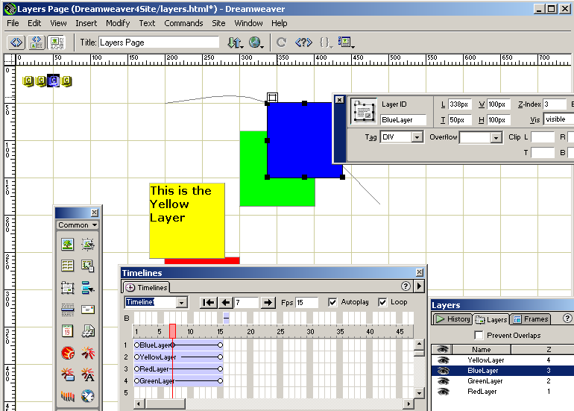

Drag the layer to a new position (we could also have changed its size and visibility)

Save and preview in the browser.

Brief Explanation of 'Tweening'

We see that Timelines are using a cinematic metaphor, in that, in each frame is a 'scene' and a viewing head moves from frame to frame, at a speed of 15 frames per second (in this case). If an object has its position changed in between frames then the object will appear to be moving.

In the early days of Disney, Master artists used to paint a starting scene (e.g. Frame 1 above) and a final scene (e.g. Frame 15 above) and leave it to more lowly artists to fill in the scenes in between. This process was known as 'tweening' and was boring and labour intensive. Dreamweaver now does the tweening for you. You specify the start and end points and it calculates the top left hand corner of the surrounding rectangle at the intermediate frames. The calculation of these intermediate points is not done via linear interpolation it appears to curvi-linear.

To put a little more flesh on this, Dreamweaver tweens between successive keyframes. The first frame and the last frame are automatically key frames (you can see that because they have circles in them).

Here, we have only been discussing motion tweening, but there are other types of tweening e.g. shape, colour, size.
AVTIVITY 3b. Add a) more key frames to the BlueLayer and make the path even more complex b) Do a similar exercise for the other layers.

Recording a layer’s path

ACTIVITY 4

a) Start again by removing all the objects from the Timelines Inspector (point to a layer in the inspector and press Delete)
b) Point to a layer. Make sure that the 8 selection handles are shown (otherwise you might have selected the content of the layer rather than the layer itself)
c) Drag the layer to its start point
d) Select Modify→Timeline-->Record Path of Layer
e) Drag the layer around. Some grey dots will appear on the screen. These indicate key frames.
f) You should then see something like this

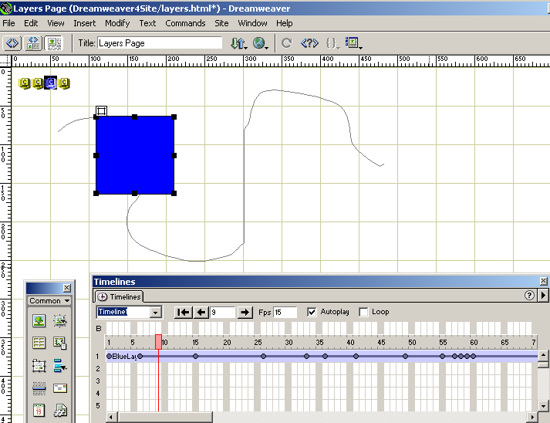

g) Point to channel 2 and do the same sort of thing with another layer, and then channel 3 and channel 4.
h) Save, and preview in browser

Summary
- Animation is achieved by adding layers to timelines.
- The start and end points of an animation are defined and Dreamweaver automatically ‘in-betweens’ the position of the intermediate frames. The start and end frames are automatically defined as keyframes.
- A timeline can be modified by the addition of keyframes. A layer is moved to a new position in a key frame and Dreamweaver ‘tweens’ between keyframes.

Ideas for experiments with layers

- Make one of the squares follow a simple path but make it gradually smaller.
- Horror of horrors. Make some text blink.
- Invent the equivalent of the <MARQUEE> tag viz. text that moves across the screen and back again.
- Make some text drop down.

