DREAMWEAVER 5
Layers

by

Hugh Lafferty

Table of Contents

1. Introduction. 1
2. Set up rulers and grid (with snap on) 1
2. To insert a layer 2
3. Opening the Layers palette 3
4. Modifying layers’ characteristics 3
5. Experimenting with the properties of layers 4
6. Adding content to a layer 5
7. Understanding z-ordering 5
8 Summary 7
8. Self Test 7

DREAMWEAVER. Layers
Contents of this session
- Layers

Introduction.

Layers allow a 3rd dimension to be introduced onto Web pages viz. z
Each layer has a z-index. Layers can overlap with the one with the highest z-index ‘winning’. We can position layers very accurately and then put content in them and then move them about.

NOTE. The only way that you are going to get movement in Dreamweaver is to use layers. If you want to text to move it must be in a layer.

Set up rulers and grid (with snap on)
ACTIVITY 1.
It is best to start with the rulers showing and with a grid and snap on as well

This is how to get the rulers shown viz. View→Rulers→ Show

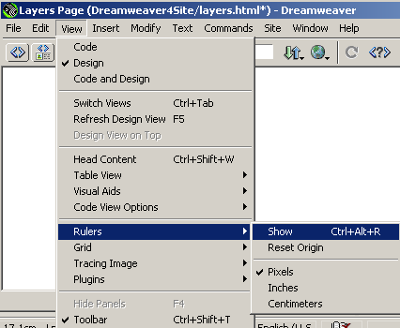
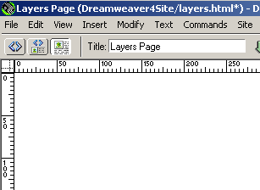

and this is how to get the grid shown with snap on viz. View→Grid→ Show, Snap To

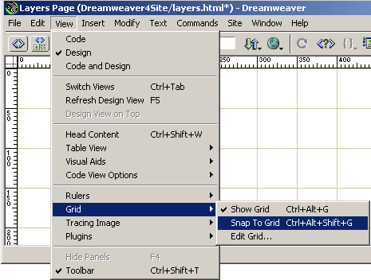

Grid Settings from Grid allow you to change a) the colour of the grid b) the size of the squares and c) the accuracy of movement when ‘snapping’ (as shown below).

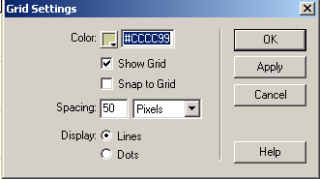

To insert a layer
ACTIVITY 2.

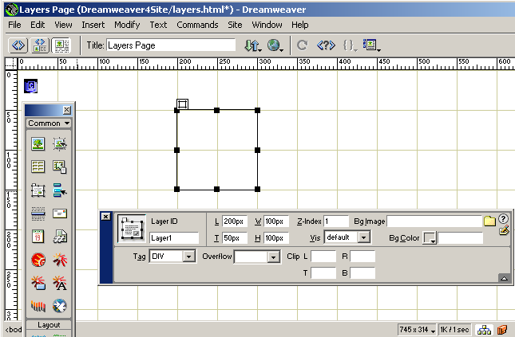

Make sure that you can see all the sizing handles and the little rectangular box above the layer. Drag the little rectangular box to drag the layer.
Point to the Draw Layer icon on he Objects Palette

And then drag a rectangular area in the Document Window

Notice the positioning of an anchor, which indicates that there is a layer here. The anchor will be invisible to the browser. If you cannot see the anchor then View→Visual Aids-->Invisible Elements. Notice also the Layers Properties dialogue box.

Opening the Layers palette

ACTIVITY 3. Open up the Layers palette with Window→Layers

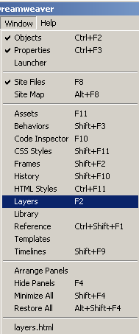
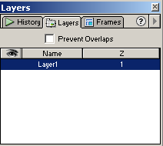

We see that this layer is called Layer1 and has z-index of 1, and is currently visible

Modifying layers’ characteristics

ACTIVITY 4. Try changing a) the name of the layer, and b) it’s z-index, by double clicking. Then change the visibility characteristic by clicking under the eye.

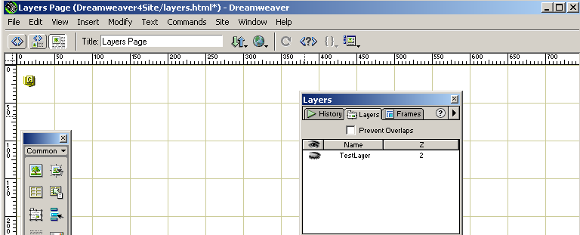

Notice that now the layer is invisible, because the eye is shut

Experimenting with the properties of layers

ACTIVITY 5. Look at the Properties of a Layer

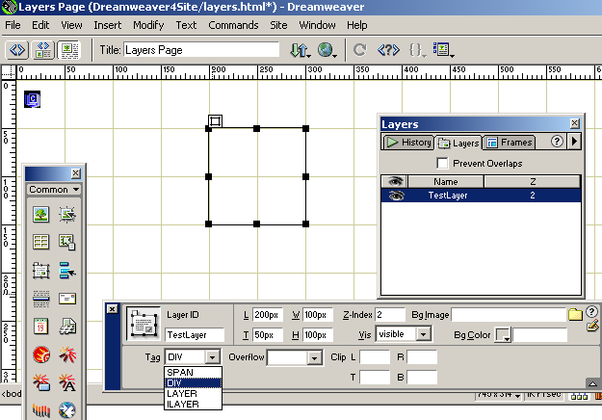

Always use the DIV or SPAN tag . Do not use LAYER or ILAYER as they only apply to Netscape.

Forget about Overflow and clipping. The rest of the properties should be obvious.

Look at the HTML produced

<div id="TestLayer" style="position:absolute; left:200px; top:50px; width:100px; height:100px; z-index:2; visibility: visible"></div>

Because we can play with these attributes of <DIV> we can achieve a) Movement by playing with left and top b) 3-D effects by playiong with z-index

Adding content to a layer

ACTIVITY 6. Draw four layers and colour their background colour

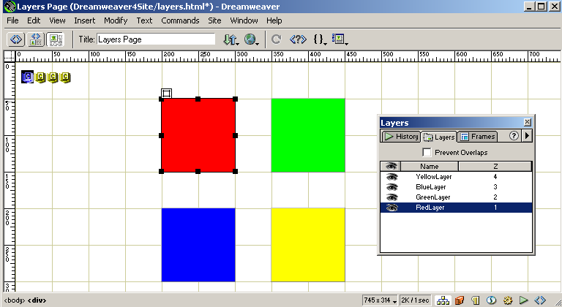

Obviously we could have added text and images to the layers, using techniques that we have already learnt.

Understanding z-ordering

ACTIVITY 7. Move the layers so that they overlap to see how z ordering works.

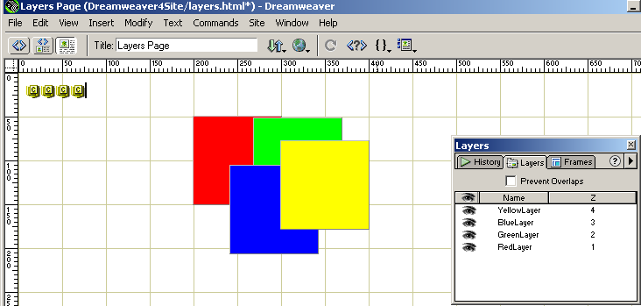

ACTIVITY8. Preventing Overlap

If you want you can prevent layers overlapping. Tick the Prevent Overlaps box, and then try and move the layers about.

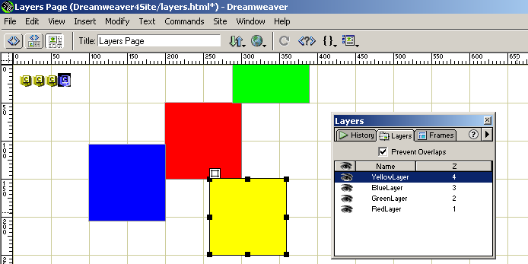

ACTIVITY 9. Placing Text within Layers. Simply write some text into a layer.

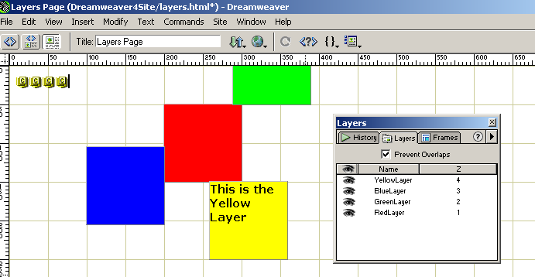

Look at the produced HTML.

<div id="YellowLayer" style="position:absolute; left:259px; top:150px; width:100px; height:100px; z-index:4; background-color: #FFFF00; layer-background-color: #FFFF00; border: 1px none #000000; visibility: visible">
<b>This is the Yellow Layer</b>
</div>

Notice how the <div> tags are just acting like a pair of brackets to whatever content is inside them. They just happen to be very useful tags because they have lots of nice attributes.

ACTIVITY 10. Placing images within Layers.. Simply drag an image to a layer (using techniques that we already know)

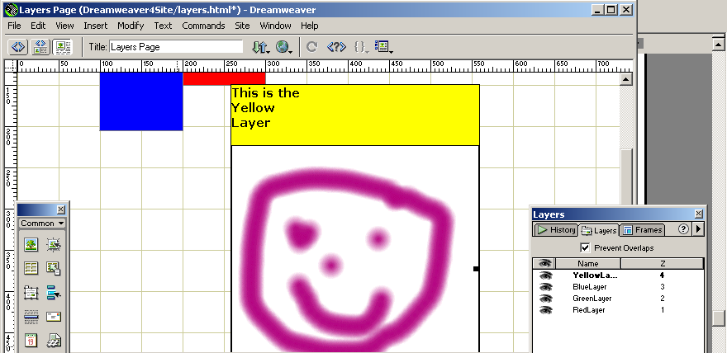

Again, look at the HTML produced.

<div id="YellowLayer" style="position:absolute; left:259px; top:150px; width:100px; height:100px; z-index:4; background-color: #FFFF00; layer-background-color: #FFFF00; border: 1px none #000000; visibility: visible">
<p><b>This is the Yellow Layer</b></p>
<p><img src="images/Image1.gif" width="300" height="300"></p>
</div>

All we have done is insert an <img> tag

Now, all we have to do to move the text and the image is to alter the left and top attributes of the surrounding <div> tag.

Summary

- A layer is a rectangular area, in which we can place colour, text and images.
- Layers have a third dimension viz. z. Consequently we can have layers on top of layers. The layer with the highest z-index is furthest to the front. The z-index is initially allocated in order of layer creation, but it can be changed.
- Layers are the only way of allowing dynamic positioning in Dreamweaver. We have not yet seen how to make layers move (see Timelines and Behaviours later).

Self Test
1.How are layers useful?
2. Which would you rather do to place an image a) put it in a 1x1 borderless table, or b) Put it in a layer.

