DREAMWEAVER4
Session 4
Rollovers

by

Hugh Lafferty

Table of Contents

1. Introduction 1
2. Creating Rollovers 1
3. Summary 2
4. Ideas for experiments 3
5. Self Test 4

DREAMWEAVER 4. Rollovers

Contents of this session
- Rollovers

Introduction

Quite often Web designers have navigational buttons on the left-hand side of the screen and as the mouse passes over each button it changes to show that the mouse is over it. This is called ‘rollovers’, and is made very easy by Dreamweaver. You simply have to specify one image for when the mouse is not over the image and one for when the mouse is over.

Creating Rollovers

ACTIVITY 1. Import another image into the images folder

ACTIVITY 2.
Create a table with a) 1 column and 2 rows b) no border c) and place it left as shown below

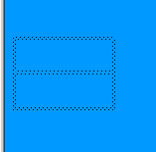

Point to where you want the image. In this case the top cell of the table

From Insert→Interactive Image-->Rollover Image

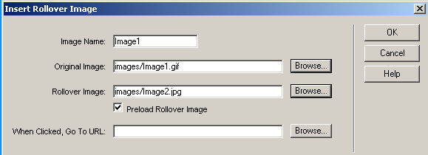

You should preview this in the browser by pressing F12, to see something like this

With mouse NOT over the gif With the mouse over the gif
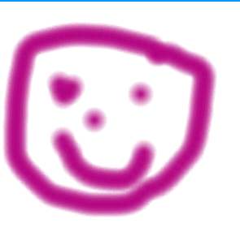
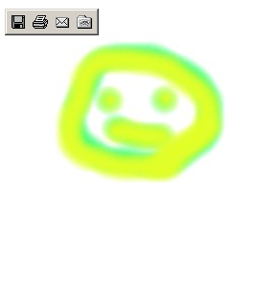

We can also make one of the gifs clickable by including a URL

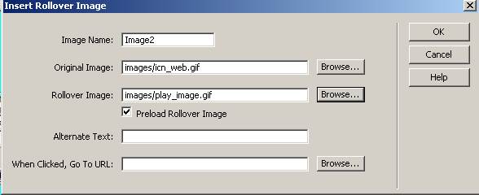

If you want to do that after you have specified the two images
then point to the image and in Link type a URL

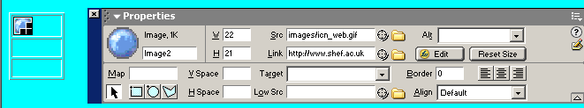

Try it out in the browser by pressing F12

Summary

- Rollovers are very simple to implement in Dreamweaver . They simply mean filling in the following dialogue box.

- The associated gifs have to found from somewhere and are better placed inside the site. Dreamweaver makes the placement within the site an easy process.
- The produced HTML is very hard to read and understand.

Ideas for experiments

- Try creating a table with one column and about 8 rows, with Border set to 0. Place the table on the left-hand side of the page. In each row place a rollover with a link to a separate page on your site. This then could be a prototype for how the navigation part of every page should look. We would like you to think about

a) Do you think the rollovers should make a noise if clicked? If so how do you think you are going to cope with this?
b) Should the rollover change to yet another image once it has been clicked? If so how do you think you are going to cope with this? Lots of sites do this so that you can tell which parts of the site you have visited
c) How are you going to easily copy this navigational structure to every page of your site?

Self Test

- In the following dialogue box how is Preload Rollover Image used?

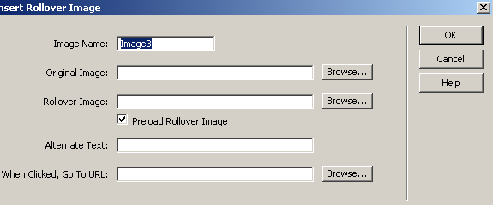

- What is the advantage of using Image Name above and how is it used?

