DREAMWEAVER4
Session 3
Tables

by

Hugh Lafferty

Table of Contents

1. Introduction 1
2. To insert a Table 1
3. Experiment with selecting cells 2
4. Experiment with table properties 5
5. Summary 11
6. Ideas for experiments 12
7. Self Test 13

DREAMWEAVER. Tables

Contents of this session
- Tables

Introduction

Tables are notoriously fiddly to build in HTML and Dreamweaver really comes to the Web-builder’s aid here. Tables are used extensively by Web-site builders to place objects carefully on the page.

To insert a Table
ACTIVITY 1. Place the cursor where you want the table and click the Insert Table icon from the Objects palette.

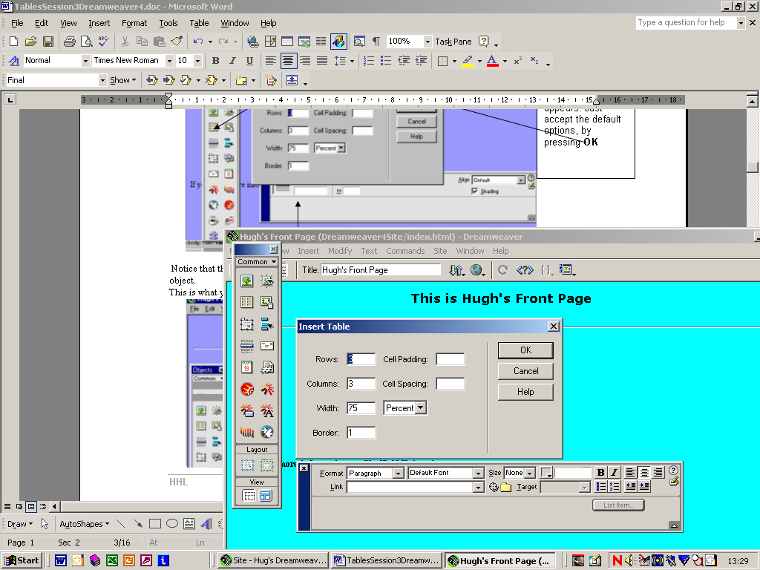
This dialogue box appears. Just accept the default options, by pressing OK

This what you should see

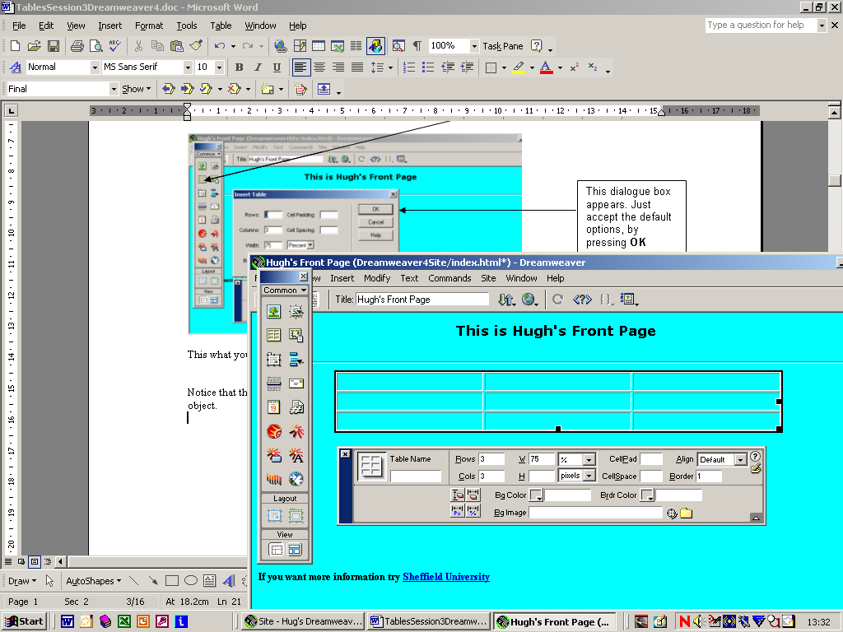

Notice that the Properties window has changed to reflect the fact that we are now pointing to a Table object.

Experiment with selecting cells
ACTIVITY 2.
a) Type some text into any of the cells. Make sure that it is a lot to see how the table changes size.
b) Change the size of complete rows/columns (just as you would in MS Word)
c) Change the size of the whole table by dragging on the sizing handles.

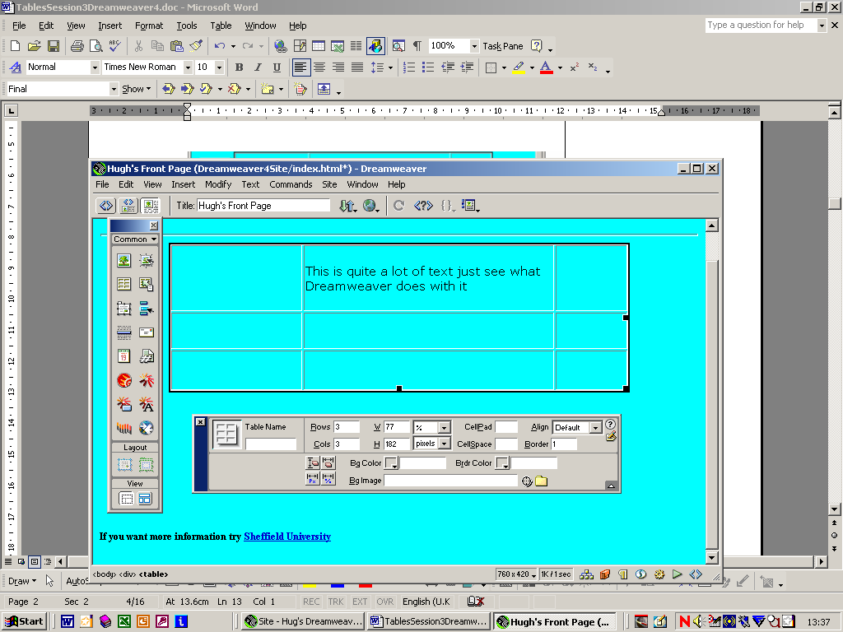

d) Select the whole table by either carefully coming up from below or placing the cursor in the table and then selecting <table>
e) Select a whole column (by pointing from the top)

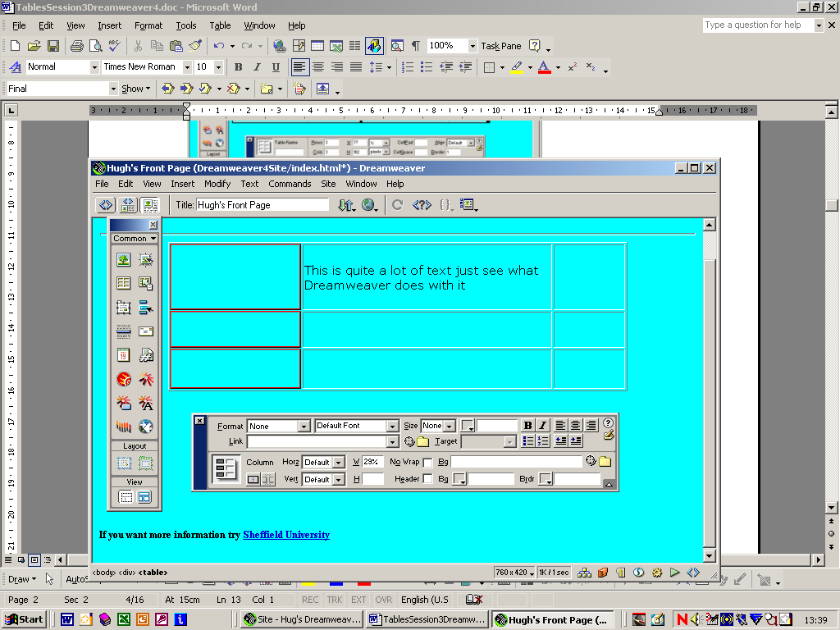

f) Select a whole row (by pointing from the left, or by positioning the cursor in a cell and then choosing <tr>)

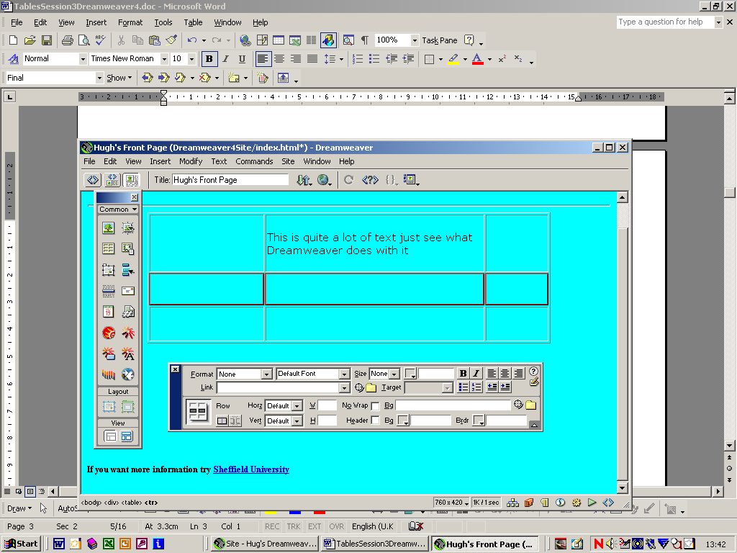

g) Select just one cell by placing the cursor in a cell and then choosing <td>

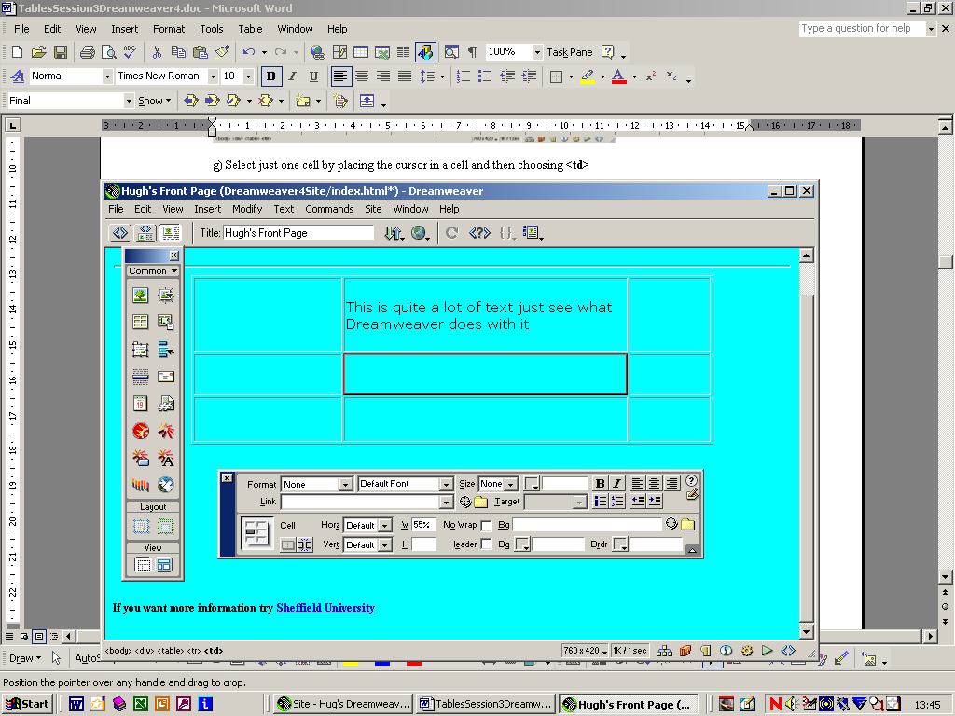

h) Select two adjacent cells by i)placing the cursor in the first cell and ii) hold down shift and then place the cursor in the second cell

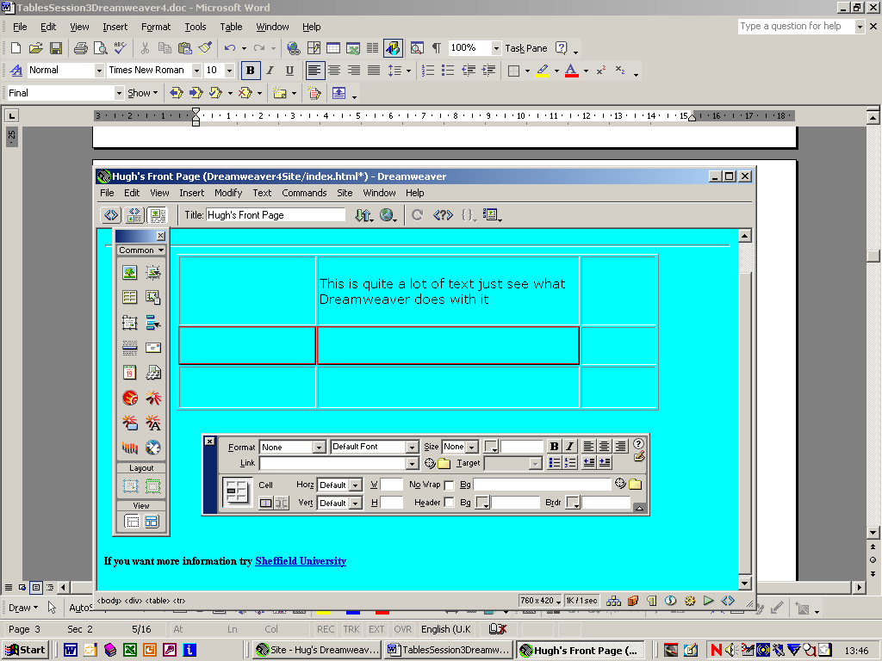

i) Select non-adjacent cells by holding down control and then placing the cursor in the required cells.

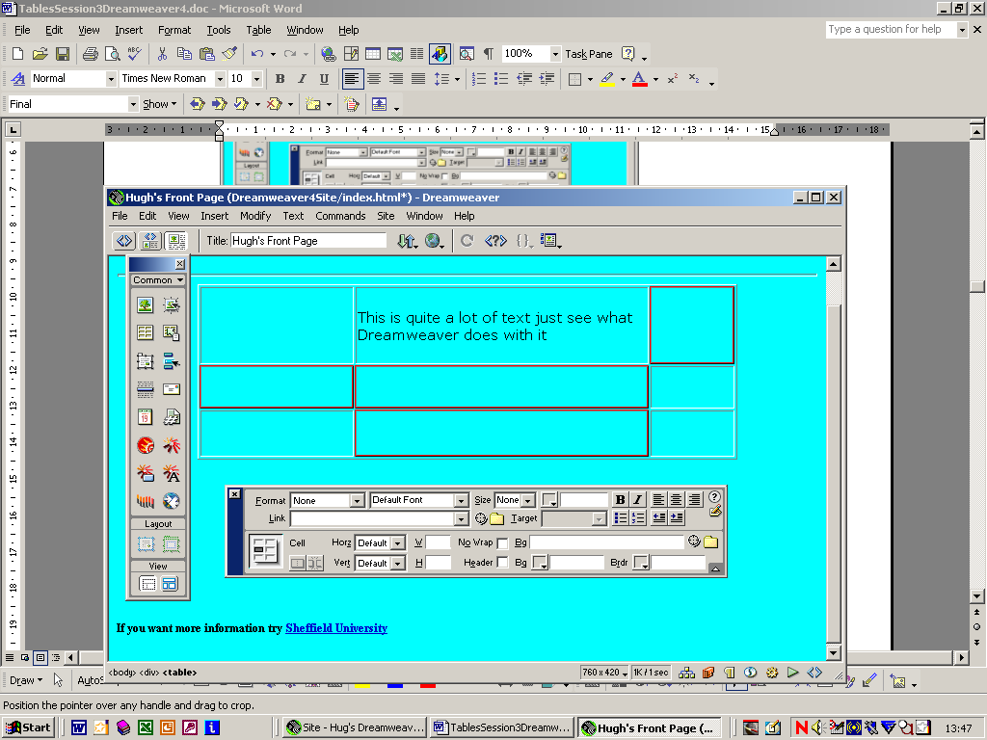

Experiment with table properties
ACTIVITY 3.
a) add a new row (Modify→Table→Insert Row or Columns)

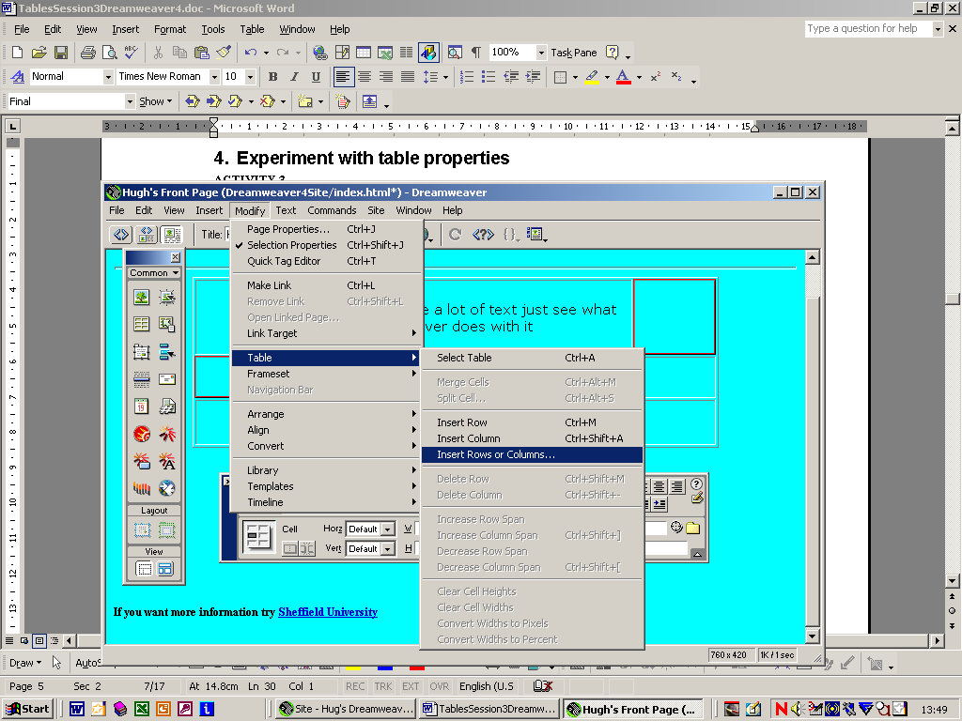

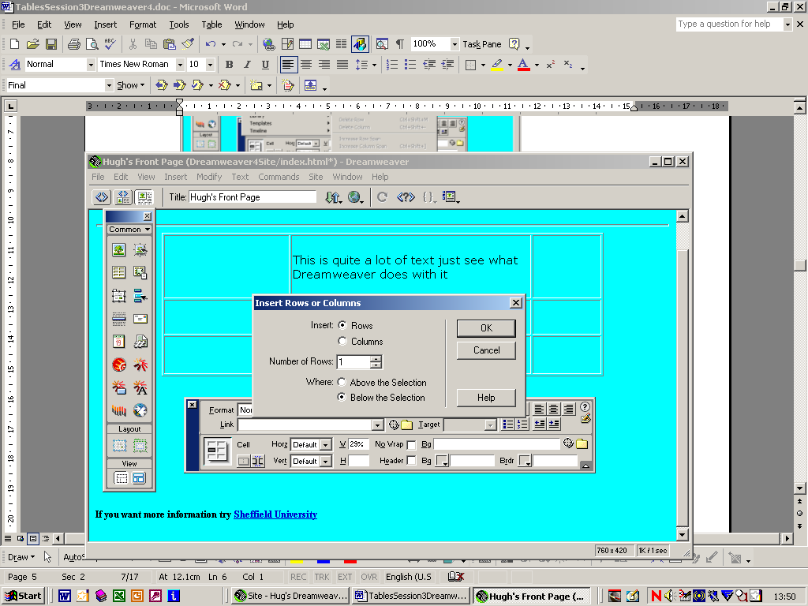
Choose Rows.
Then the no. of rows.
Then where(above or below)
Then press OK

b) add a new column, by a very similar process

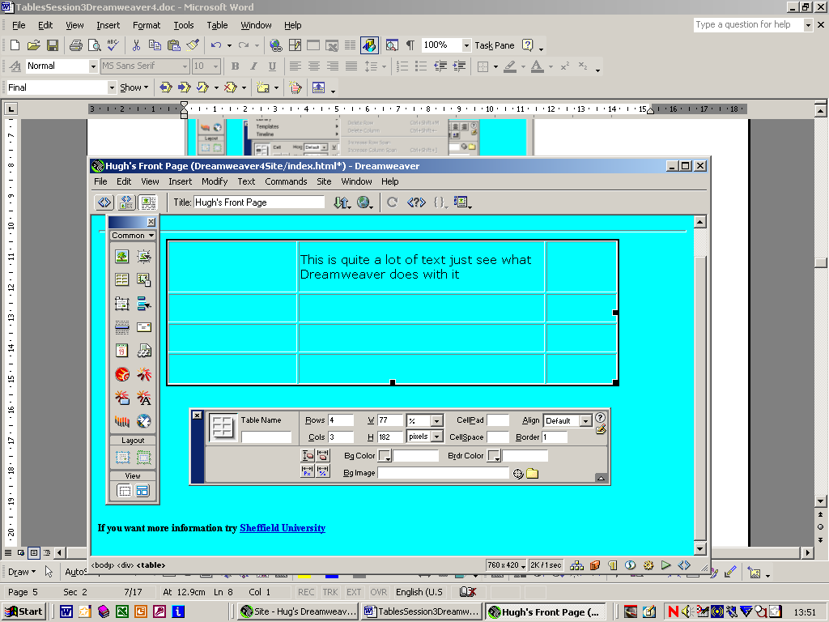
or change the number of Rows
or Columns
from the Properties Window

c) change the Border to 0 (people do this a lot when they want to use a table to position a graphic)
Note the dotted borders.

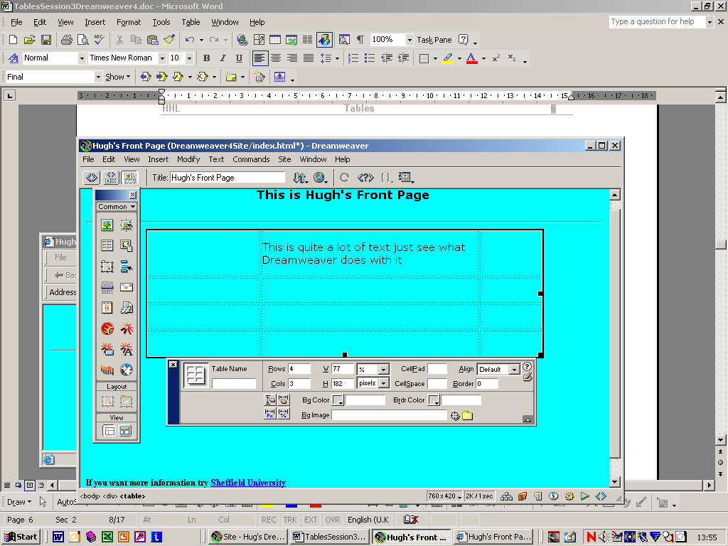
Press F12 to see the effect

d) Insert an image in all the cells and change i) CellSpace and ii) CellPad

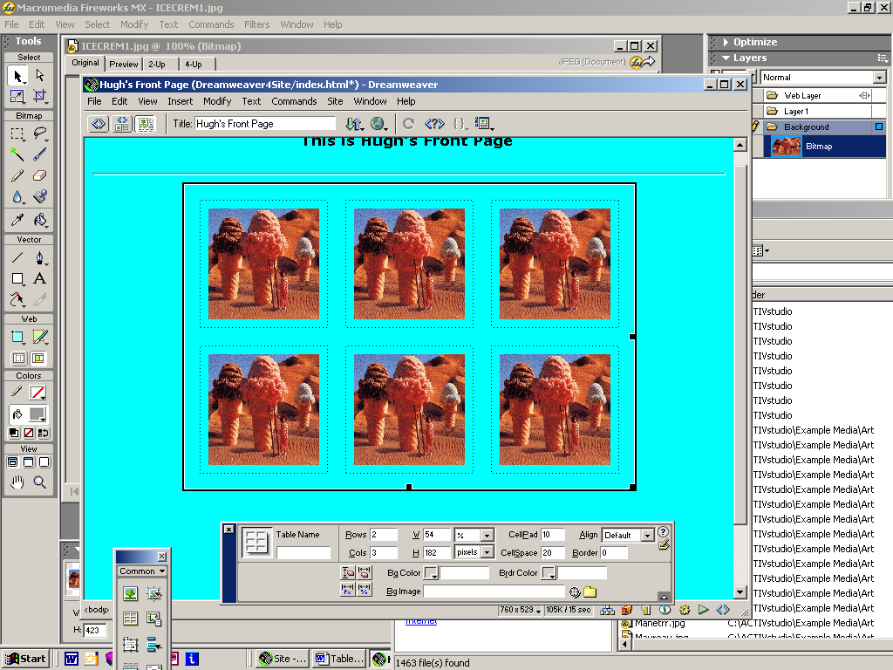
Cell Pad
Cell Space

e) Experiment with aligning the whole table. This is what people do when they want an image centred on the page. They make a 1x1 Table with no border and place an image in it and then centre the Table.

f) Experiment with
i) Brdr Color
ii) BgColor
iii) BgImage

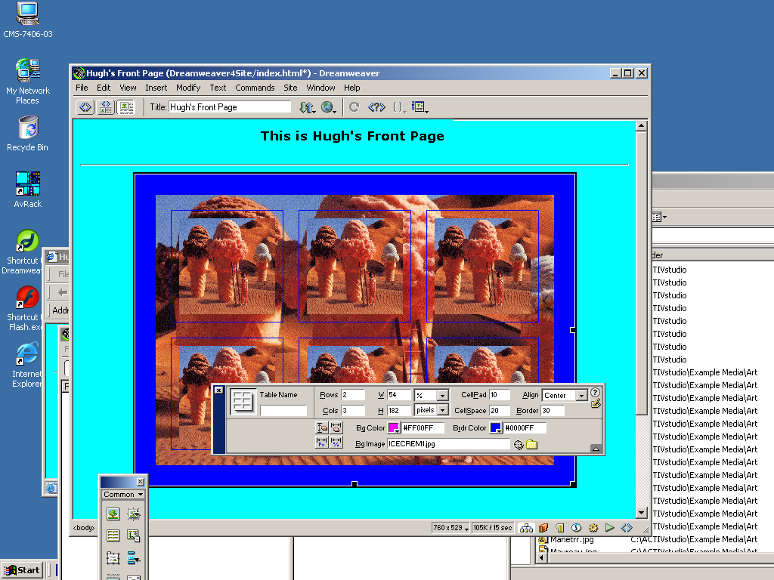

g) Experiment with merging and splitting cells

Start off something like this

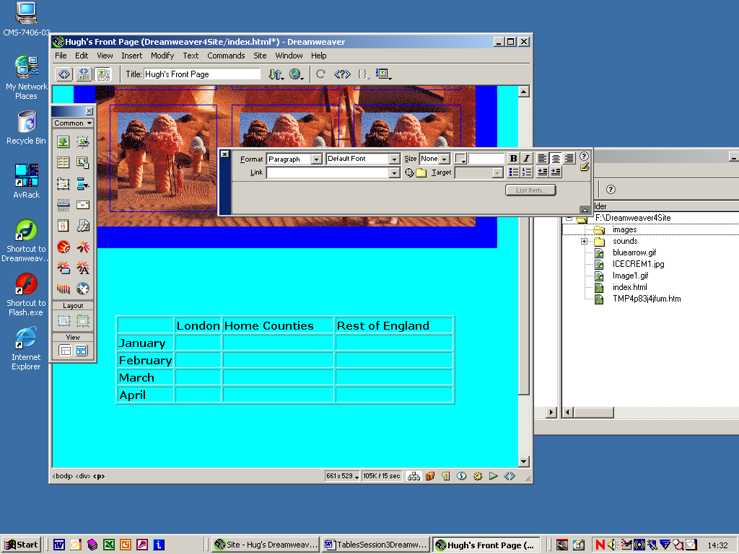
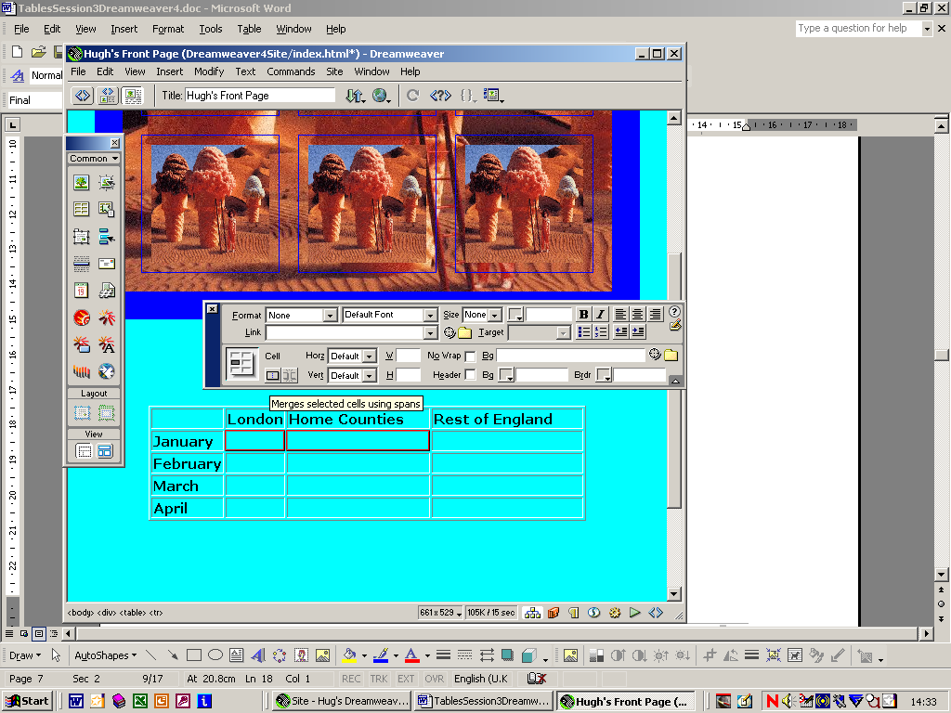

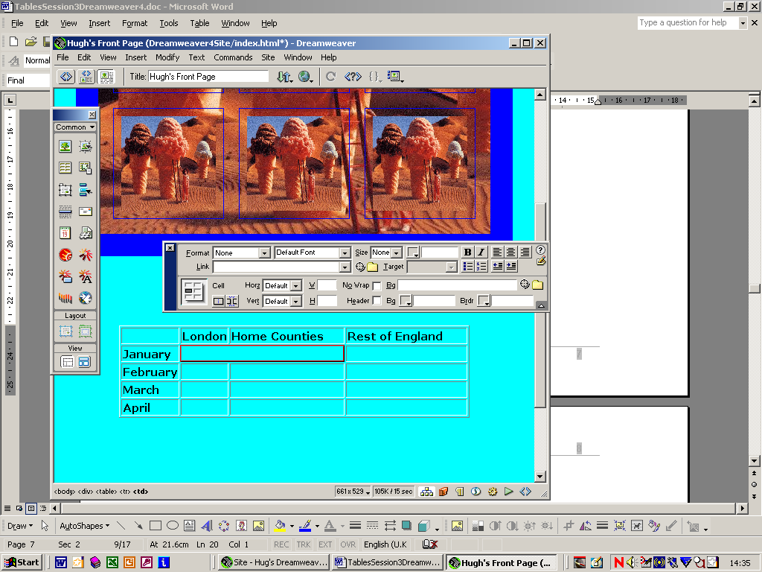
Look at the HTML produced

Point to two adjacent cells and then press Merge selected cells using span

h) Select rows one at a time and experiment
with Vertical alignment/horizontal
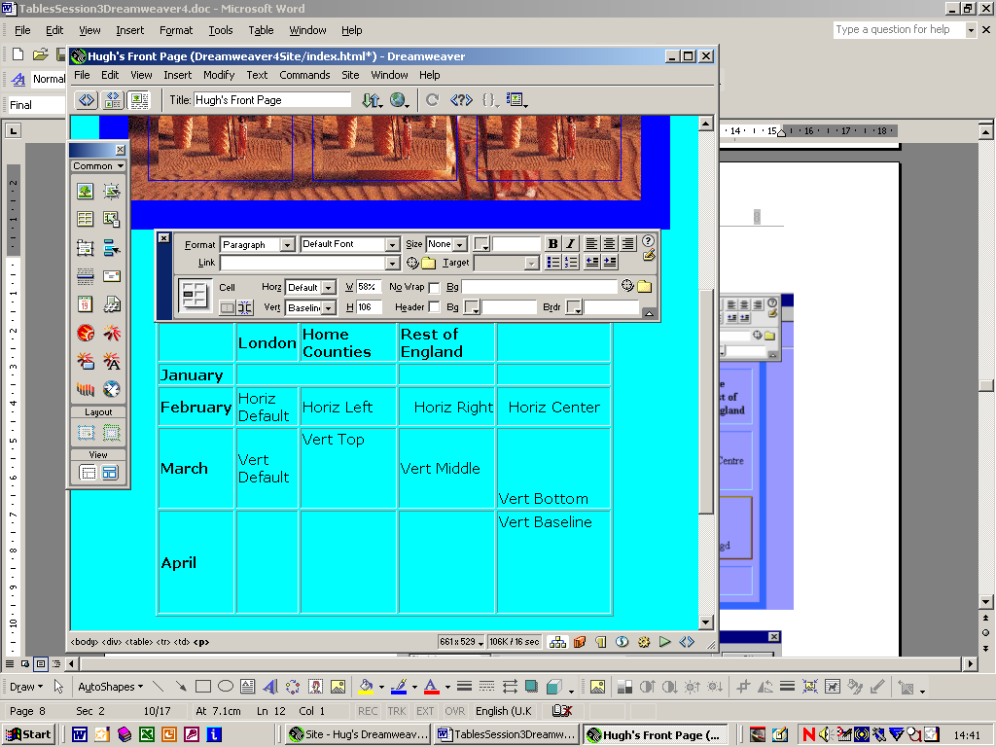

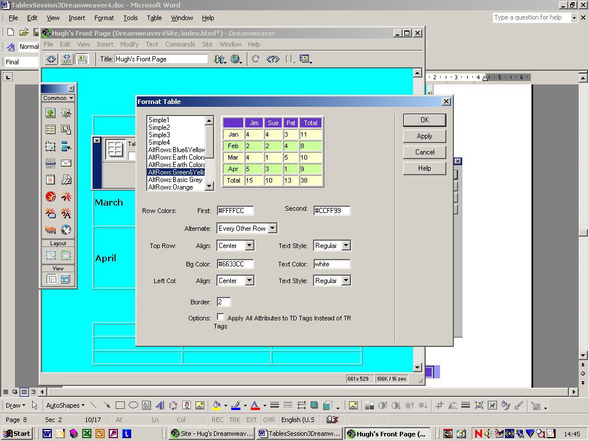
i) Create a new Table
and from
Commands→Format Table
choose one of pre-defined
set of Table formats

and this is what you should see

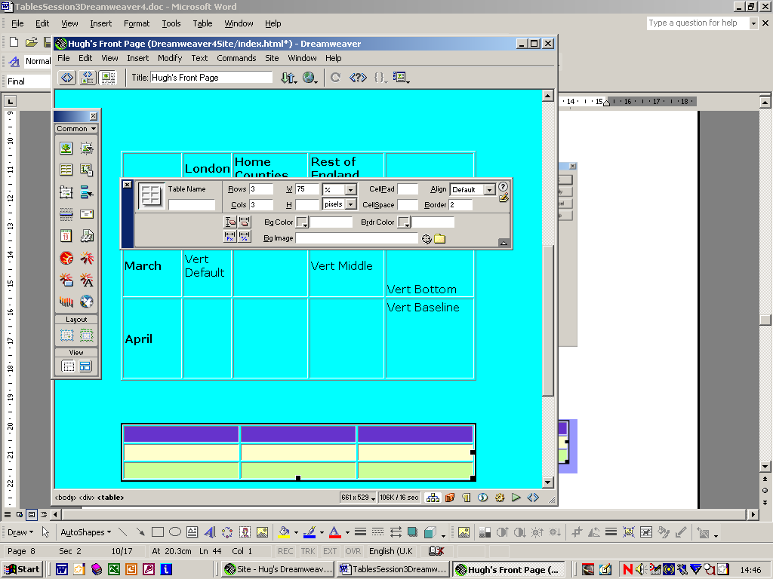

j) Put some data in the second table and experiment
with sorting the data from Commands→Sort Table

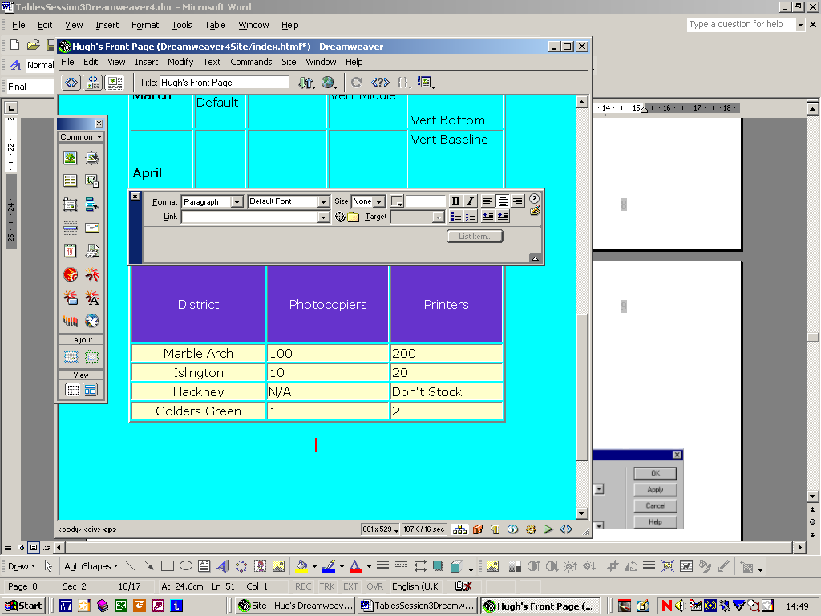

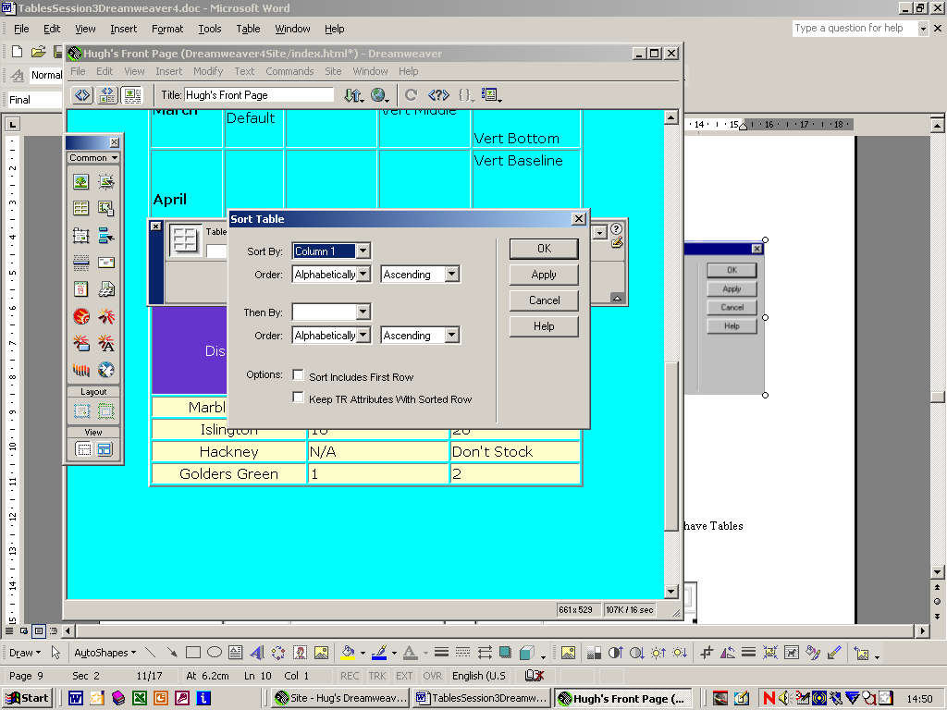

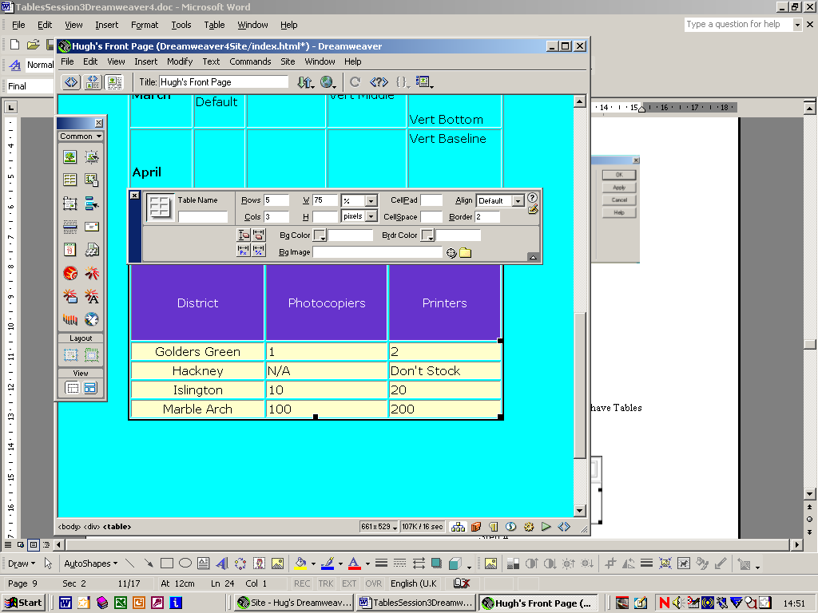

j) Tables within Tables (i.e. nesting Tables)

Web page designers quite often spend a long time designing their layouts with Tables and often have Tables nested within Tables as illustrated below. See if you can produce the following.
Step 1
Step 2

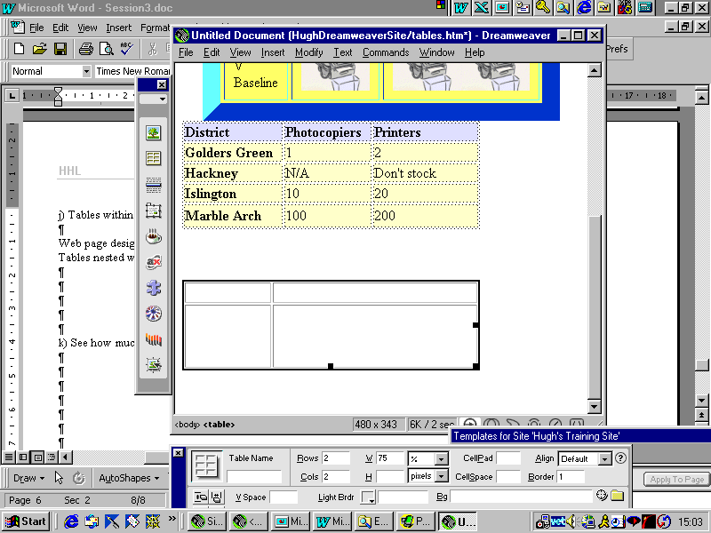
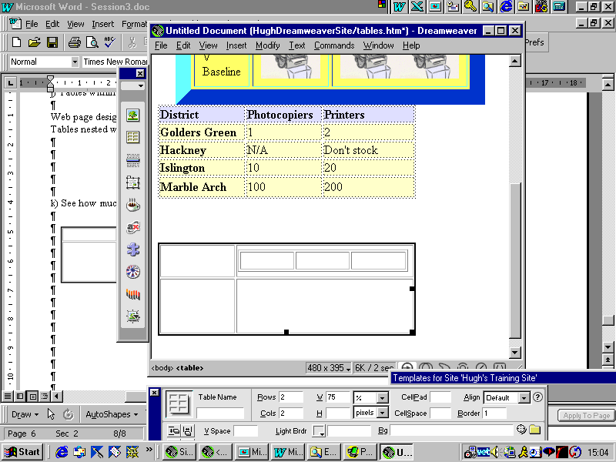

Step 3
Step 4
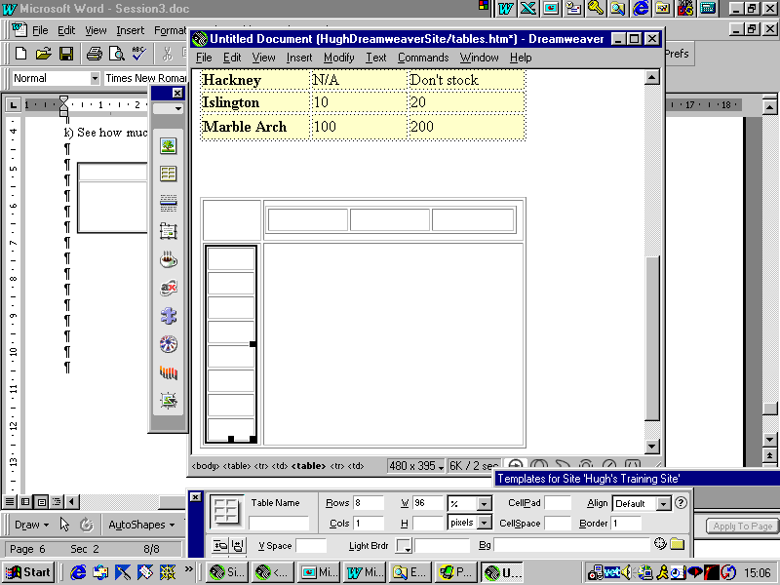
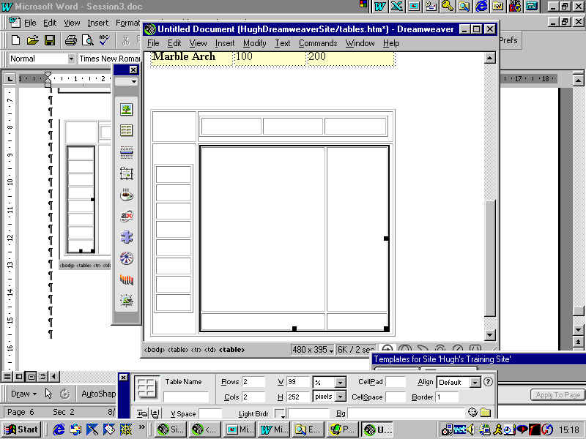

Step 5
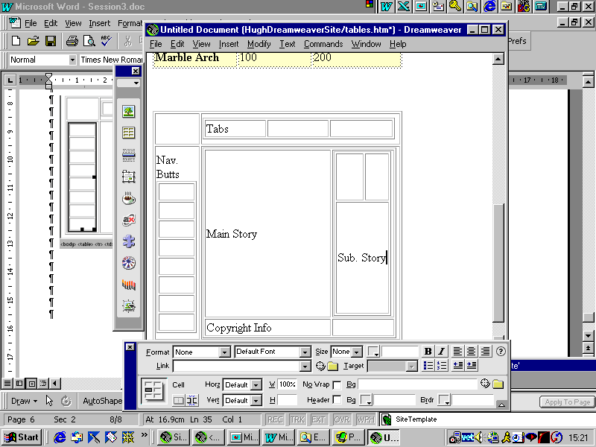

k) See how much work Dreamweaver has done for you by looking at the generated HTML

Summary
- We insert Tables from the Objects Palette or from Insert→Table

- We can decide some table properties early

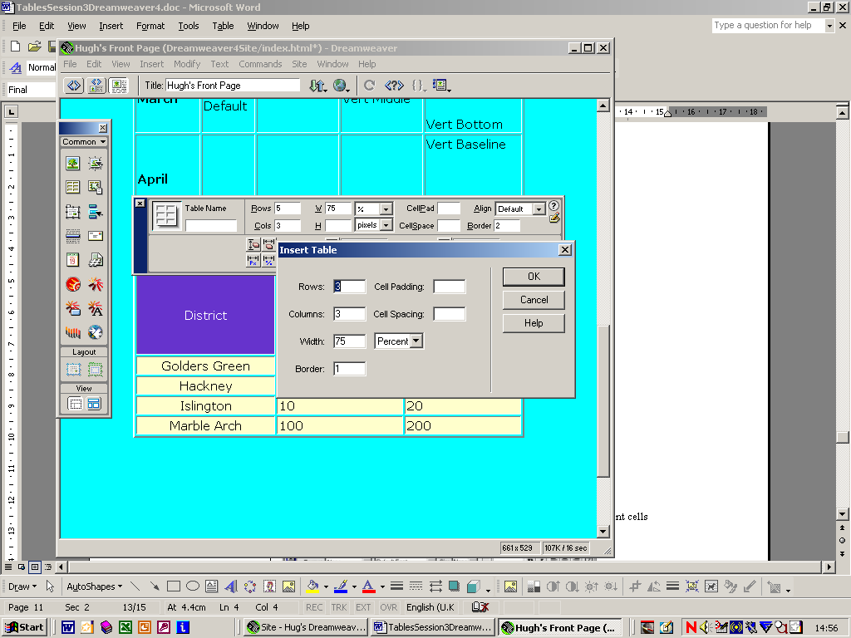

- We insert rows/columns either from the Table Properties dialogue box,
or from Modify→Table→Insert Rows or Columns
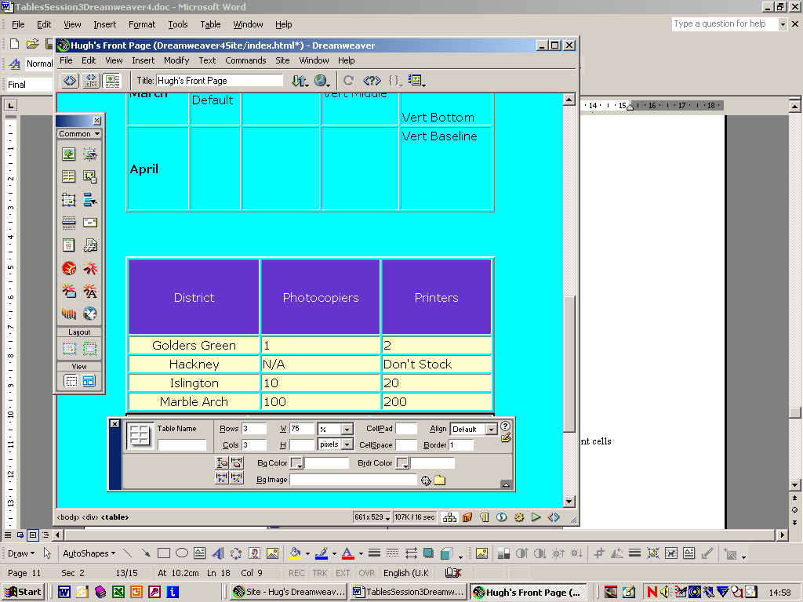

- We can modify table properties from the above dialogue box.
- We can point to a) a whole table b) a row c) a column d) adjacent cells (Shift) e) non-adjacent cells (control)
- Cells can be split and merged via a process very like in MS Word.

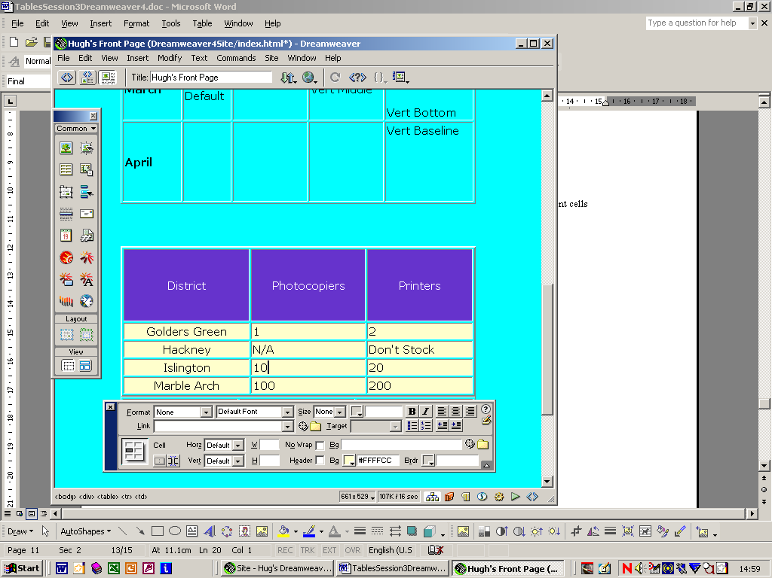

- Tables can have tables within them
- Tables can have images in them.
- Tables can have URLs in them
- We can use pre-built styles to format tables(Commands→Format Table)
- We can sort data in tables.
- All the complex HTML associated with tables is automatically produced by Dreamweaver

Ideas for experiments
- Experiment with the Table properties dialogue box

- Without using a table try inserting an image, and then centring it. Then try creating a 1x1 table with no border and putting the image in it, and then centre the table.

Self Test
1.
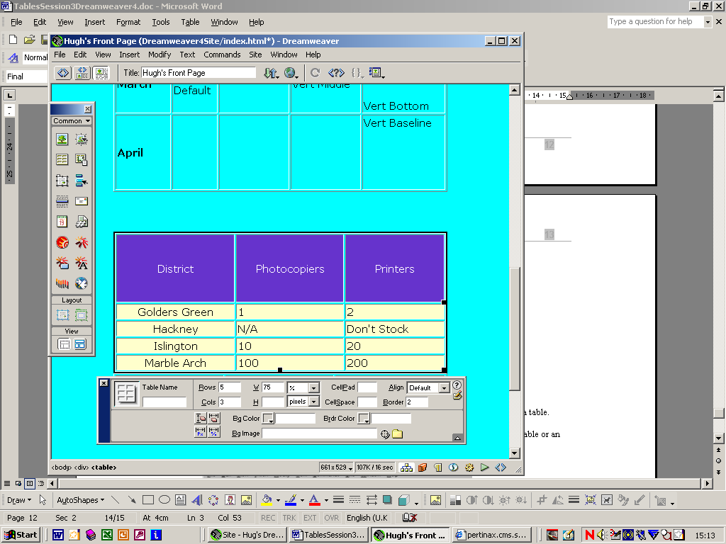

Make sure that you know what everything in here is for
For example "Why should a table have a name?"

2. As you can see, the following is the properties dialogue box when pointing to a single cell in a table.

Did you realise that the properties box changed, depending on whether you were pointing to a Table or an element of a Table (see question 1 above)?

