DREAMWEAVER4 2
Creating Folders & Files
Page Properties
Handling Text

by

Hugh Lafferty

Table of Contents

1. Creating Folders and files in Dreamweaver 1
1.1. Creating folders in Dreamweaver 1
1.2. Creating files in Dreamweaver 2
1.3. File/Folder naming conventions 2
2. Page Properties 3
3. Handling Text 5

Creating Folders

Contents of this session
- Creating folders and files
- Page properties
- Handling text
- Inspecting the produced HTML

Creating Folders and files in Dreamweaver
ACTIVITY 1. Create some folders in a Dreamweaver site

Creating folders in Dreamweaver

File→New Folder
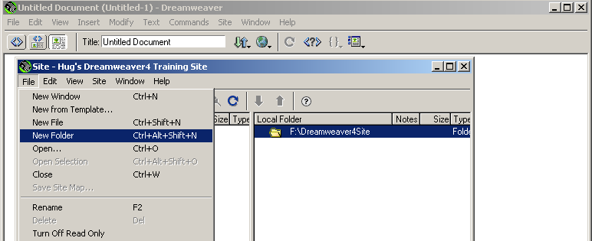

Then create a few folders and you should see something like the following

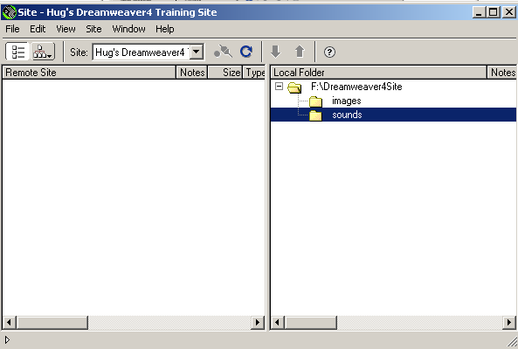

Don’t worry if you make any mistakes (e.g. putting folders at the wrong level). All you have to do is point to a folder and delete it.

Creating files in Dreamweaver

ACTIVITY 2. Create some files in a Dreamweaver site

Point to F:\Dreamweaver4Site, and then from

File→New File create index.htm

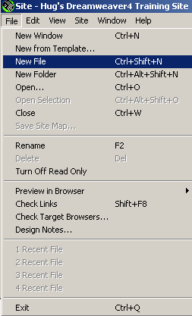
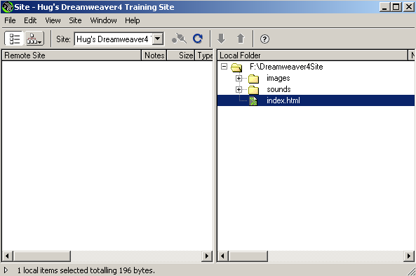

NOTICE that there is a little confusion here in that it looks like index.htm is inside Sounds BUT it is inside Dreamweaver4Site

File/Folder naming conventions

You are advised to obey the following naming conventions for file names

- Don't use spaces in file names
- Don't use underscore(_) because it gets lost in anchors (URLs)
- Use all lower case because some Web servers are case sensitive
- Avoid punctuation in file names
- Use meaningful names (Don't use names like File1, File2)

ESSENTIAL SHORTCUT F8 Site Map

ACTIVITY 3. Spend a few seconds toggling F8

Remember that we now know 2 shortcuts F4 to toggle floating palettes
F8 to toggle the site window

Page Properties

ACTIVITY 4. Double click on index.htm and we will start developing our first page

Right click in the background of the page and choose Page Properties

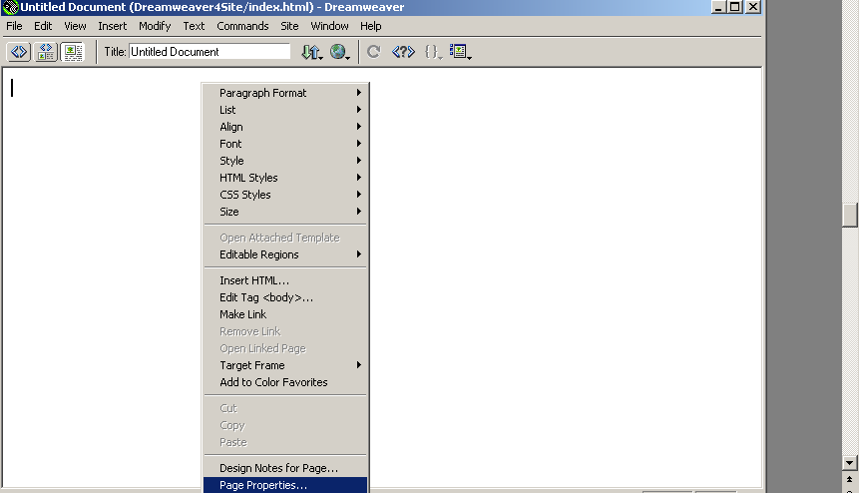

Type in a title and choose a background colour. Then press OK

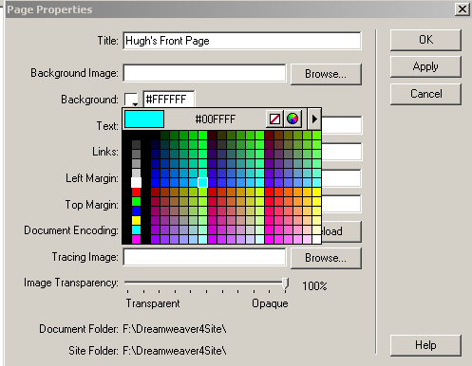

And this is what you should see

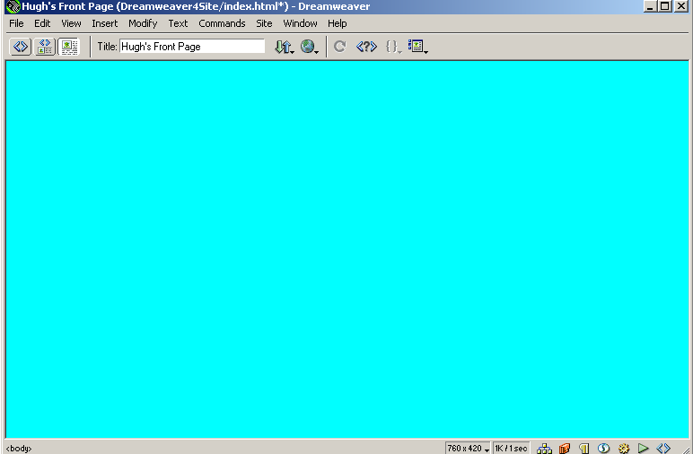

Handling Text

ACTIVITY 5. Type in some text

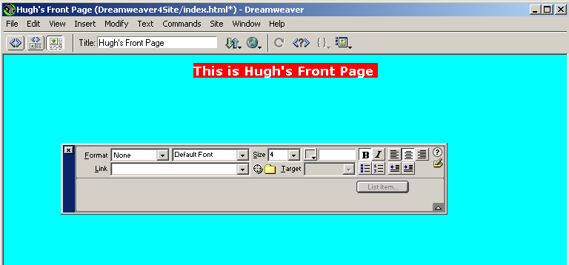

and experiment with the text editing properties window

NOTE. The size property is a bit odd. Dreamweaver uses sizes 1,2,3 etc or +1, +2 etc. But this corresponds directly with HTML.

ACTIVITY 6. Switch on the Show Code and Design Views tab

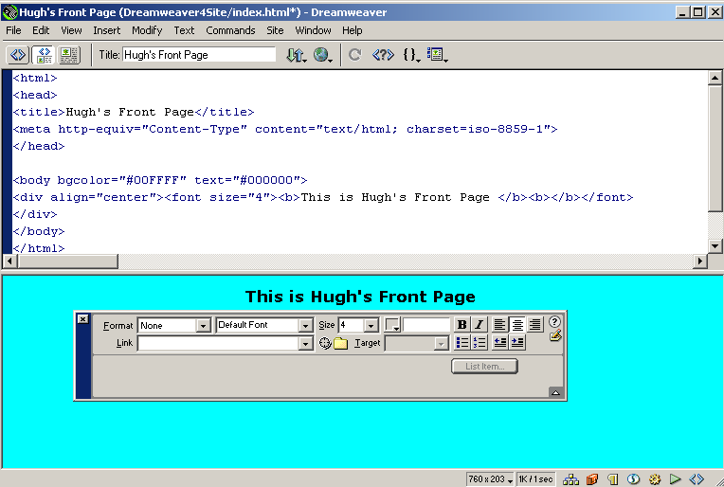
Examine this code carefully. You should understand all of it.

The <div> tag is useful as it acts like brackets round a whole set of lines, and itself can have many attributes

The <meta> tag describes the content of the page and is used by web crawlers e.g. google

You can now see both the HTML and the design at the same time. Here we see Dreamweaver's major strength of it being an HTML editor.

NOTE. If you press Enter then you get 2 line feeds. If you want 1 line feed press Shift+Enter

ACTIVITY 7. Experiment for about 5 minutes with a) Format b)Fonts c) Size d) Colour e) B f) I g) alignment of paragraphs

ACTIVITY 8. Experiment for about 5 minutes with the list properties and indentation tools, and then check the spelling via Text-->Check Spelling (Shift+F7). NOTE. This might not work depending on how it has been set up on your machine/network

ACTIVITY 9. To enter a link to another site a) type in some text b) highlight the text c) in Link type a
URL e.g. http://www.shef.ac.uk

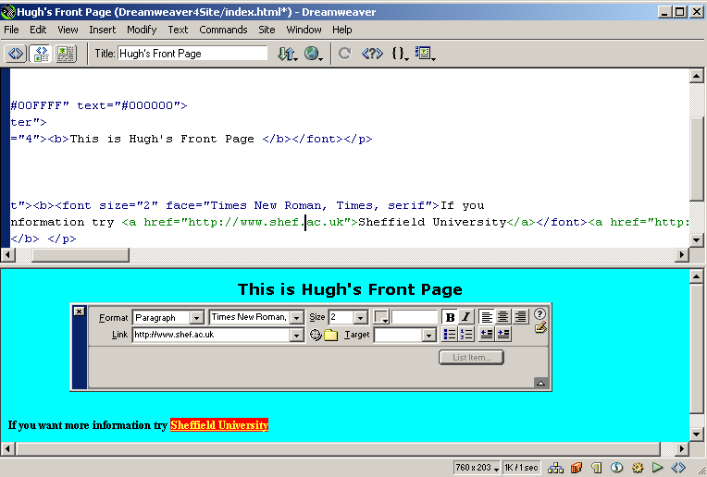

Press F12 to see it working

ESSENTIAL SHORTCUT F12 Preview in Browser

ACTIVITY 10. Insert a line break from the objects palette.

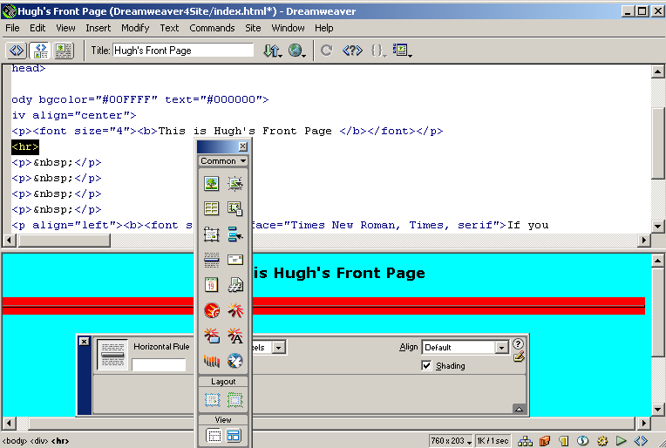

NOTE. You could also have done this via Insert→Horizontal Rule

