DREAMWEAVER 1
Setting up a local site

by

Hugh Lafferty

Table of Contents

1. Introduction to Dreamweaver 1
1.1. Text editing 1
1.2. Inserting objects 1
1.3. Creating and maintaining sites 1
1.4. To create a local site. 2
2. Exploring the menu structure 2
3. Toggling floating palettes 3
4. Planning your site 3
5. Setting up your site 3
6. Setting up your Browser preferences 4
7. Resources 5
7.1. Books. 5
7.2. Other resources 5
8. Downloading some media assets 5

DREAMWEAVER

Contents of this session
- Brief introduction to Dreamweaver
- How to set up a local site
- Pointers to some resources

Introduction to Dreamweaver

Dreamweaver, used in its most simple way, is just a tool to produce HTML easily. In August 1999 the professionals were saying that the tools that they use are a) Dreamweaver b) Javascript. In January 1999 they were saying that the only tools they used were a) Notepad b) Photoshop. It is the author’s opinion that the message that is coming across is that "Producing and maintaining the media assets" is the hard part of the Web. Tools like Dreamweaver make a) the production of Web pages and b) Web-site maintenance easier. Sites like alpedia are leading us to believe that site maintenance can be simplified by keeping all the assets in a database and then if anything changes then the whole site can be re-generated automatically.

The sorts of things that Dreamweaver makes easy are
- Text editing
- Inserting objects
- Creating and maintaining sites

Text editing

Dreamweaver has an in-built word processor, so, the user does not have to do something like

<B> make this bold </B>

but simply highlights the text and points to the B button and the above HTML is automatically produced.

Inserting objects

The production of Tables has been the bugbear of lots of HTML programmers, because it is so fiddly. Tables are made very easy in Dreamweaver.
Inserting gifs and animated gifs is done via drag-and-drop as is inserting sound , movie and Shockwave files.

Creating and maintaining sites

Let us assume the existence of a friendly ISP.

The development process is a) create a directory structure on the development machine b) create a directory structure on the ISP c) create the Web material on the development machine d) use Dreamweaver's in-built FTP agent to transfer material to the ISP. It really is as simple as that. To prove that we are going to do some of that now. We will work locally to begin with.

To create a local site.

Start Dreamweaver and this is what you should see. (If you cannot see some of these windows then open them from the Window drop-down menu)

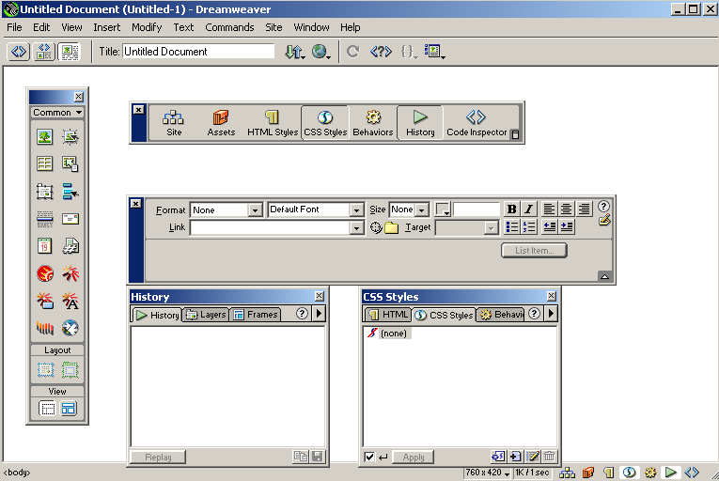
History window
Styles window
Properties window
Launcher. Switch it off
Objects Palette

The objects palette is where you an insert things like Tables and Shockwave movies. (If you cannot see it then find it from Window→ Objects)

This is the launcher. (If you cannot see it GOOD because it is useless. It is useless because the same facilities are here). If you really must see it then find it from Window→Launcher). TIP. Always switch the launcher off.

This is the document window where you will spend most of your time.

The properties window changes depending on what you are currently looking at. If you cannot see it then find it from Window→Properties). You usually see more properties by pressing the down arrow.

We will look at the styles and history windows later. If you cannot see them then find them from Window→HTML Styles or Window→History

Exploring the menu structure

ACTIVITY 1. Please spend 10 minutes exploring all the menu structures and from that you will be able to forecast the topics of the course.

ESSENTIAL SHORT-CUT 1 to remember F4 hide/show floating palettes (later on we will show 2 more shortcuts)

Toggling floating palettes
ACTIVITY 2. Please spend a few seconds toggling F4 to see what it does

Planning your site

ACTIVITY 3. Please draw a sketch of the rudimentary structure of your site.

Setting up your site

ACTIVITY 4.

a) Create a folder for your new site e.g. F:\Dreamweaver4Site

b) Now go Dreamweaver

Site→New Site

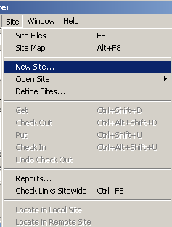

and this is what you should see

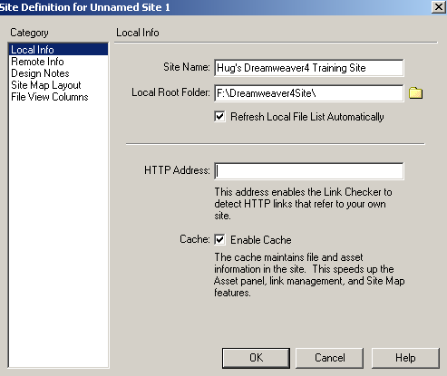
Type in any name for the Site Name
Choose the folder you created earlier

Leave the HTTP Address blank for the moment

Tick Cache
Then Press OK

and this is what you should see

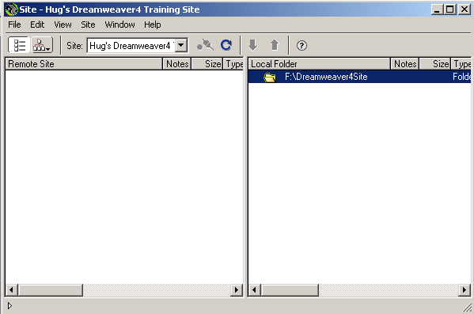

We now see the Site Map window. In here we can create folders and files (just as in Windows/NT Explorer). We can also come back later and create a directory structure for our remote site on the ISP.

Setting up your Browser preferences
ACTIVITY 5.
File→Preview in Browser→Edit Browser List

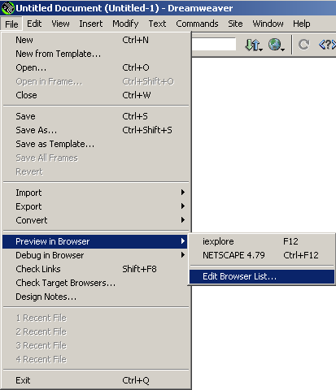

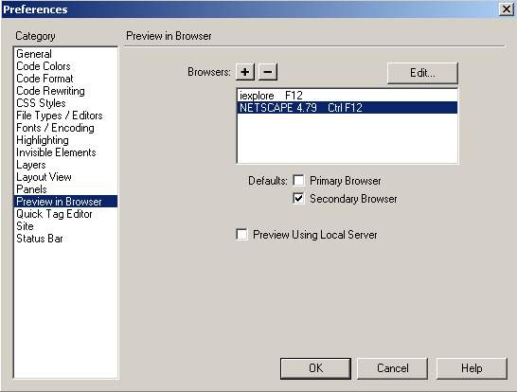

Set Internet Explorer as the Primary Browser and Netscape as the Secondary Browser.

Resources

Books.
1. “Dreamweaver 3 Bible” by Joseph W. Lowery. Published by IDG Books 2000. Price £27 (June 2000). ISBN0-780764-3458-0.
Critique. This is all you need. Order it from amazon.co.uk and you will get it the next day.

Other resources
- The LTI centre (Mark Pettigrew)
- CMS Web Manager (Martin Cooper)
- Help inside Dreamweaver
- The Web
- Sites for info. about Dreamweaver
www.macromedia.com/support/dreamweaver/contents.html
- Sites for media assets
www.iconbazaar.com
www.clipartguide.com
http://www.geocities.com/SoHo/1085/
http://www.geocities.com/SoHo/3505/
http://www.htmlgoodies.com/

Downloading some media assets

ACTIVITY 6. Download some logos into your site from www.clipartguide.com

