Active Server Pages Tutorial

By Carl Davies

Learning Outcome

By the time you have completed this tutorial, you should:

- Have learned how clients and servers communicate over the Internet.
- Be aware of the role of HTML, ASP and client/ server side script. You should also be able to write basic code in these languages.
- Have an understanding of how ASP, HTML and databases interact to produce an e-commerce site.
- Be able to use an FTP tool to upload files to a remote Web server

Recommended Reading

Deitel, H.M., Deitel, P.J., Neito, T.R., (2001) e-Business and e-Commerce How to Program, Prentice Hall

Kauffman, J. ,Spencer, K.C., Willis, T., Buser, D. (1999) Beginning ASP Databases, Wrox Press Inc.
Smith, E.A. (2001) Active Server Pages 3 Weekend Crashcourse, IDG Books Worldwide, Inc

A. Introduction to Client/ Server technology on the web

Typically, when you are browsing the Internet, you will be using Web Browser software such as Internet Explorer or Netscape navigator. The computer which is running a browser is called a client, whilst the machine which is providing Web pages is called a server.

When you dial up to an Internet Service Provider (ISP) e.g. Blue Yonder, Aol, your computer is forming a network connection to a Web server. In this situation, your computer is in effect a client, which is linked to an ISP Web server. The web server, as the name suggests, serves your browser with Web pages (e.g. HTML, ASP, JSP pages etc).

The diagram below demonstrates how Web pages are accessed via a browser.


Web Server
Client
The Internet
Page Request
Page Request
Web Page
Web page
Enter Web Address
Web page

B. Introduction to HTML, Scripting Languages ASP technology

HTML

The World Wide Web was first developed as a way of posting information that could be shared between various groups. No matter how geographically dispersed, it was possible for a group of people to share information using the World Wide Web.

A language called HTML was developed specifically to format and present information on the Web. HTML stands for Hyper Text Mark Up Language. HTML can display both text and images, which is one of the reasons it became so popular. An additional feature of HTML is its ability to link documents together via a technique called hyper-linking.

HTML works by telling your browser what to display e.g. buttons, text and images. It also tells your browser how to display this data- in terms of screen positioning, colour, size etc.

10 Minute Crash Course in HTML

Building a Web page using HTML is a fairly straightforward task. HTML will generally forgive you for your coding errors (which can be a good and bad thing). This means that you can get some passable results in a short amount of time.

So, as we have mentioned, HTML works by telling your browser (e.g. Internet Explorer) what to display and how to display it. This is done by producing a sequence of commands which your browser interprets from top to bottom. These commands are stored as a file which usually has a .html or .htm extension. In the case of the tutorial, we will be using a .asp extension. Your browser can then read this file, and display it as a Web page.

Writing and saving HTML files

There is nothing particularly complicated about a HTML document – it just consists of simple text. This means that you can use primitive tools such as notepad or word pad to build your Web pages. Of course, there are numerous software tools which will generate HTML code for you e.g. Dreamweaver, Frontpage, Visual Interdev.

So, in theory, all you need to do is open up notepad, type in your HTML code then save your work with a .html extension.

HTML Tags

All HTML commands that you write are enclosed in angle-brackets e.g. the code below will display the text ‘Hello Chaps!’ in bold on your browser.

<B> Hello Chaps! </B>

Anything which you place in these angle brackets is called a tag. In most cases, every tag you use must have a matching closing tag.

Any text which is within the above tag will get the ‘bold’ treatment. Quite simply your browser switches to bold text when it processes the <B> tag. It then switches bold off when it gets to the </B> tag. <B> is called an opening tag, whilst predictably, </B> is called a closing tag.

Note that HTML tags are not case sensitive, therefore the tags above could have been in upper or lower case, or a mixture of both. It is really up to you. Of course the text you want to display on the browser will be displayed in upper and lower case, exactly as you told it to.

So what is happening to the text below? – Well, ‘Hello Ladies’ will be displayed both underlined and bold. The bold tag (<B>) is closed after ‘Hello Ladies!’. However, any other text after this will continue to be underlined since we have not closed the underline tag (<U>).

<B> <U> Hello Ladies! </B> Am I still underlined? – Of course I am. </U>

If you come across the following kind tag, you are reading the programmers comments on his/her code:

<!-- Don’t be too harsh – this is my first HTML page -->

There are many more tags to learn, which will allow you to add buttons, lines, colour, pictures, sound etc to your web page. You may want to do some more research on these in your own time. Here are enough tags to get you through this tutorial:

<TITLE> My ASP Page </TITLE>

Gives your window in the browser a title

<CENTER> Caught In the middle <CENTER>

Will centrally align any content within these tags

<H2> I am text of a certain size </H2>

Formats your text in the pre-fixed H2 font size

<TABLE border= “1”>
<TR>
<TD> Cell 1, row 1 in a table </TD>
<TD> Cell 2, row 1 in a table </TD>
</TR>
<TR>
<TD> Cell 1, row 2 in a table </TD>
<TD> Cell 2, row 2 in a table </TD>
</TR>
</TABLE>

This is a table. <TR> indicates a new row on a table and <TD> places a cell within this row. As usual, we can freely place text within each cell. Note how these tags have been carefully ‘nested’. This is not essential, but is an excellent practice to ensure your HTML code is easy to read.

<FONT COLOR = “blue” size = “2”> I’m sure feeling blue today </FONT>

This tag indicates that the text colour should be blue. As you can see, this tag, like many others has properties or values which can be altered. This can be done by declaring the property and value in quotation marks-all within the opening tag.

<TABLE border = “2”>
<TR>
<TD width = “20%”> Cell 1, row 1 in a table </TD>
<TD width = “7%” bgcolor = #008080> Cell 2, row 1 in a table </TD>
</TR>
<TR>
<TD> Cell 1, row 2 in a table </TD>
<TD> Cell 2, row 2 in a table </TD>
</TR>
</TABLE>

The table above has been given a specific border width. The cells within the table have defined widths (as a % proportion of screen width), along with a background colour in hexadecimal.

<LI>Item 1</LI>
<LI>Item 2</LI>

This produces a bulleted list.

<IMG SRC =”coolPic.gif” ALT = “Your mouse pointer is hovering over my cool pic!”>

The <IMG> tag will display the graphic you have specified. Its ALT property lets you display a ‘tool tip’ if the cursor is hovered over the picture.

<A HREF = “movePage.asp”> Click here to teleport to the another ASP page </A>

Use the <A HREF> tag, you can turn text or an image within this tag into a hyperlink.

<FORM ACTION = “processForm.asp” METHOD = “POST”>
Please enter secret code <INPUT NAME=”code”>
<INPUT TYPE = “submit” VALUE= ”Click to Win £10”>
</FORM>

This rather more complicated bit of code produces a HTML form using the <FORM> tag. Two types of <INPUT> tag are used. The unspecified input tag <INPUT NAME=”code”> is a simple text box, which we have called “code”. We have also used an input tag which produces a submit button <INPUT TYPE=”submit”…>. By assigning text to the VALUE property for this tag, we can decide the text that appears on the button surface.

The ACTION property of this form indicates the Web page that will be loaded when the submit button is clicked. The values entered in the textbox will then be passed on to this new page. We will se more of this in the Introduction to ASP Section, later.

HTML Document structure

One of the few conventions that you need to follow in HTML is to make sure your document follows a pre-defined structure. Here is how you do it:

<HTML>
<HEAD>
</HEAD>
<BODY>
</BODY>
</HTML>

The <HTML> tag indicates to the browser that any subsequent code should be interpreted as HTML. At the end of the document, you need to tell your browser that you are no longer dealing with HTML by closing the tag with a </HTML> tag.

The <HEAD> tag is a header section which is used to give the browser information about your document. This might be data for submission to search engines, or references to other files on your web sites.

All the ‘meat’ of your Web page will sit within the <BODY> tag e.g. tables, forms, images, text etc

The Limitations of HTML

We have reviewed a series useful HTML tags. Unfortunately, HTML in its own right is severely limited:
  - HTML cannot perform calculations, or process information
  - HTML cannot respond to user instructions (except for hyper-linking)
  - HTML does not know anything about the user (it is blind in this respect)
  - HTML cannot store information or files
  - HTML cannot talk to a database
  - HTML cannot make intelligent decisions based on user instructions
Etc…

You might be getting the gist by now. In summary, HTML is not a programming language and perhaps was never meant to be. As we have mentioned, it is a mark-up language and is known as static.

Scripting Languages

Imagine what happened when the popularity of the World Wide Web began to grow- of course, users demanded a bit more than just pictures and text. Since the WWW was so good for connecting people together, why not use it as a place to sell products? Or do your banking? Search for plane departure times? Watch movies? Do videoconferencing? Etc.

The potential of the WWW was recognised, but unfortunately HTML is a mark up language – it can’t do any thinking for itself. To make it a truly exciting place to be, the WWW needed to be intelligent and possess the ability to interact with the user. This is where a set of programming tools called Web Page scripting languages came into existence. In fact, e-commerce would be impossible without Web scripting languages.

A scripting language is a programming language which can be embedded within a Web page. Code written in this way is commonly referred to as client or server scrip t (More about this later). Script will happily live inside a standard HTML page, and does not require any special programming environment. You do not have to use a special kind of Web page to include script.

Scripting languages usually look very much like any other programming languages – for instance, VBScript is a ‘watered down’ version of Visual Basic – which is a fully-blown development language.

Here are some other examples of Web Scripting Languages:

- PERL
- Java script
- VBScript
- PHP
- J Script

To indicate a section of script in a Web page, simply use a <SCRIPT language = ‘vbscript’> tag. The language property simply indicates which flavour of scripting language you will be using. When you have finished your script code, don’t forget to use a </SCRIPT> tag.

Popular Web browsers such as Internet Explorer 5 have the ability to read, interpret and act on the commands written in script. For example, whenever you see a message box whilst visiting a web page (e.g. “Welcome to My Cheap Beer.com”), it will have been generated by script.

The example below requests your browser to respond to the click of an input button called btnBuy, located on your web page. This is achieved by alerting the user with a message box that says ‘thank you for purchasing from swindle.com’ . It is written in VBScript.

<SCRIPT language = vbscript
sub btnBuy_onclick
msgbox (“thank you for purchasing from swindle.com”)
end sub
</SCRIPT>

In contrast to HTML, script is quite picky about your coding accuracy. Unlike HTML, if you use an incorrect syntax, or make a coding error, your script code will simply stop working. This will often happen without any warning – except a script error icon on the status bar of your browser. Depending on how your browser is configured, and the design of your Web page, you may not get any indication whatsoever of an error in your script. This can be highly frustrating from the user’s perspective. The solution? Be careful and meticulous when using script, and test your code thoroughly before letting your users loose on it.

Client and Server Side Script

You should be aware that there are two kinds of script on the Web: Client-Side and Server-Side. As the names suggest, Client side script performs actions on the client. Likewise Server-Side script performs tasks on the server.

Each of these two kinds of script will service particular roles. In fact, to undertake demanding tasks such as e-commerce, Web developers will need to use both client and server script. Below are some examples of the roles both client and server side script play.

Examples of Client Script Functions | Examples of Server Script Functions
Checking user information entered | Reading/ writing records to/from a database
Performing simple calculations | Returning error messages
Checking browser used | Logging site statistics
Changing screen features according to user input | Putting cookies onto client machine
Re-direct user to a different page | Returning dynamically generated web pages

Implementing Multiple Scripting Languages

This is where life becomes a little more complicated. To get a sophisticated e-commerce site up and running, a web developer will need to program script for both the server and client. Moreover, he/she may use a different script language for each. Getting specific data from a database will probably require skills in SQL, in addition to HTML or even XML. To cater for WAP (Wireless Access Protocol) users, coding skills in WML will also be required. Did you count them – that’s 6 scripting/ mark up languages of some variety. Who was it that said programming for the web was simple?

The diagram below gives you an example of the range of client and server side scripting languages that are currently in use.

Client Scripting Languages | Server Scripting Languages
Jscript | PERL
Javascript | ASP (Is normally written in VBScript
VBScript | Coldfusion
 | JSP
 | PHP
 | CGI (this is old hat these days)

C. An introduction to ASP

ASP stands for Active Server Pages. It is one of many languages that can script, or program code on the server rather than the client. HTML on its own cannot be used to do interesting things on the server. It would be impossible to create a functioning shopping cart using HTML alone. As we have discussed, HTML simply tells your browser how to format and display content. In fact, the server completely ignores HTML and simply passes it straight on to the client.

Conversely, the client Web browser cannot see ASP code- this code is only available to the server, and for a good reason too. Often, ASP may contain sensitive information about confidential database content etc. Obviously, you do not want to let your users know the structure of your database, or how you process transactions behind the scene.

By scripting the server using ASP, you can dynamic create Web content- that is generate Web pages ‘on the fly’.

Like HTML, ASP can be programmed using simple tools such as notepad. However, to view ASP pages, you will need access to a Web server. This means a PC that is running Internet Information Services or Personal Web Server.

ASP is a technology developed by Microsoft, and it has gone through numerous revisions. The current and final version is 4. Microsoft has now released ASP.net which will ultimately supersede ASP. ASP.net has a huge number of revisions over ASP, but is rather more complicated. Amongst other things, ASP.net no longer uses traditional script, and is completely object-oriented.

We are using ASP for the purposes of teaching this module because I believe it is a useful tool for introducing you to basic server-side script. If you are serious about server side Web development, you will no doubt be using ASP.net some time in the near future.

ASP is an extremely popular Web technology and is relatively easy to use. ASP is a huge step forward from cumbersome existing technologies such as Common Gateway Interface.

Don’t be fooled into thinking ASP is the only server scripting technology worth looking at. There are some highly successful, widely used alternatives in existence such as PHP and JSP. You would be well advised to do some research on these alternative approaches in your own time.

ASP is not really a programming language – it is a type of technology for talking to a Web server. To use ASP, you need to use a scripting language such as VBScript. VBScript is the most common language to partner with ASP, although you can quite happily use C, javascript or even, heaven forbid, COBOL.

VBScript is a programming language, and is a stripped down version of Visual Basic (A fully-blown development language). Therefore, VBScript has most of the features which are built into Visual Basic. So, you can use the following conventions:

Dim x
X = 1000

For…
next

If..
then…
else if…
end if

Select case
case...
end select

Sub test1(x,y,z)
end sub

call test1

etc.

If you have used Visual Basic, you will find VBScript a walk in the park.

So, what can ASP do that HTML can’t? ASP can:

- Interact with databases to read and write data
- Read and write ‘cookies’ to a users computer
- Read data that has submitted in a form
- Track user activity within a Web site
- Check user input (validation)
- Make intelligent decisions based on user interaction
- Talk to other applications e.g. Word on the server
- Talk to custom built applications on server
- Upload files from the client
- Send bulk email or automated email responses
- Return dynamic HTML code back to the client
- Read data from the end of a URL (called a querystring)

Remember, PHP, JSP, Perl etc can also do these things.

Although it does have its niggles (some programmers argue that there are more than a few!), ASP can be used to create powerful Web applications (Web sites that have complex functionality). Large organisations like Halifax are migrating many of their back-office systems across to ASP Web Applications. You can do some serious projects using ASP. The following are just some of the kinds of functionality that can be achieved using ASP and other server scripting languages:

- Search engines
- Online banking
- E-commerce
- Web mail
- Financial calculators
- Online mortgage, credit, loan applications etc

How to write Web pages using ASP

It may come as a surprise that if you are familiar with programming, it is extremely simply to achieve basic results in ASP. Take a look at the example below:

<HTML>
<HEAD>
</HEAD>

<BODY>

<% dim x
x = “Good morning, and welcome to glorious ASP”
response.write(x)
%>

</BODY>
</HTML>

All code enclosed within the <% and %> tags is ASP- written in VBScript. Note that you do not have to use a ‘<SCRIPT>’ tag. Using the response.write command allows you to send data back to the client. In this case we are sending text containing a greeting back to the client browser. This is what the ASP page would look like in Internet Explorer.

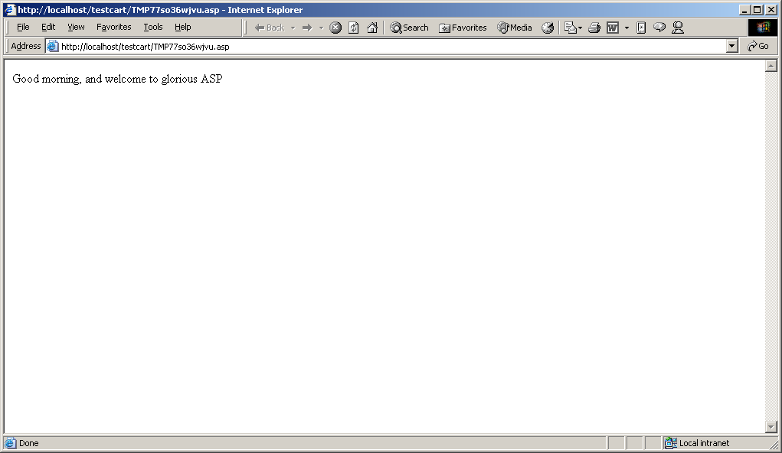

If you were to view the source code behind this page (view>>>Source code), you would see:

<HTML>
<HEAD>
</HEAD>

<BODY>

Good morning, and welcome to glorious ASP

</BODY>
</HTML>

As you might have noticed, there is no sign of the ASP code that we have earlier entered – this was interpreted by the server, which responded to our request to send some text back to the client, doing just that.

Also, note that the HTML tags which we entered are still in place. In fact you could in theory have an ASP page which does not have any ASP code within it. Of course, that would be a bit pointless. The point I am making is that the server always ignores HTML tags in an ASP page, and passes them straight to the client.

The main concept to remember is that an ASP page looks very similar to a HTML page. This means that you can use HTML to display static information e.g. page title, but use ASP to insert dynamic data e.g. a list of names read form a database.

This is exactly how the Shopping Cart example works. For much of the page content, HTML tags are used. Where the Web site needs to generate a list from information held in a database, ASP code is used to extract this information. In many instances, ASP code is used ‘inline’ – that is, tucked in between HTML code as below:

<HTML>
<HEAD>
</HEAD>

<BODY>

<% dim p1,p2
p1 = “Jonny Rotten”
p2 = “Sid Snot”
%>

<TABLE>
<TR>
<TD>Punk Number 1:</TD>
<TD><%=p1%></TD>
</TR>
<TR>
<TD>Punk Number 2:</TD>
<TD><%=p2%></TD>
</TR>
<TABLE>

</BODY>
</HTML>

D. Getting acquainted with Microsoft Access databases

A database is a way of digitally storing and organising digital information. Any e-commerce enabled Web site must be able to read and write data to and from a database. There are alternatives, such as using email to order products, or placing cookies on the client machine. However, any e-commerce Web site which does not have a database back end will be extremely restricted in what it can achieve. For instance, how will a customer know if an item is in stock if the company does not have a record of stock levels on a database? It really is a non-starter – databases are a must in e-commerce.

The ASP Web Application we will be looking at in detail (The Shopping Cart) utilises a Microsoft Access database to store information about the products it sells. This database, which is called catalog.mdb is composed of four ‘tables’: products, authorlist, authors and technologies. Each of these tables holds information relating to specific business areas. For instance, the author table provides the names of authors and allocates each author a unique ID.

The information on these tables has been entered manually via Access. For the purposes of today’s tutorial, we will simply be reading data from this database using ASP. Of course, it is possible to both read and write

As the diagram below illustrates, these tables are linked together (central picture in diagram, called as relational diagram). We are using a Relational Database method in this instance. Relational Databases, if designed well, can enhance the efficiency and flexibility of your database.

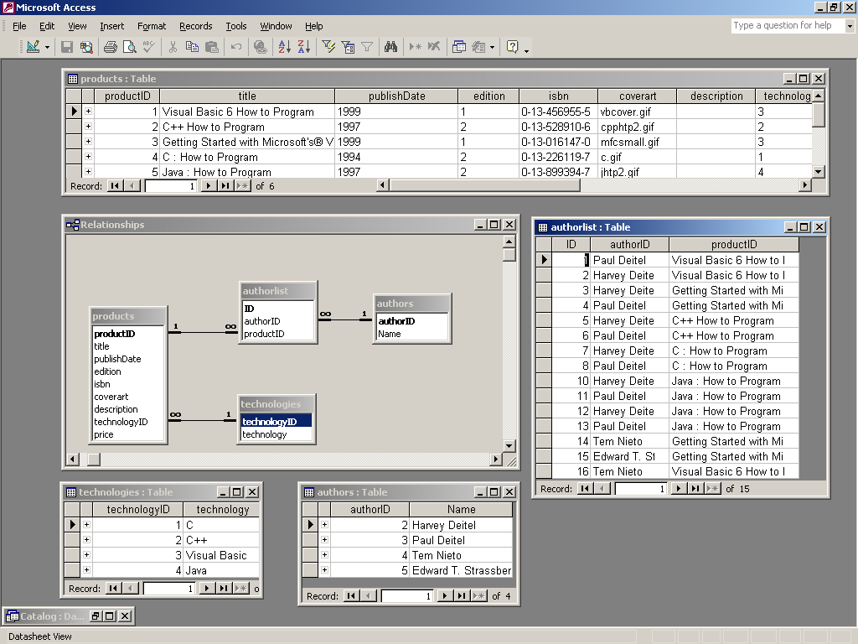

Note the information contained in each table, and how this information is grouped together. Each table also has a primary key – which is marked in bold on the relational diagram. A primary key is a way of uniquely identifying a record and is a vital component of any table in a relational database.

Talking to the catalog.mdb database using ASP

As we have discussed, reading data from a database is an essential activity for any e-commerce project. During the scheduled practical activities, we will be using a series of commands in ASP to ‘talk’ to the catalog.mdb database.

Since this module is intended as an overview, it is not appropriate to explain in great detail how we can connect to a database using ASP. Suffice to say that one can read and write records to and from a database with relative ease using either the ODBC or OLEDB database access protocol. Today we will be using ODBC (Open Database Connectivity) in conjunction with a DSN (Data source name). Feel free to research these areas in your own time.

You should also be aware that a different language called SQL (Structured Querying Language) is commonly used to specify which sections of data you want to deal with and from which table(s). There are other alternatives such as XML, which you may want to read about in your own time.

The ASP code below is all you need to read or ‘query’ a database using ASP. In this case, we are using a SQL command to ‘grab’ data from all the data columns in the products table. This is achieved by opening the catalog database, creating a connection to this database then requesting the data that should be read, using a SQL statement. You would follow a similar sequence of commands for writing to a database.

<%
Dim connection, query, data
Set connection = Server.CreateObject( "ADODB.Connection" )
Call connection.Open( "catalog" )
query = "SELECT * FROM products WHERE productID="&Request( "productid" )
Set data = Server.CreateObject( "ADODB.Recordset" )
Call data.Open( query, connection )
%>

Summary

In summary, this preparation material should have given you a rudimentary understanding of:

- Client/ server technology on the Web
- HTML
- Client/ Server Script
- Database features
- Database access over the Web

We will revisit all these areas in more detail, with plenty of practical exercises, during the scheduled residential week.

Pre-Session Research

During the residential session, I will be introducing you to some ‘cutting edge’ web technologies.

If you have a spare half hour or so, I would like you to do some research on the internet to prepare you. See if you can gather some information on the following areas. I will ask you all one or two questions on these areas during the session. This is your chance to astound your colleagues, family and pets with your knowledge of hi-tech gizmos.

- What is Pocket PC 2002? – what are the pros and cons of this format?
- What is Pocket Internet Explorer? – how does it differ to Internet Explorer 5/6
- Is Pocket Internet Explorer compatible with ASP?
- Is Pocket Internet Explorer compatible with VBScript?
- What are the benefits/ pitfalls of mobile e-commerce?
- What is Bluetooth? How useful is this technology?

