CM304 BIS: Theory and Applications

Sourcing

An important function of procurement is the identification of suitable sources of supply. The systematic investigation and comparison of sources, the evaluation and monitoring of performance of supply sources and the development of appropriate procedures with suppliers are therefore of importance.

The model below outlines a procedure that is often used to select suppliers. It suggests that the buyer, on receipt of a request to purchase, first checks whether the organisation is currently committed to the particular supplier for the supply of such items and, if not, whether an existing source might satisfy the requirement.

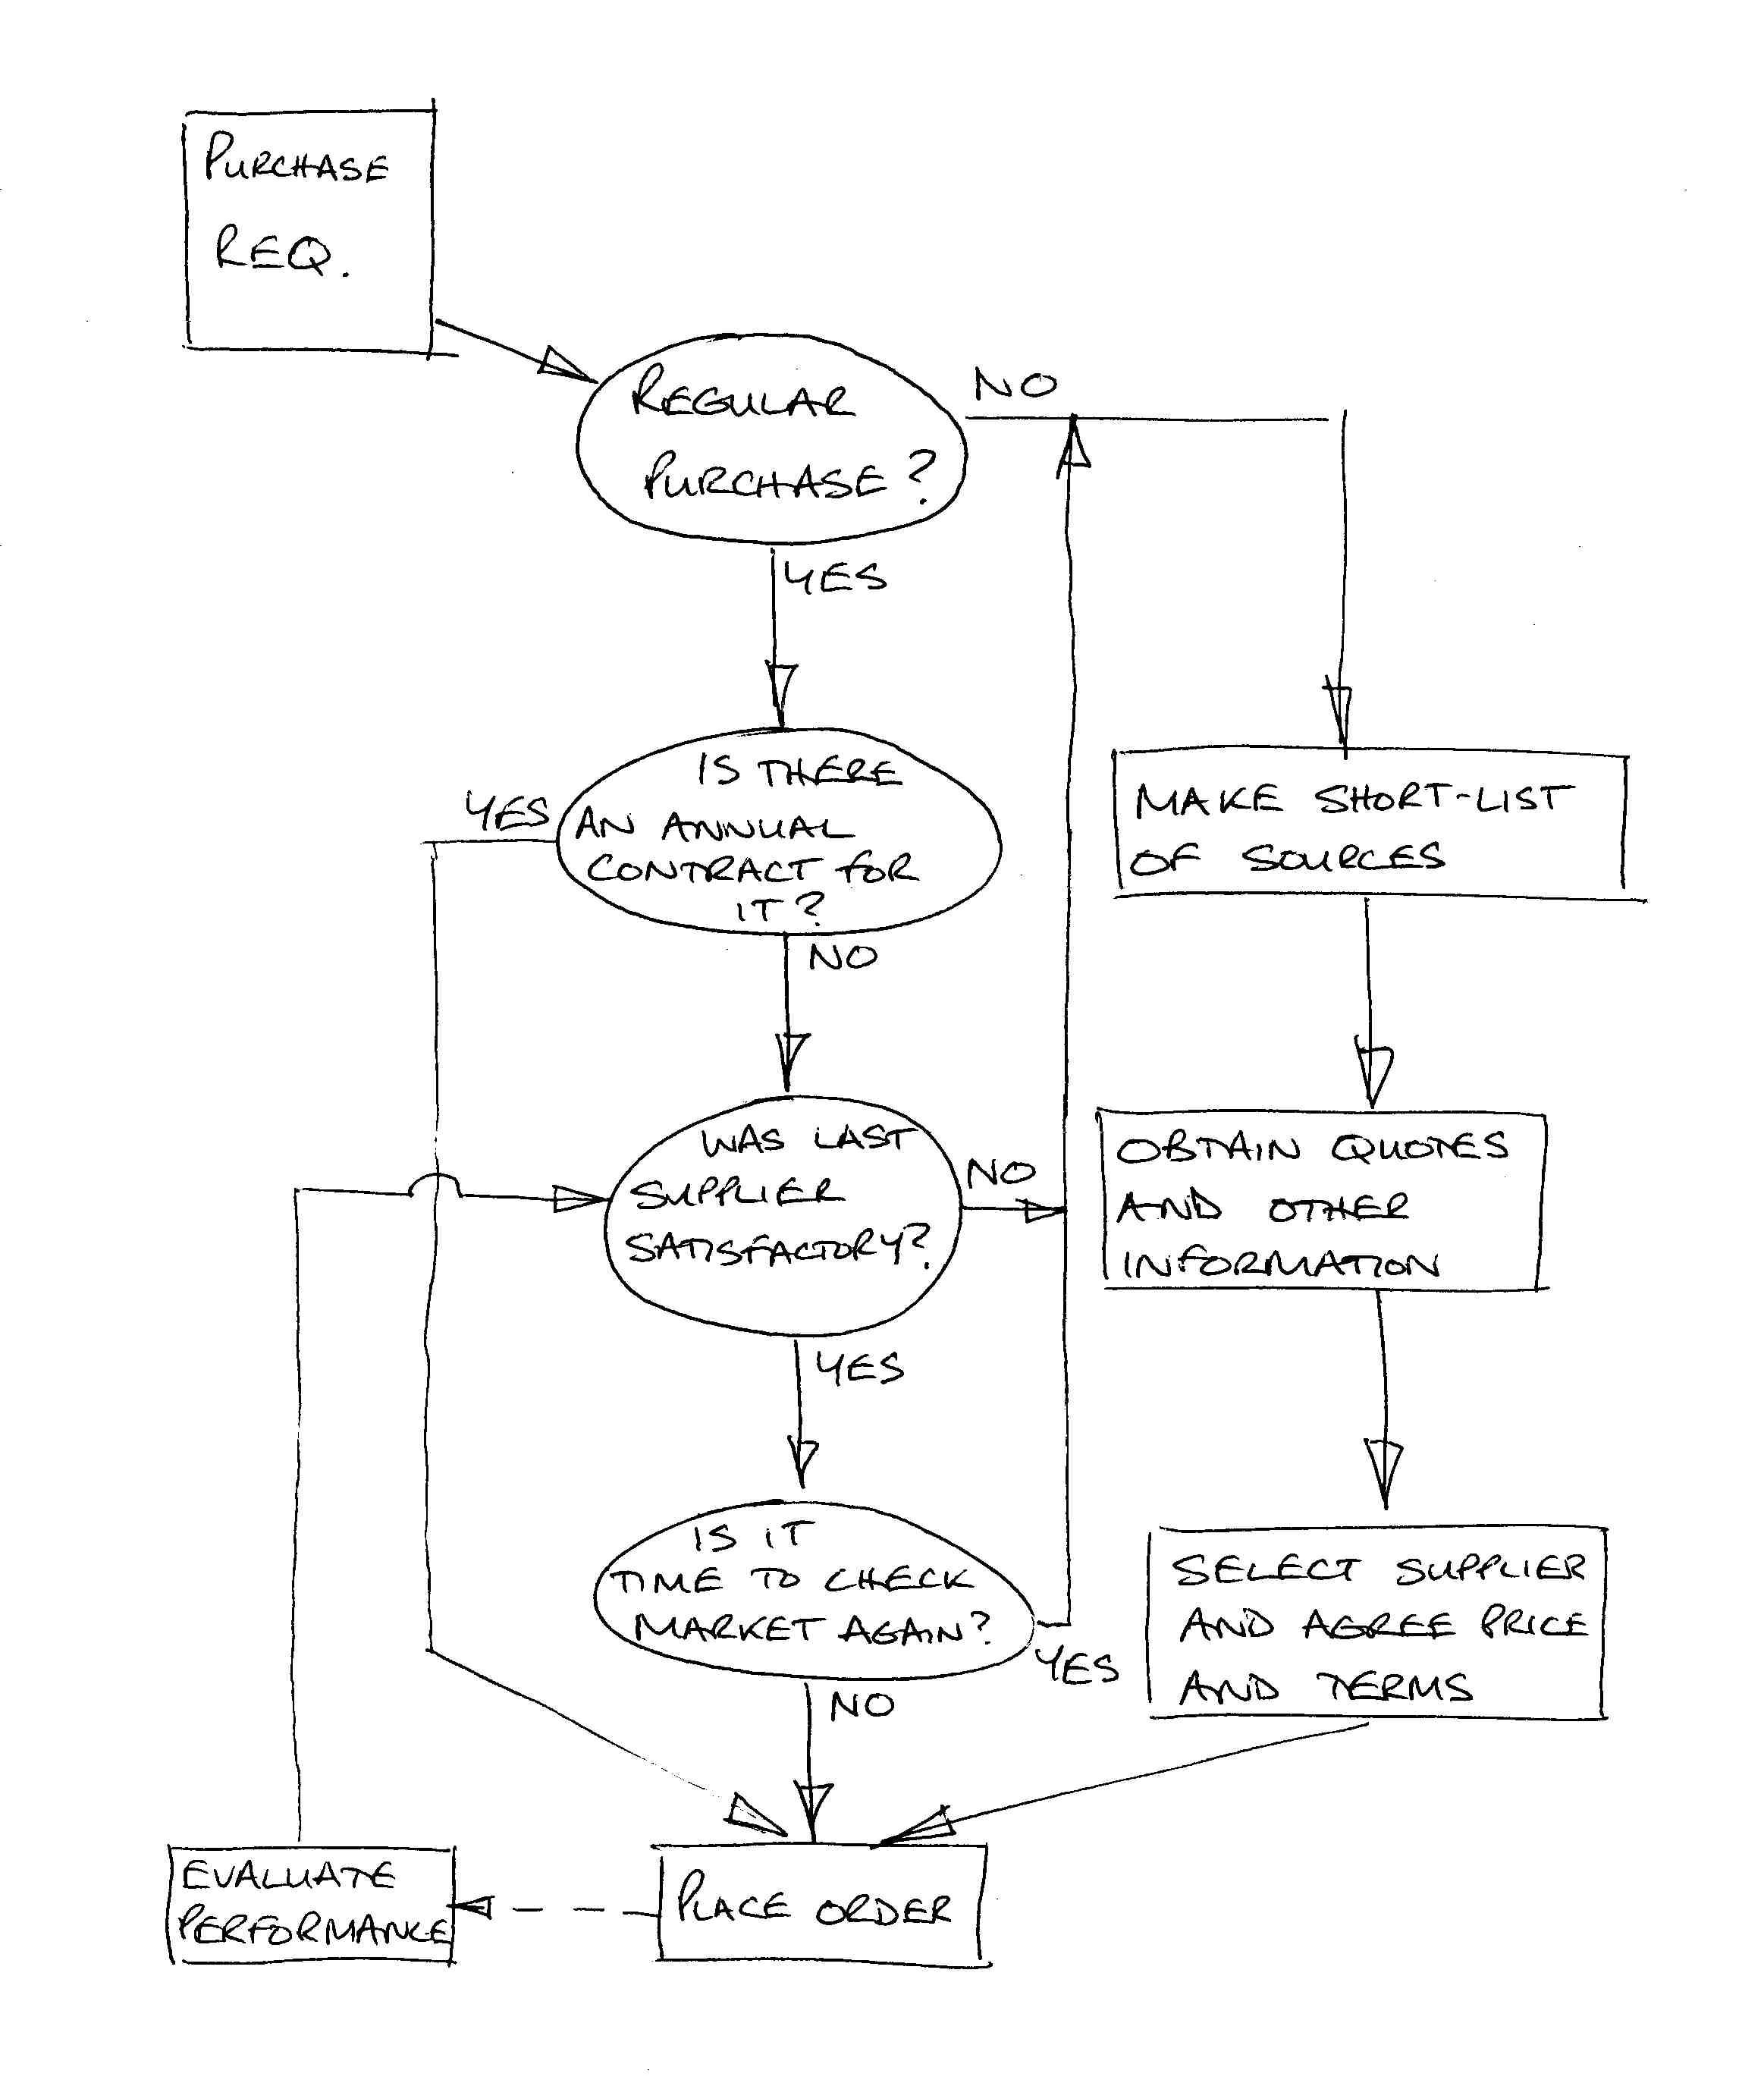

Repeat ordering with an existing source would be normal, unless for some reasons necessitating a review of such an arrangement. Such reasons might include recent price increases, recent extensions in supplier supply lead time, failing to meet specifications, decline in vendor rate performance, etc.

Buyer source loyalty is a well-documented phenomenon, and clearly offers benefits in terms of reduced administrative difficulty, improved vendor/buyer understanding, and relationship. In fact, benefits accrue to both supplier and to vendor. Vendors also tend to give preference to existing customers.

Often an investigation of possible sources for the supply of new items and materials will reveal several alternatives, hence the question of single or multiple sourcing often arises. Factors to be considered in this respect are:

- Effect on price – single sourcing of increased quantities may reduce purchase price. Alternatively, in certain circumstances, multiple sourcing may in fact reduce price as a result of supplier competition for orders.
- Effect on supply security – while organisation of supply will be simpler with a single source, the organisation will be dependent and thus at great risk as a result of any disruptions through, for example, strikes.
- Effect on supplier motivation – although the security resulting from regularly supplying large quantities to an organisation might increase supplier motivation, and thus increase willingness to improve specifications, undoubtedly in some circumstances increased motivation might also result from a competitive situation.
- Effect on market structure – single sourcing may in the long-term result in the development of a market monopoly, with the elimination of competition.

The process of identifying and determining supply sources will often involve obtaining competitive bids and analysing such bids and proposals. The latter will often involve price and delivery comparisons, but in most cases more detailed analysis will be necessary. The following factors may be among those considered:

- Price and cost factors, delivery costs, insurance etc.
- Lead times, delivery quantities, delivery frequencies
- Specifications, quality control practices
- Legal factors, warranties, terms and conditions of purchase

Procurement Checklist

If currently purchased from an outside source |  | If currently undertaken within the company
Does capacity exist? |  | Is there a matter of secrecy to be considered?
Is such capacity likely to be available for the planned period of time? |  | If the item is withdrawn would redundancy costs be incurred?
Is the resource required available at economic rates? |  | If equipment is used, what is its condition? Can it be re-deployed?
Will that resource continue to be available? |  | Is there the possibility of development work being done?
Is any special equipment required? |  | Will the quantities interest an outside supplier?
Are we satisfied that the current suppliers are the most economic source? |  | Do we know the true cost of alternative supply?
Is there a patent involved and royalties to be paid? |  | Is the item part of an integral route involving several stages? Can outside sources coordinate supply satisfactorily?
Is VAT chargeable? |  | Are all specifications current?
Are the current suppliers doing development work towards an improved version of the item? |  | Is there any advantage in supplying raw resource to reduce costs?
Have the current suppliers had difficulty with quality, quantity or time factors, and have their costs escalated as a result, thus affecting their selling price? |  | Can we indicate to the supplier the remaining life of the work?
If their quality has been affected, has the suppliers’ quality system been vetted? What has been the extent of quality failures? Are we confident that we can maintain the specified quality standard? Are we over-specifying? |  | Can the supplier indicate areas where cost might be removed from the product?
If their other costs are spiralling what are the reasons, are we confident that we will not be affected in the same way?
If the skill is being imported, what is the cost breakdown? Is duty payable?

Group Activity Two:

1. | Organise yourselves into groups of four or five people.
2. | Consider how IT-based information systems can assist the procurement function of businesses. Think about the requirements of software, hardware architecture, and existing legacy systems, and trends in e-commerce.  Word-storm your ideas on paper. | 5 mins
3. | Using your experiences of project and risk management, develop a plan for a company that wishes to move from internal working to out-sourcing. Examine the key tasks involved, and highlight measures you would use for monitoring and control, as well as the major risk factors. Produce advantages to justify the move. The entire plan must fit on one OHP slide. | 10 mins
4. | Present your plan as a prospective supplier team. | 5 mins

