Modeling Object Collaborations and Interactions

Given that we already have a method of capturing and modeling requirements and object/class relationships via the Use-case and Class Diagrams, what is needed now, to more of less complete the model of our system is a method of modeling the collaborations that take place between these objects.

We already know from ideas of OOD/OOP and from CRC cards discussed earlier that objects collaborate with each other to realize a use-case. That is, objects in a system work together, via a process of message sending in order to achieve a high level responsibility identified within a use-case.

Thus relationships or associations between objects in a system (captured on our class diagram) were simply an expression of this need for one or more objects to send messages to another, i.e. where there was a relationship drawn between two classes on a class diagram, then a message could be sent from one instance of that class to other, but such a relationship is essentially a static requirement, frozen during analysis, it gives no indication as to what messages are sent, or in what order when an actor interacts with the system.

What is really needed is a diagram which will capture this dynamic message-passing concept; one that will capture the propagation of messages as they ripple through the system from object to object in their attempt to realize a use-case. Once these messages have been documented, a designer or programmer can then step in and realize these messages in the form of methods or member functions within the class. Thus message passing, captured within the analysis model ultimately gets translated into objects invoking member functions within other objects, in the design model.

So how do we capture this dynamic object interaction? With an interaction diagram of course.

Interactions Diagrams

UML has two types of interaction diagrams :

- Sequence diagrams
- Collaboration diagrams

Both essentially attempt to capture the same thing: Objects interacting and sending messages to each, but they do it in slightly different ways. The fact that two such diagram types exists to capture more or less the same requirements is mainly historical, before UML was finalized, there were a number of competing methodologies around all vying to become the ‘industry standard’ object modeling tool.

When sense prevailed and the competing standards rationalized and became UML, there was inevitably some overlap, as all of the methodologies where trying to do the same thing, but using different diagrams to do it.

Furthermore, some developers had become accustomed to particular way of doing things and were reluctant to give that up unless there were obvious benefits which all too often there weren’t, so both and new diagram were incorporated into the UML.

However, it is fair to say that many analysts prefer sequence diagram to collaboration diagrams, but whichever one you choose, Rational Rose can convert it to the kind of diagram, so don’t worry unduely.

Sequence Diagrams

Let’s start off with an example. The picture below shows a typical sequence diagram.

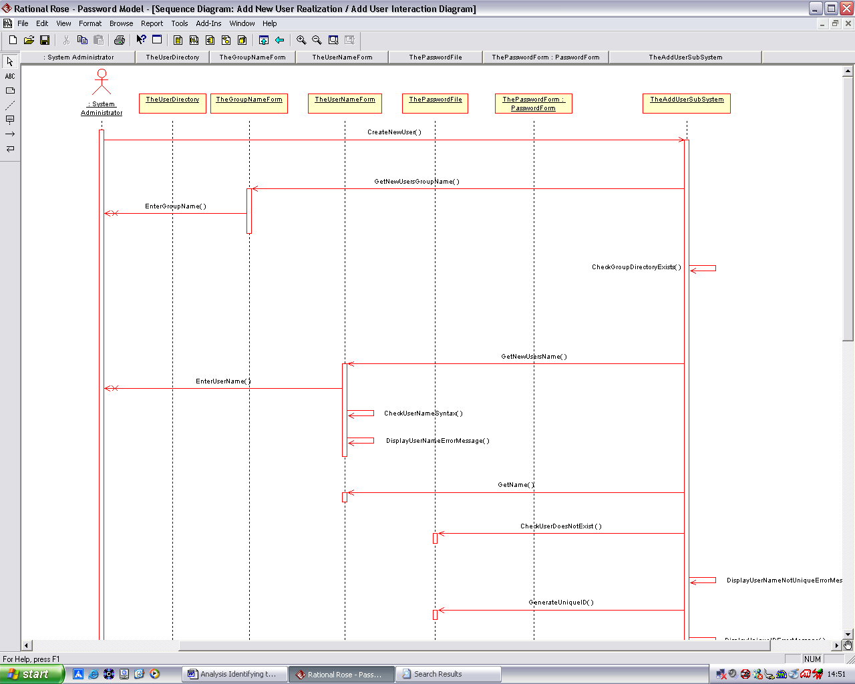

It is important to remember that the purpose of a sequence (or a collaboration) diagram is to model the interaction of objects as they attempt to realize a use-case; therefore a sequence diagram always commences with an Actor stimulating the system in some way, i.e. commencing a use-case.

Such diagrams should be read from top to bottom, as a sequence, thus the ‘Y’ axis represents the passage of time from top to bottom. The dotted line emerging from the bottom of each object and traveling downwards is called the object ‘lifeline’. Positions along the x-axis are reserved for actors and objects that collaborate in the use-case. These can be placed in any order to reduce clutter and increase the readability of the diagram (i.e. try to avoid lines crossing over other lines).

The first significant event to take place within this interaction diagram begins when the actor ‘System administrator’ sends a message CreateNewUser() to the object ‘TheAddUserSubSystem’.

This object, immediately sends the message ‘GetNewUserGroupName’ to the object ‘TheGroupNameForm’ (a dialog box object that provides a visual means of data entry for the system administrator).

Then a message ‘EnterGroupName’ is issued to the ‘systems administrator’, and the software waits until the system administrator has entered whatever data is required for continuation (presumably the group name).

Flow of control in the system then returns via the object ‘TheGroupNameForm’ to the object ‘TheAddUserSubSystem’, which sends a message to itself ‘CheckGroupDirectoryExists’ etc.

Creating a Sequence Diagram

As with a class diagram, a sequence diagram belongs with a particular use-case realization, i.e. it is designed to model how a particular set of objects interact to realize a use-case. To begin with, create a sequence diagram in the logical view (see below). Note: you can always drag and drop this to a use-case later.

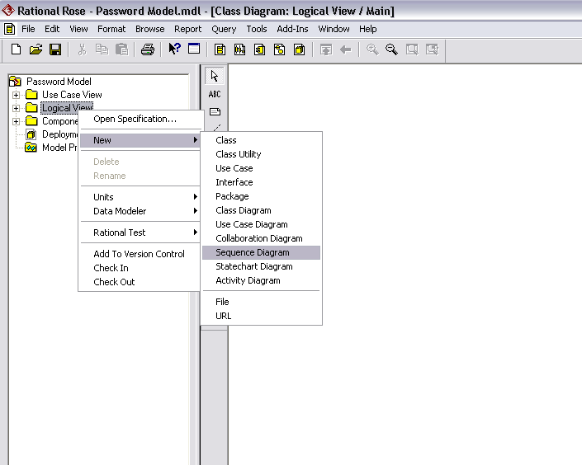

Give the diagram a name then double click in it in the browser to open it. (See below). Notice how the tool bar and its button have changed.

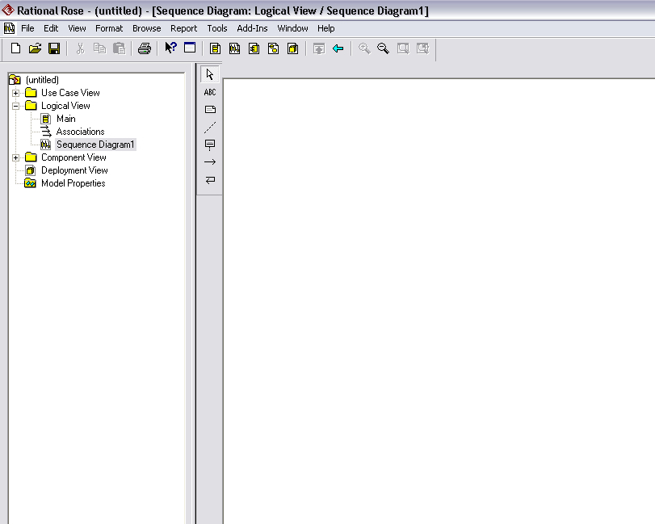

Adding Actors

If you haven’t already done so as part of your use-case analysis, create a new Actor in the Use-Case View, name it (system administrator in this example_ and then drag it onto your sequence diagram (see below).

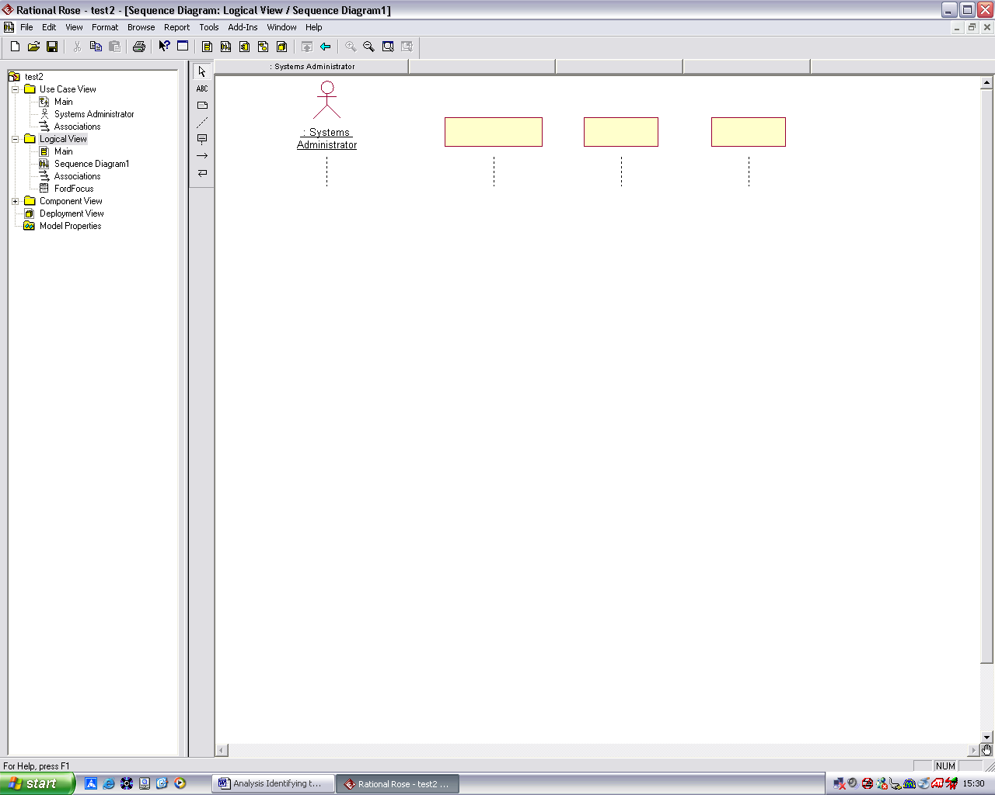

Adding Objects

Now you can add the objects to your sequence diagram. Remember that objects are just instances of classes and thus there may be more than one instance of a class within you model e.g. a car has four wheel objects. You can drag classes from the browser onto your sequence diagram. Alternatively, you can just use the object toolbar button to add new objects to your sequence diagram. To name the object and set its class, double click on it and fill in the dialog box below

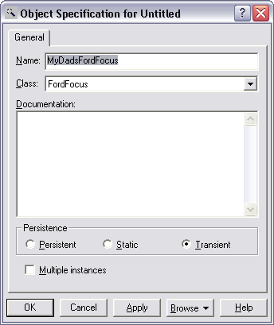

Note: To set the class name, choose an option from the drop-down list box and select from the list of classes already present in the model (or the New option if you wish to create a new class to represent your object). Notice how the object changes on the diagram (see below). Its name is now of the form ObjectName: ClassName.

Note also that objects can be anonymous i.e. without name. This can be useful when modeling messages that pass to multiple instances of that class, For example, when large numbers of objects are created dynamically during program execution, it is impractical and event impossible to show them all on the sequence diagram, so an anonymous object is instead shown with only a class name to represent all instances of that class. Messages sent to this class imply that the message is sent to all instances of it.

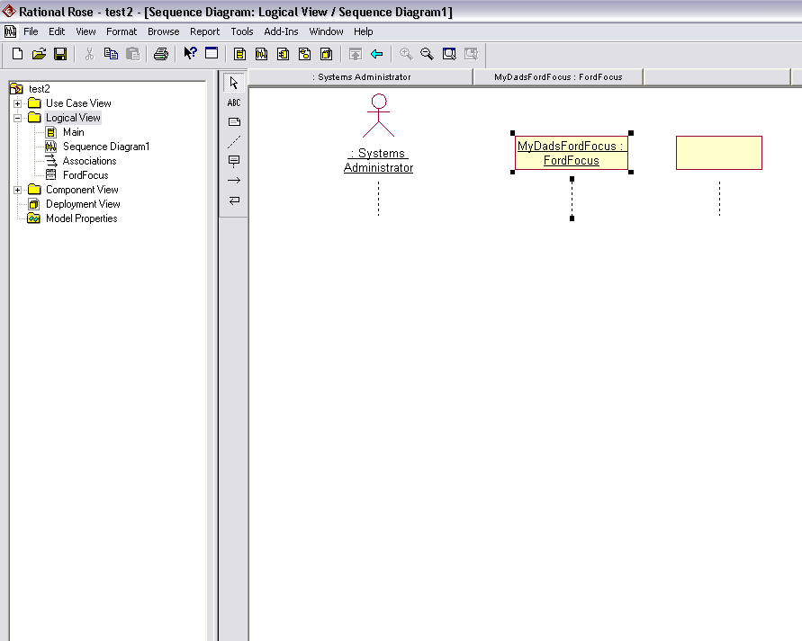

Adding Messages to Sequence Diagrams

Once you have added some objects to your diagram, you can then add messages. Using the message toolbar button, drag a line from one objects ‘lifeline’ to another, as shown below.

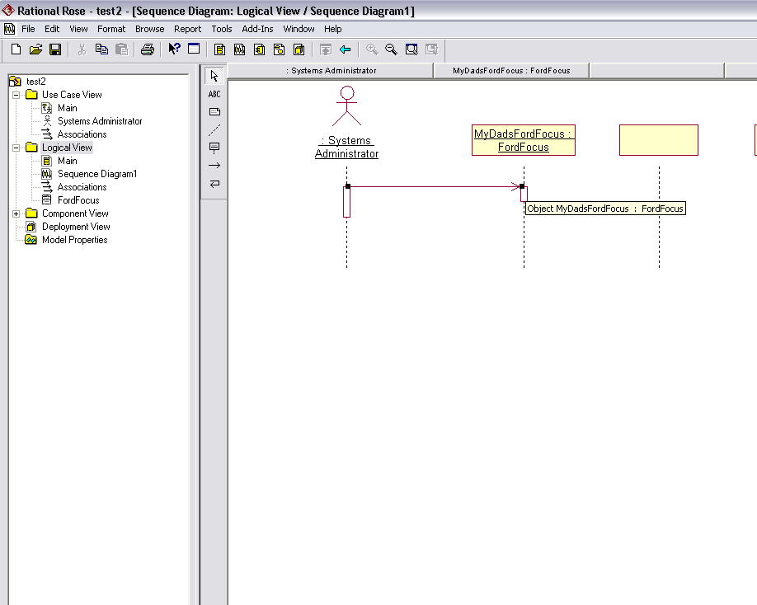

Double click on the message and enter the relevant details as shown below

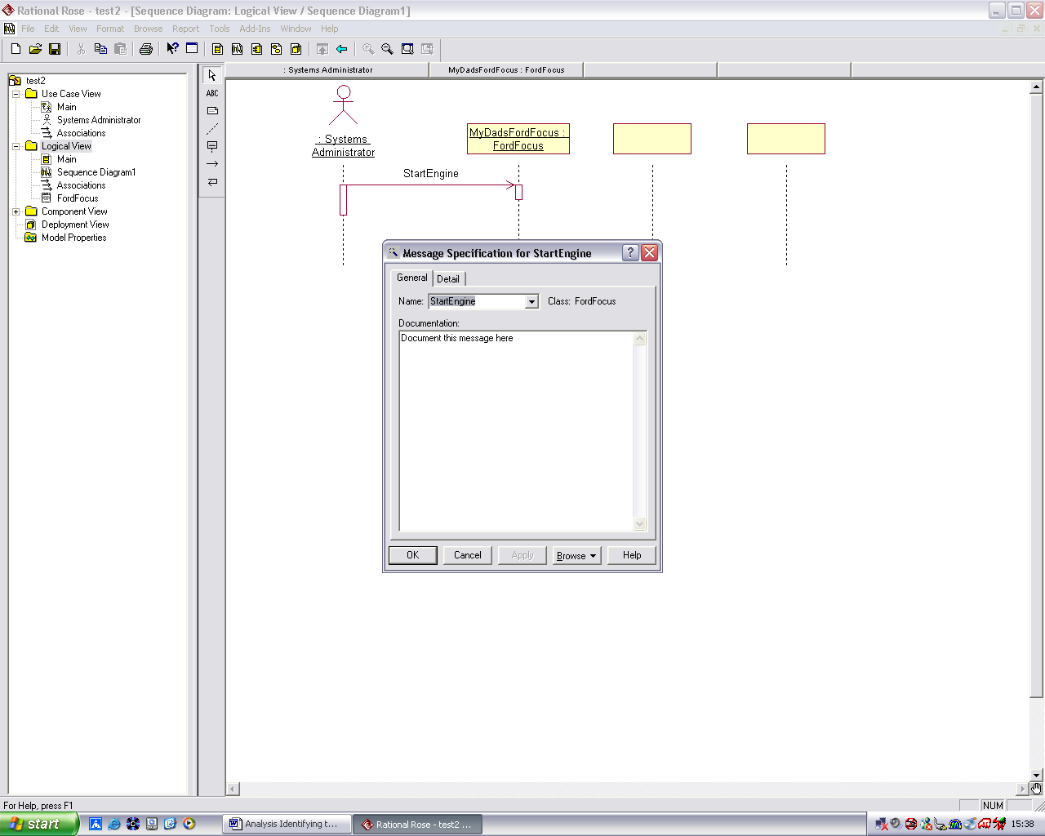

In the detail tab set the type of message (see below) to simple (the default).

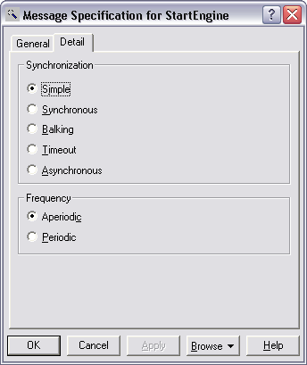

Message Types

The table below describes the differences between the various types of messages

Message Type | Description
Simple (default) | The message has a single thread of control.
Synchronous | The operation proceeds only when the client sends a message to the supplier and the supplier accepts the message.
Balking | The client passes a message only if the supplier is immediately ready to accept the message; the client abandons the message if the supplier is not ready.
Timeout | The client abandons a message if the supplier cannot handle the message within a specified amount of time.
Asynchronous | The client sends a message to the supplier for processing and continues to execute its code without waiting for or relying on the supplier's receipt of the message. This is useful in multi-threaded systems.

Each type of message has its own visual representation as shown below

You will see from the above diagram that a ‘Focus-of-Control’ box (FOC) has appeared on the objects lifeline.

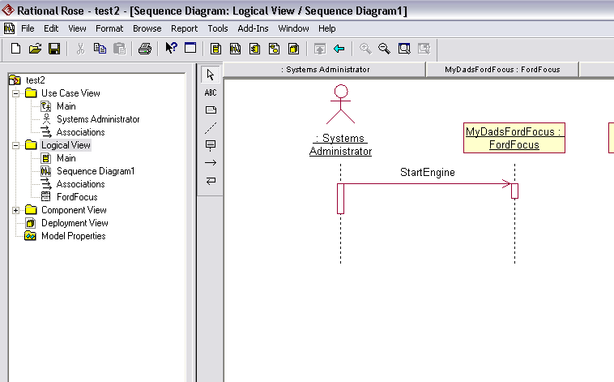

The FOC is an advanced notation which can be turned on or off as required. The intention is that FOC shows the length of time that an object has a thread of program execution actively running through it. When an object sends a message to another object, the thread of program execution passes from sender to receiver while the receiver carries out the message (i.e. its member function is executing), only to return again later when the receiver has finished. To control the display of this notation, choose, click Tools->Options from the main menu, select the diagram tab, and check the FOC option if you want it displayed.

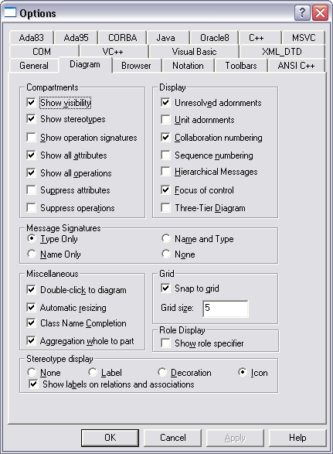
Below is a typical Sequence Diagram for starting a Car with an Automatic Gearbox (which must be in Park position before it will start) and then driving it away. See if you can follow it.

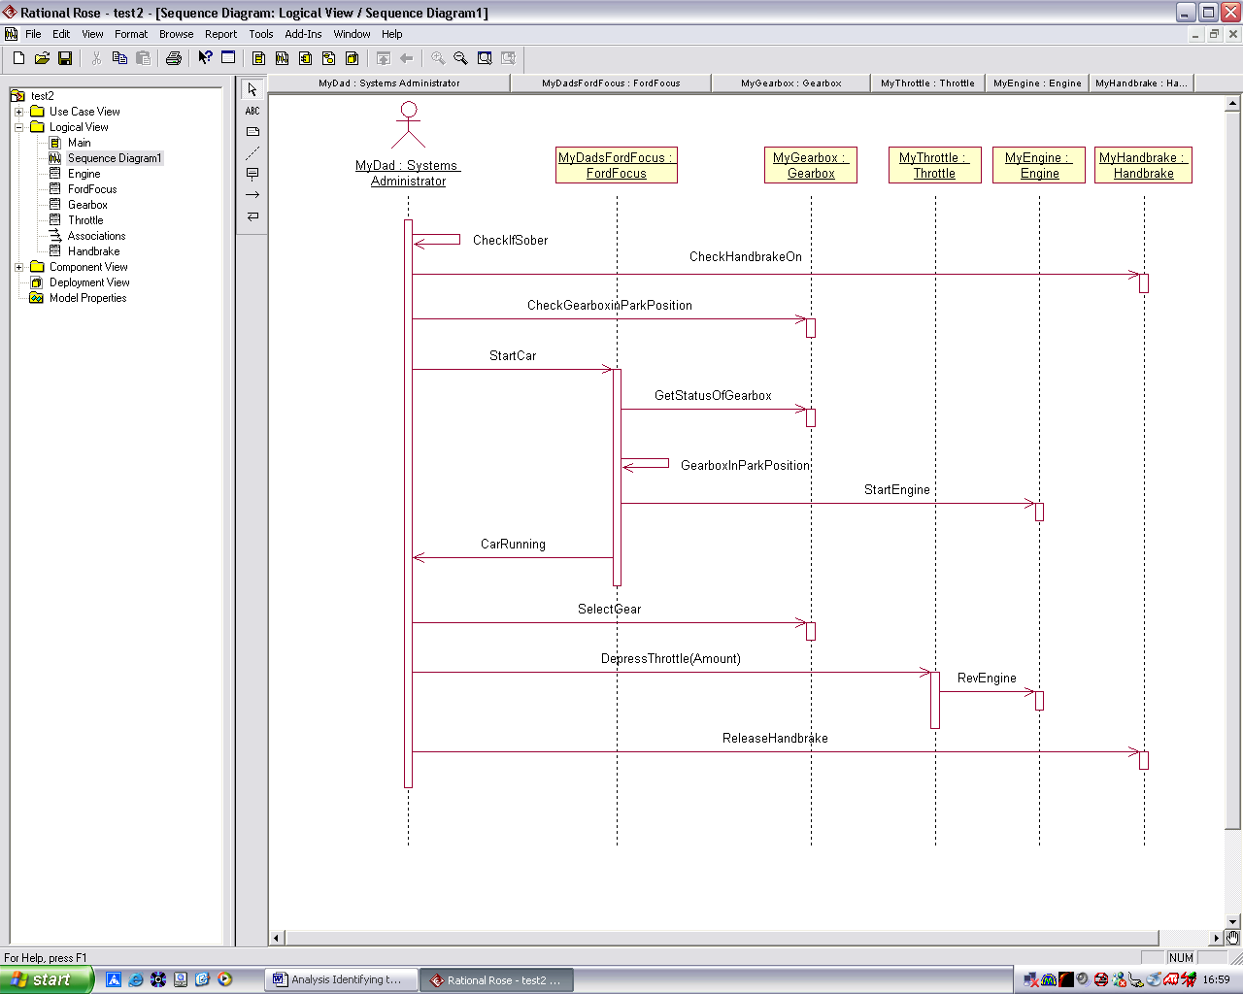

Mapping Messages to Member Functions

Now that diagram has been captured, we can map the message to member functions within the classes. This is done by right-mouse clicking the message and selecting either an existing member function within the class or selecting ‘New’ to create a new function (see below) as we have done in the case of the CheckHandbrakeOn message.

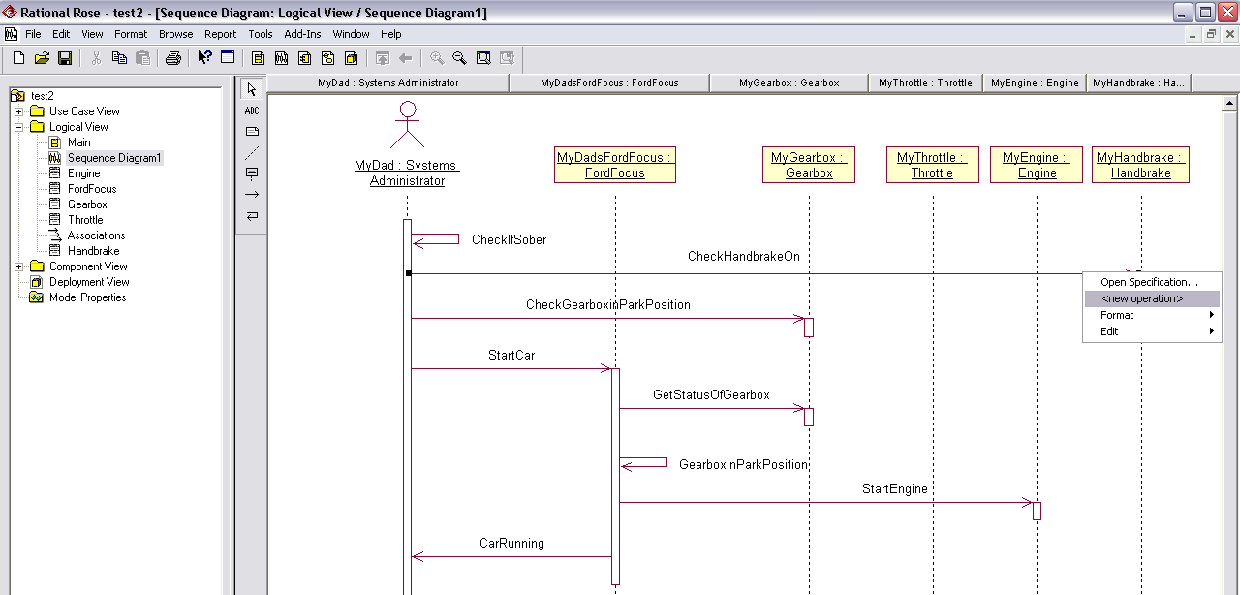

A class dialog box will open (see below) fill in the details for the new function.

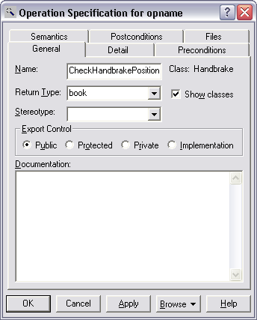

Checking Your Model

The whole model can also be checked for consistency. This is particularly useful for sequence diagrams, since it can check of all messages have been mapped to member function. To performs such a check, choose Tools->Check Model (see below) from the main menu and examine the Log for any errors and warnings. Correct them if necessary.

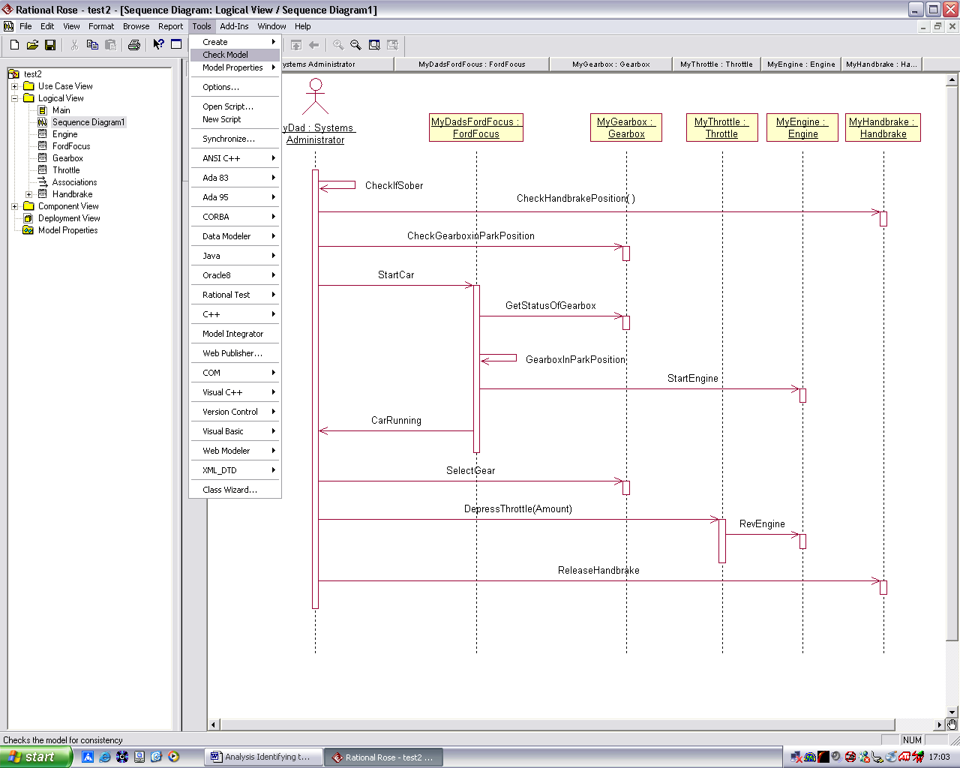

Adding Comments to your Sequence Diagram

Its sometime very informative to able to add comments to a sequence diagram to provide additional clues as to what is happening, particularly when the sending of a message is not straightforward.

For example, you can see below, that the car checks that gearbox is in park position. Then a message is sent to the engine to start. Was it the designer’s intention to send this message to the engine if the gearbox was NOT in park. Probably not, but a definitive answer could not be inferred from the diagram alone. For this reason, the designer has annotated the diagram with comments (these are usually placed on the left hand side, but they in fact be placed anywhere). Now the circumstance in which this message is sent is clear.

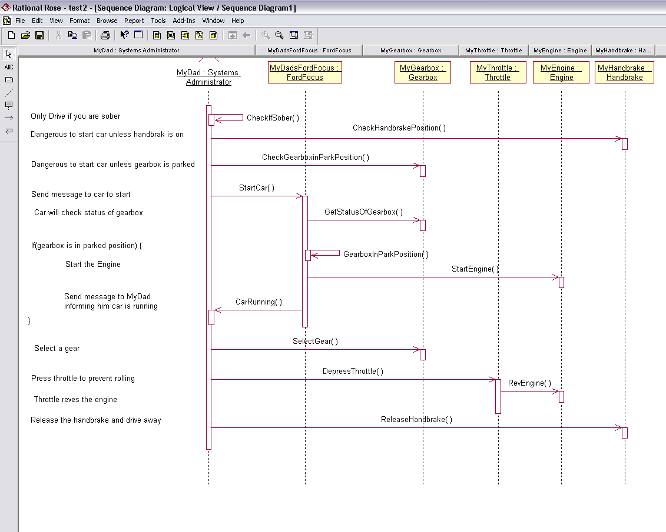

Notice also that ‘hierarchical messages’ are also shown. This is another advanced feature, which can be controlled through the same options as the FOC.

Showing Argument Passing on Sequence Diagrams

So far we have only shown simple messages being passed from source objects to receiver objects and we know that these will ultimately translate into the sender object invoking a member function within the receiver object, but what if the message is more complex than that, what if the message requires information from the sender (and perhaps returns an answer to it), how do we show this on the interaction diagram?

Once we have mapped our messages to functions within classes, we set up the argument(s) and return type for that function in exactly the same way that we did when we created classes and class diagram, by double clicking on the class and selecting the operations tab, or you can double click on the object in the sequence diagram and select the browse class option on the browse button as shown below for the object MyHandbrake.

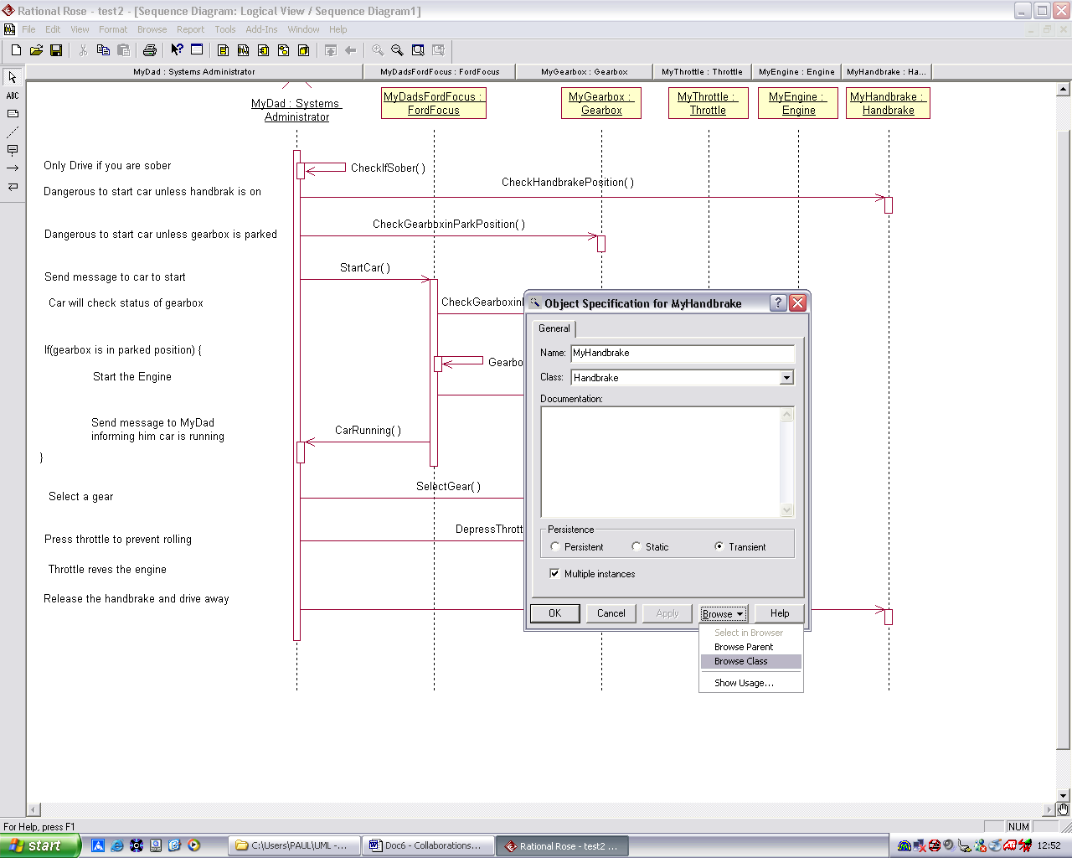

As an example, let’s make the DepressThrottle and RevEngine messages take an integer argument each. Go to the classes that represent them, i.e. ‘Throttle’ and ‘Engine’ and open the specification for them. Then go to the ‘operations’ tab and, as we did before for classes, insert a new argument of type ‘int’ each of these two operations. When this is done the interaction diagram should look like this

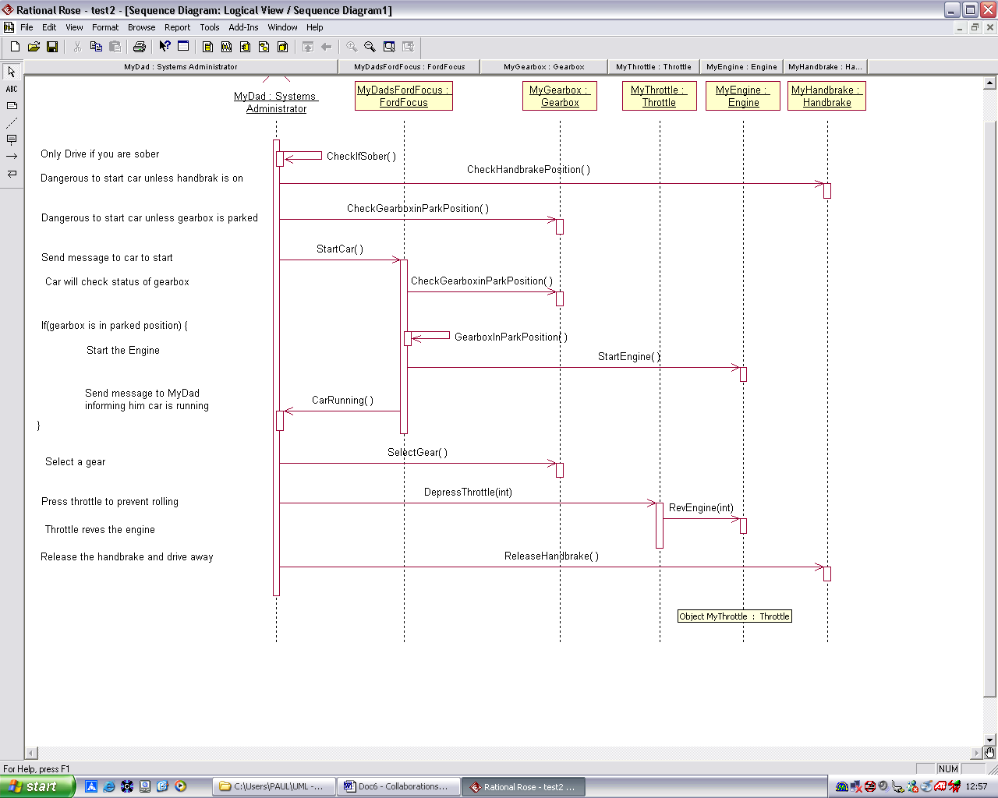

Code Generation and Interaction Diagrams

Unfortunately, Rose generates no code for any interaction messages that are shown on an interaction diagram. (It would be extremely difficult anyway if you think about it), so you have to manually go through the process of

- Creating, via your own code, the instances of classes (i.e. the objects), represented on the interaction diagram
- Mapping the messages shown in the diagram into function calls applied to the objects, including any argument passing and saving any returned answer.

