Code Generation and Reverse Engineering

One of the nice features of a good UML case tool is its ability to generate template code for the classes on your class diagrams. Don’t get too excited by this however, since even though the code generator can produce code to capture attributes, relationships (inheritance, association, aggregation, composition) and even the member functions, it leaves you to fill in the code for the latter and create instances of these classes within your program. In other words you still have a lot of work to do. Lets take a look at how Rose generates code to take some of the donkeywork out of writing programs.

To generate Visual C++ code for you class diagrams, follow these steps. Click Tools->VisualC++->UpdateCode from the main menu (see below)

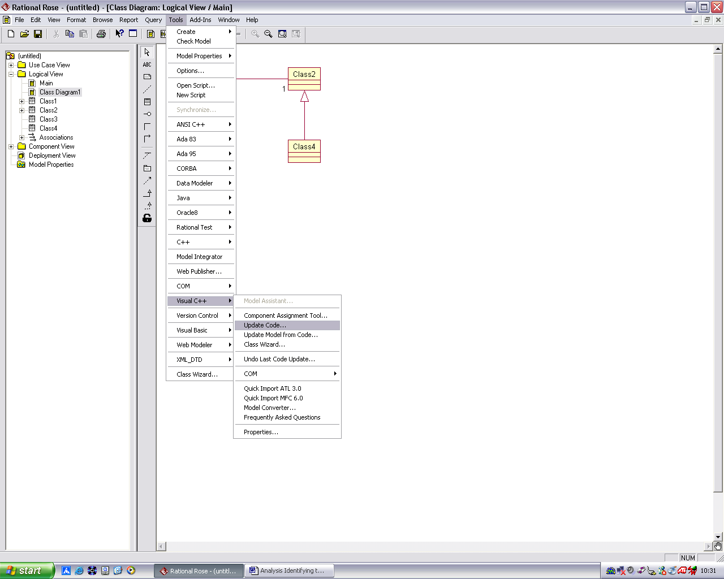

If you have not already generated code previously from your model, the following dialog box appears asking you to create a VC++ component and add classes to it. In simple terms a UML component is nothing more than a Visual C++ projects, i.e. a collection of source and header files which can be compiled to make a single executable program

Because Rose can generate code for lots of different languages, it can in fact have some classes realized by Java, some by Basic and other by C++, so we have to assign our classes to a particular language. This is what the dialog box below is asking us to do

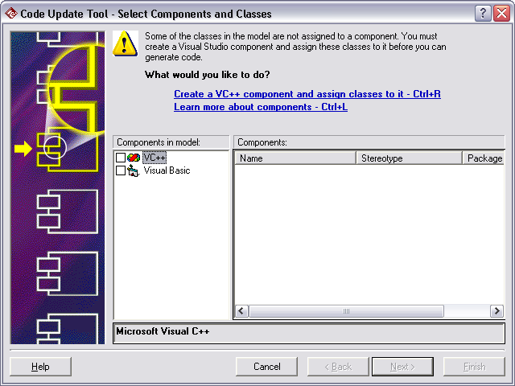

Click on the VC++ option and the following dialog box should pop up

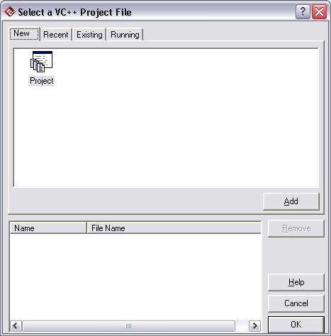
Click OK for new project, (or chose the recent or existing tab, if you want already have a Visual C++ projects that you want to assign your new classes to). Visual C++ should now start, asking you the type of project you want to build (see below). Assuming we want to build a console application (i.e. a program that runs in a dos type screen), chose the option below and enter a project name, then click OK

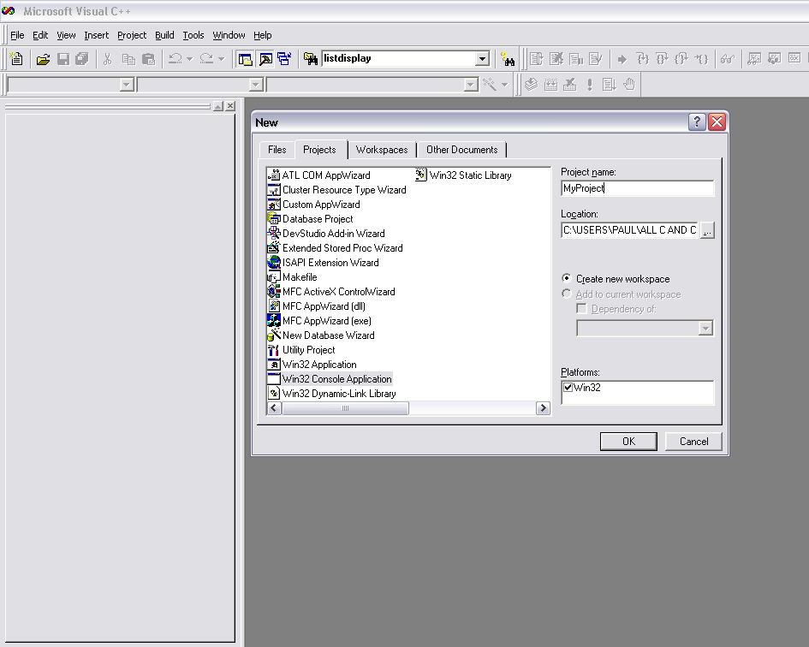

click finish on the next dialog box (see below)

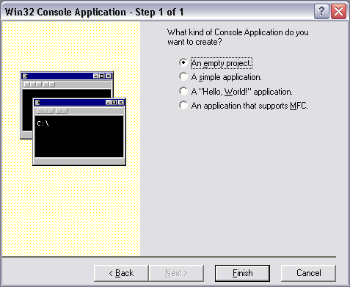

then click OK when this dialog box appears

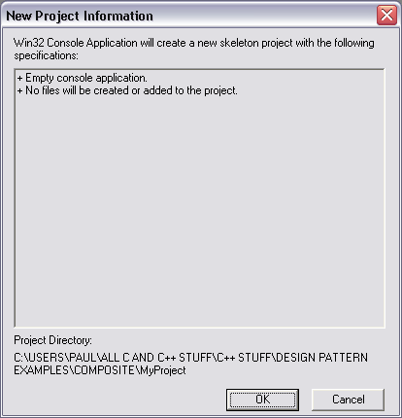

Visual C++ will then close having made a new Visual C++ console application/project (i.e. a UML component). You will then be returned to Rose and the following dialog box appears, asking you which classes in you UML diagrams are to be assigned to this new component/Visual C++ project. Place a tick next to each class that is to be assigned to this project

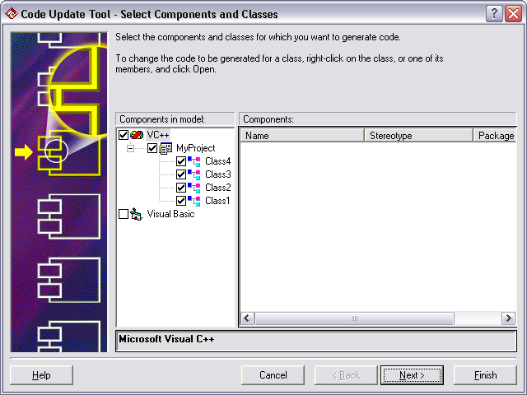

Click the next or finish buttons and Visual C++ will start up your previously created project, and Rose will generate the header and course code files for your projects (one for each class in your model) and assign them to the project.
If you return to Rose, you can examine the summary and log for any errors or warnings produced during the code generation phase (see below). Don’t worry about warnings, they can usually be ignored and rose will often correct them as shown below, where Rose has added ‘role’ names to the class diagram because you didn’t specify them. You can delete these from the diagram afterwards once Rose has set them

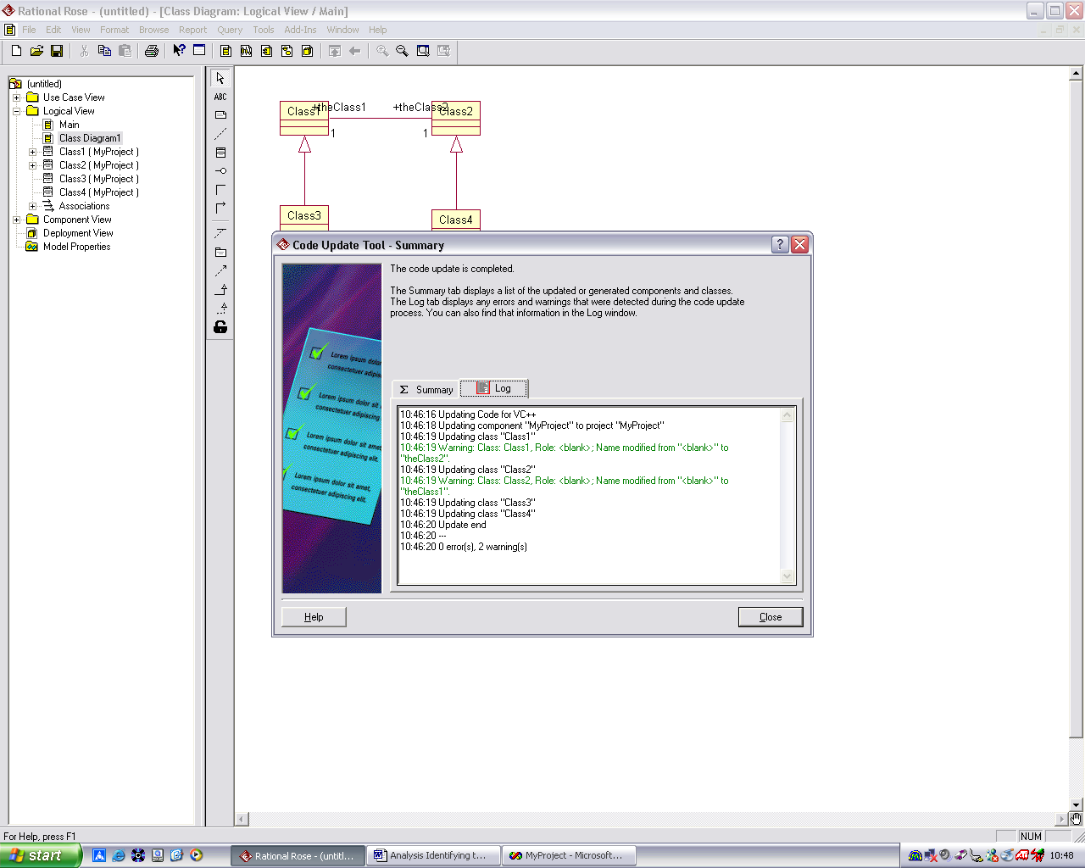

Close this dialog and go to the Visual C++ environment, you can now expand the source and header files in the file browser (see below) and observe that a header and source file has been created for each class in your model (i.e. all classes, not just the class diagram you were looking at when you generated code)

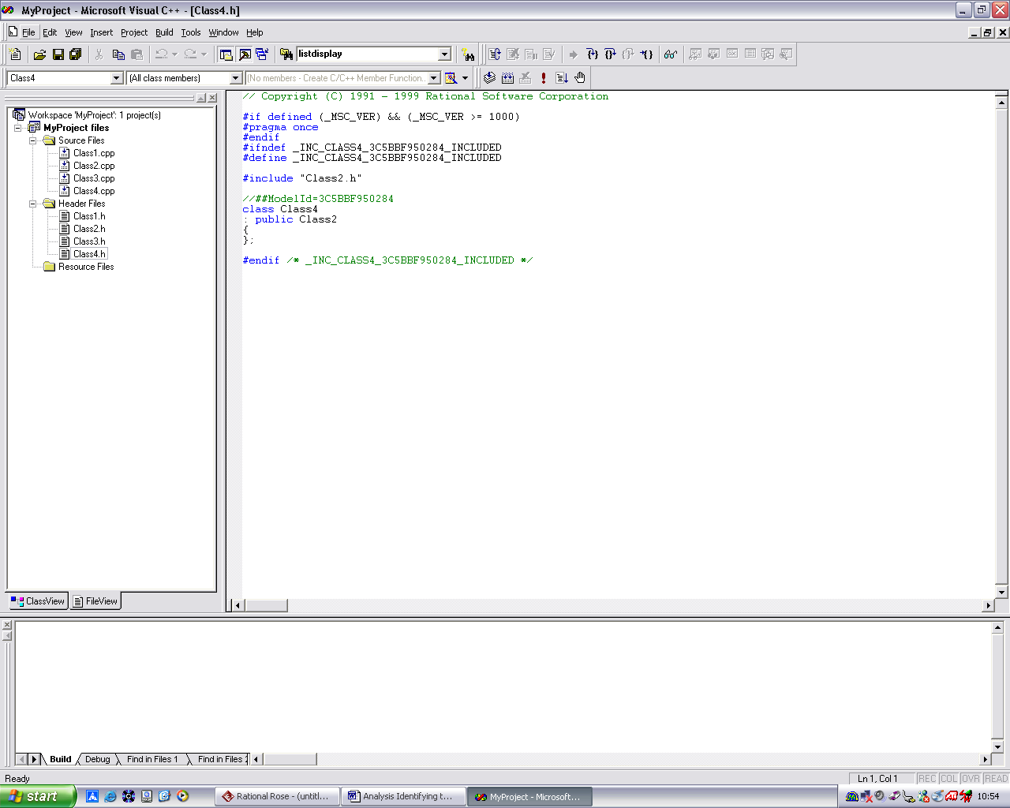

You can now compile these files to check them out, but you cannot successfully build the application because you don’t have a function main() and probably none of the member functions in your classes have any code inside them, so they won’t do anything. Notice that Rose include lots of comments in the source file similar to this

//##ModelId=3C5BBF950284

Do not delete these, as they are used by Rose to synchronise its model with the C++ code generator. This happens typically when either the model or code is updated and the other needs to change to reflect this (see later).

Modifying your Model and Updating the Code

Let’s suppose that you now go back to Rose and play around with your model e.g. let’s suppose you

- Add classes
- Change/add new relationships
- Change/add new attributes or functions to a class

Obviously you would like Rose to update the code to reflect these changes. This is easy to do, just repeat the previous phases as shown below, where a new class has been introduced (class 5)

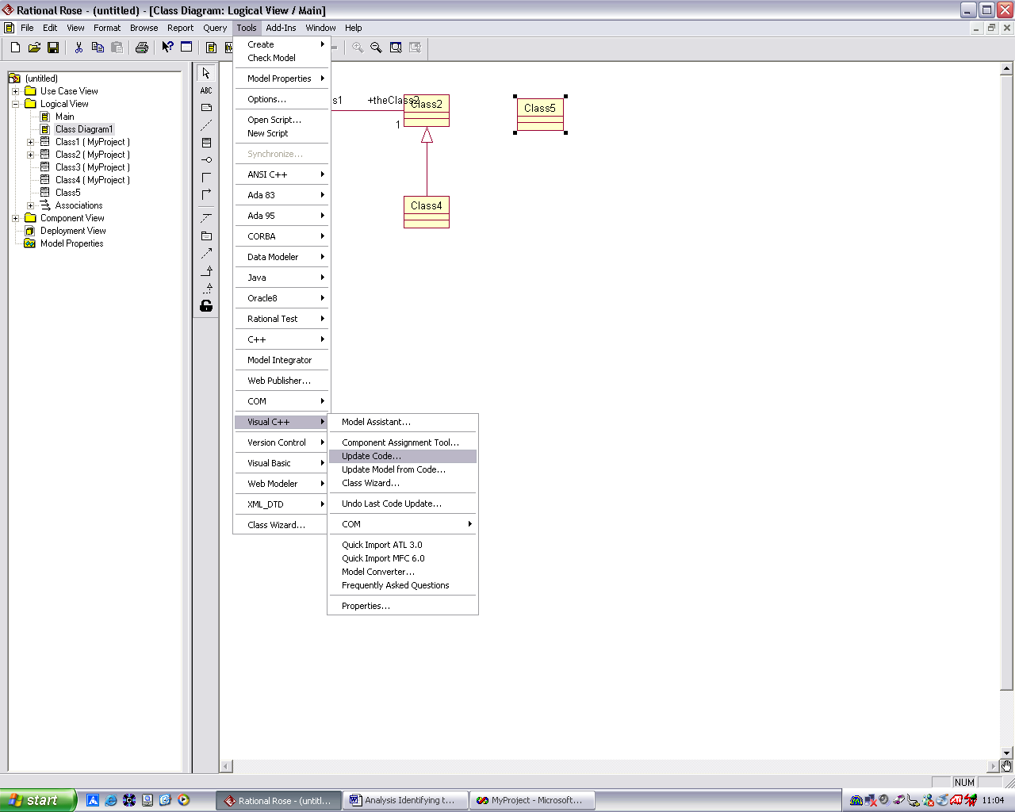

If new classes have been created in the model (as in this particular example), you will have to assign those classes to a project/language as we did before, thus the following dialog box appears.
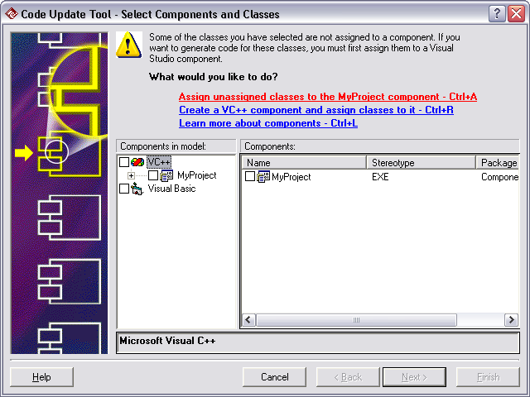

You can either assign this to a new project, or more commonly, assign it to the same project as the other classes in the model, thus chose the top option (shown in red) to assign the new classes to the existing project (you will recall we called that project ‘MyProject’. Click ‘yes’ when the new dialog box appears confirming this choice.

The following dialog box now appears showing all the classes assigned to this Visual C++ project. Place a tick next those classes that you which Rose to update the code for (note Rose will automatically place a tick next to those classes that it thinks need updating because you have changed the model). Click Finish

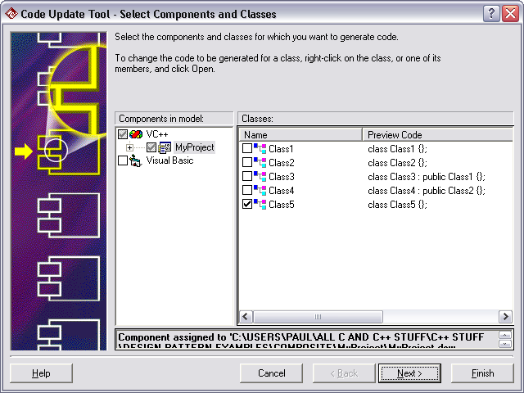

The code will now be updated and the Visual C++ files will be updated

Reverse Engineering the Model from the Code

One of the big problems with the use of any CASE tool is the divergence that all too frequently occurs between the model and the code that represents it. Developers often start off with good intentions by capturing the requirements in a UML model and then generating the initial code as we have seen above.

However, once this has taken place, and the job of detailed design and code writing begins, the programmer all too quickly gets embroiled in generating the C++ code, making changes and inclusions to the code that were often not present in the model. All to quickly the code and model go their own separate ways with none being a true reflection of the other and the model is often discarded as the code “becomes the documention”

Rational Rose attempts to limit this problem by providing a facility to reverse engineer C++ code into a UML model, i.e. analyse your C++ code and make changes to the UML model based upon what it sees. This can prove useful when you don’t have a model to start with, only raw C++ code, or when you extensively modified the code and wish to reflect the changes in an updated model.

Before attempting this operation it is vital that the code you are attempting to reverse engineer if correct. In other words it must compile without errors, so don’t reverse engineer syntactically incorrect code or your model will may be corrupted.
To update the model from the code, choose Tools->Visual C++->Update Model from Code from the main menu (see below).

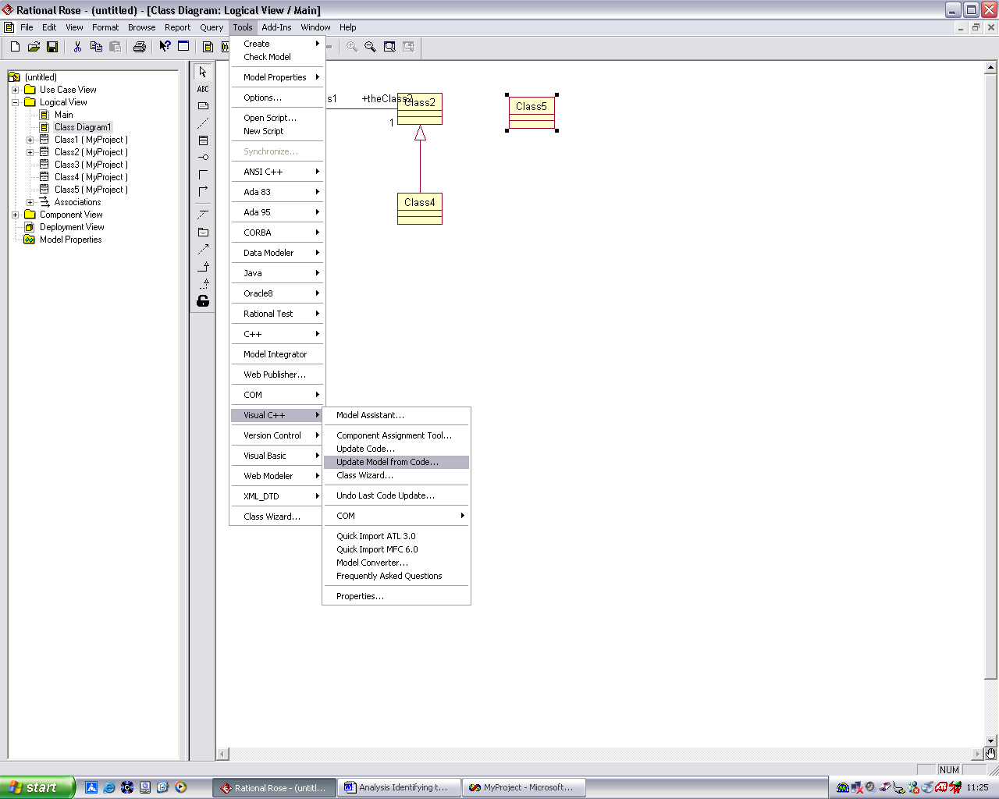

The following dialog box appears. Click Next

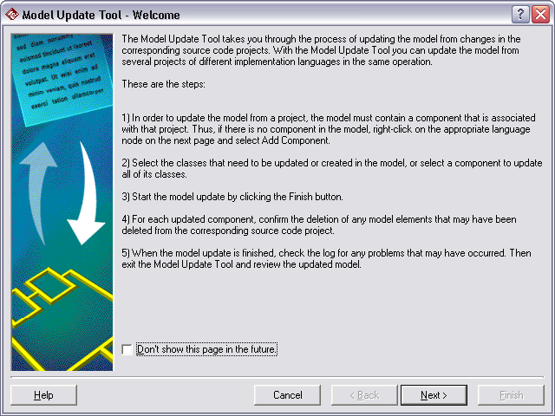

The following dialog box appears, showing the project(s) you may have created along with the classes assigned to them. Place a tick next to any classes which need to be updated from the code, then click Finish

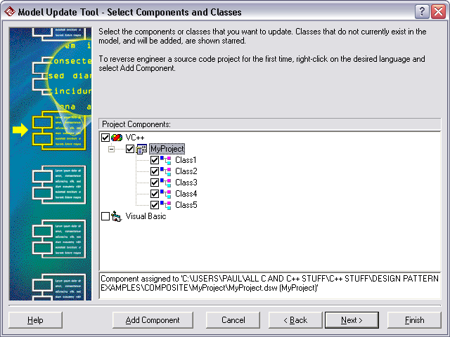

The model will be updated and you can examine the log for any errors as shown below. Click on Close and you can examine the model within Rose

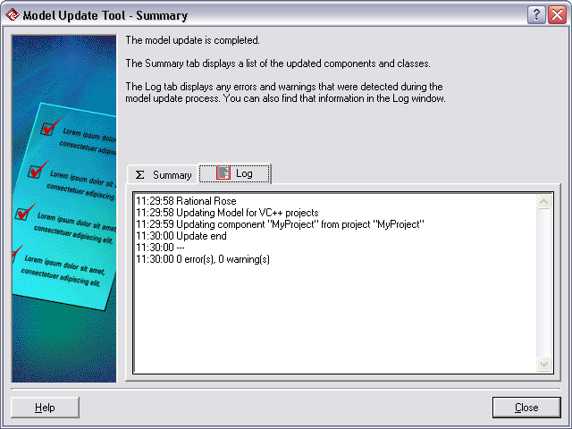

Note that the only changes made to the model by Rose will be the classes and the class diagrams. No changes are made to other diagrams such as use-case diagrams, interaction diagram, state chart diagrams etc, so it is not the answer to all your prayers !!

Using the Model Assistant

Another nice feature of Rose is the model assistant. This can be used to generate a lot of the more commonly used functions within a class e.g.

- Various Constructors and destructors
- Accessor functions to enable access to member attributes
- Operator functions such as ‘=’, ‘!=’, ‘<’, ‘>’, ‘<=’, ‘>=’ etc.

To use the model assistant, make sure the classes have been assigned to a Visual C++ project/component (as previous), and then right mouse click on a class either from a class diagram or in the browser, and select Model Assistant (see below). (Note this option won’t appear unless that class has been assigned to a VC++ project).

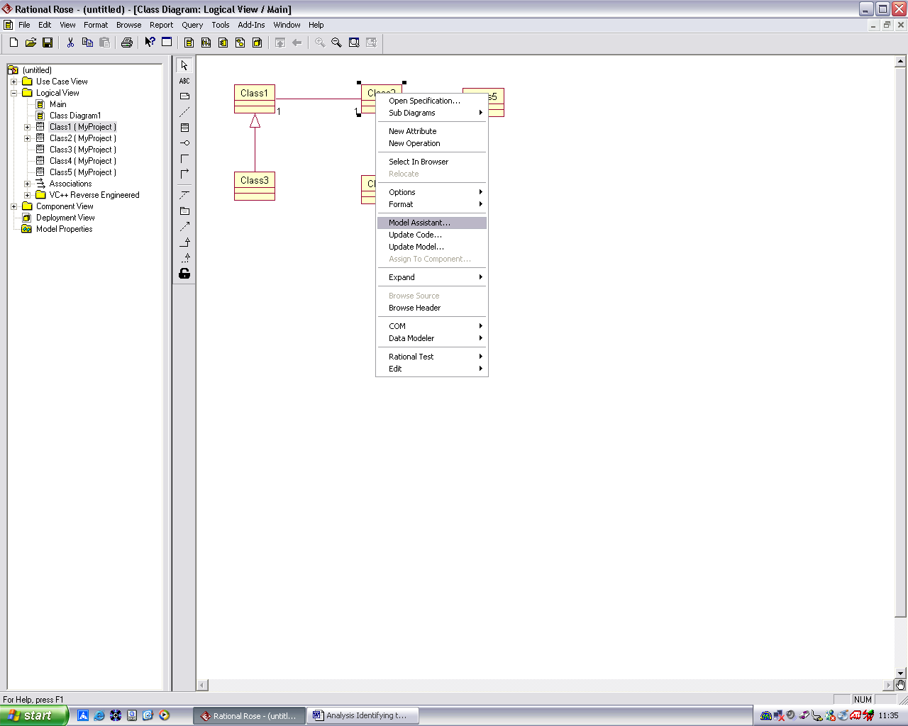

The following will appear. Expand the sections in the browser left hand pane as required
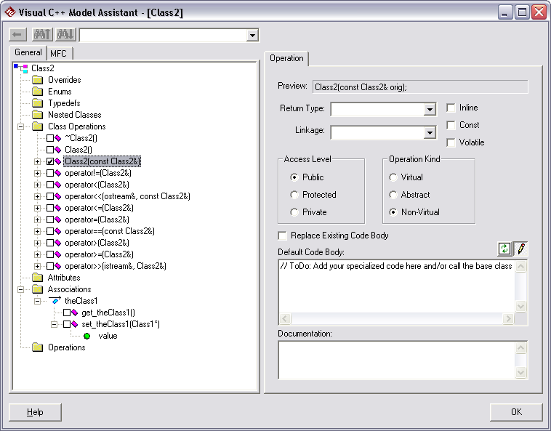

To get the model assistant to generate the code for say the copy constructor, place a tick next to it as above, ditto for any of the operator functions. You can provide detailed implementations of the corresponding function in the right hand pane. You can also provide set and get functions for any attributes and associations in you class.

Now although the model assistant is useful, particularly for beginners, more experienced programmers often prefer to carry out this sort of code generation by typing the code directly into the Visual C++ source code and reverse engineering the model from that. You pays your money, you takes your choice !!.

