UML Class Relationships

Once you have placed two or more classes on your class diagram, you can now begin to define the relationships between them. The UML provides several important types of class relationships.

- Association
- Aggregation
- Composition
- Generalization

Association Relationships

An association relationship implies that one class makes use of another in some way. The most common reason for this type of association is simply that an instance of one class wishes to navigate to, or perhaps send messages to an instance of the other class in the relationship (i.e. a collaboration between objects). For example, a CPU sending messages to a Hard Disk, or a Brake pedal sending messages to the brake lights and servo.

To capture such a relationship we introduce a class diagram showing the classes that represent the communicating objects and draw the association between those classes. An example of an association between several classes is shown below.

As shown above associations can be bi-directional, meaning that messages and navigability can be passed from either object to the other, or uni-directional, implying one way passage of messages and navigability only. For example, in the diagram above, we can infer that it is possible for instances of class 3 to send messages or even navigate to (i.e. gain access to) instances of class 4, but not the other way around. Likewise, instances of class 1 can navigate to, or send messages to instances of class 2 and vice-versa.

In either case, an association relationship implies that the source class (i.e. the one able to navigate or send message to the other) would contain a pointer to the destination class instance within it. For example, the implementation of Class 1 might look like this

class Class1 {
private:
Class2 *theClass2 ; // pointer to an instance of class2
. . .
} ;

While Class 2, would look like this (due to the bi-directional navigability between instances of these two classes)

class Class2 {
private:
Class1 *theClass1 ; // pointer to an instance of class1
. . .
} ;

Obviously, such a pointer needs initializing within the object at run time, and this would typically be done within the objects constructor, which would need to be passed (in the case of Class1), the address of an instance of Class2 (and vice-versa). For example

class Class1 {
private:
Class2 *theClass2 ; // pointer to an instance of class2
Class1 (Class2 *MyClass2Instance) :
theClass2(MyClass2Instance)
{ }
} ;

class Class2 {
private:
Class1 *theClass1 ; // pointer to an instance of class1
Class2 (Class1 *MyClass1Instance) :
theClass1(MyClass1Instance)
{ }
} ;

Given that each instance of Class1 now has a pointer to an instance of Class2 (and vice-versa), the pointer can be used to navigate to or access facilities within the destination object using the ‘->’ notation e.g.

x = theClass1->Function1() ; // use class2 to invoke function in class1
y = theClass2->Function1() ; // use class1 to invoke function in class2

Multiplicity

Multiplicity is an important part of any association. It indicates how many instances of class ‘X’ exist for each instance of class ‘Y’. In the example repeated below, we can interpret this to mean

- For each instance of Class3 there is exactly one instance of Class4 and vice-versa.
- For each instance of Class2 there is exactly 1 instance of Class1, and vice-versa.

For example, the relationship between CPU and Motherboard might be a 1:1 relationship implying that a motherboard has exactly one CPU and a CPU only communicates with one motherboard. Other kinds of multiplicity are also possible. For example

- 0 none
- 1 exactly 1, i.e. known at design time
- 0..n unknown, usually determined at run-time
- 1..n at least 1 but determined at run-time
- 0 or 1 exactly 0 or 1, i.e. known at design time
- ‘*’ or ‘n’ meaning ‘unknown many’

To set the multiplicity of a relationship, right click on the end of the relationship you are setting and chose the multiplicity required, e.g.

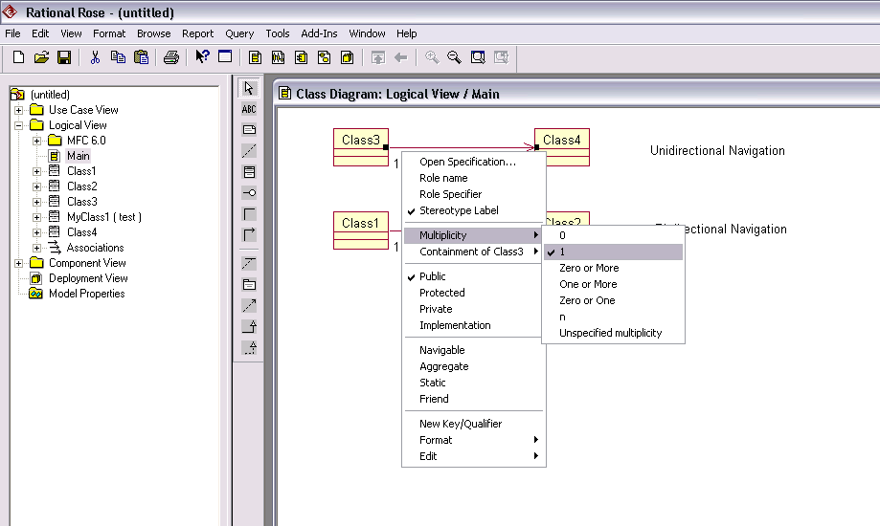

Here is another more sophisticated example

This diagram can be interpreted to mean

- For every Computing Unit, there are 1or more (1..n) Computing Lecturers (e.g. PJD and AG representing instances of computing lecturers sharing a unit).

- Likewise, for every computing lecturer there are ‘n’ computing units that they are involved with (e.g. PJD teaches unit 2220, 2330, M212, M213, EP353 etc. representing instances of computing units).

- For each computing lecturer there are ‘n’ computing students that they are involved in teaching, and each computing student is involved with 1 or more ‘1..n’ computing lecturers.

- For every Computing Unit there are 0 or more (0..n) Students studying it, and each Computing Student takes 1 or more (1..n) Computing Units

Role Names

When a class participates in an association, it has a specific role to play. A role is defined as the ‘face’ that the class presents to the other end of the association. The concept of a Role is quite natural in Acting where individual actors take on a particular role within a scene. For example Arnold Schwazzenegger playing the role of the Terminator. The same is true UML. Think of a class diagram as a scene from a play or film (a use-case realization in fact), with the actors represented by the classes. Each class acts out a particular role with respect to the other classes.

Think about yourself, what roles do you play on a day-to-day basis? Son, daughter, brother, sister, husband, wife, employee, house-owner, car-owner, tax-payer, student etc. When you interact with another person, you generally assume one or perhaps a subset of these roles. Each role then defines your relationship with that person, i.e. what each of you does or expects from the other. Such roles can be captured and shown on an association to give extra meaning to the association, but it is fair to say that role names are often restricted to situations where a class may take on many different roles, i.e. it has many associations. For example

This class diagram, with both roles and multiplicity shown, can be interpreted to mean

- Each instance of the class ‘Person’ is an employee of exactly 1 company.
- One Person (who also happens to be an Employee) is also the Chairman of the company he works for.
- A company interacts or associates with many instances of the class Person (i.e. many employees), but interacts with only one chairman.

Although the use of role names is optional, the code generator for a UML case tool can use the role name to generate the name of the pointers or variables within the classes. For example the code for the above class diagram might look like this

class Person
{
public:
Company* employer;

Company* theCompany;
};

class Company
{
public:
Person* employee;

Person* Chairman;
};

If you do not specify a role name for the end of an association, then the Rational Case tool will generate a default one which is the name of the class at that end of the association prefixed by the word ‘the’, e.g. thePerson, theCompany etc.

Setting the Role Name

This can be done in one of two ways

- Right mouse click on the end of the association and select Role Name from the pop-up menu (see below)

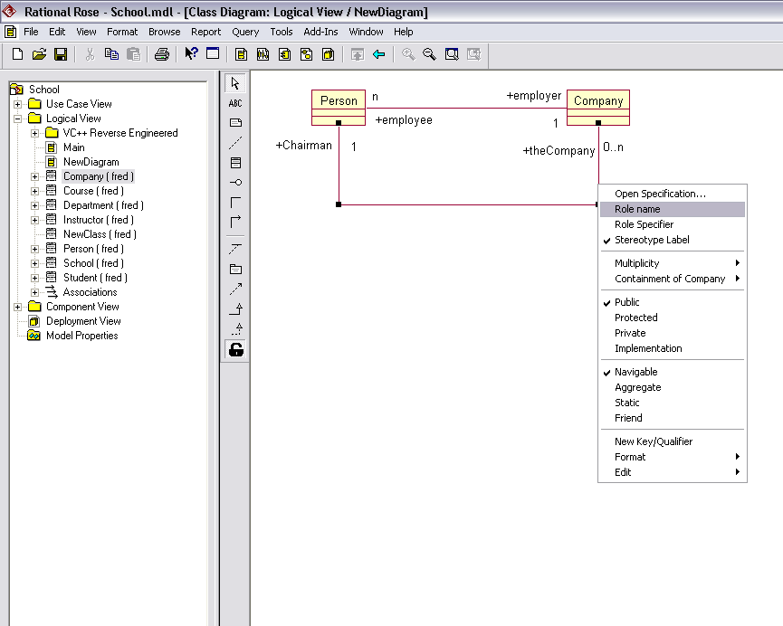

- Double click the association to open the specification. Select Role ‘A’ or ‘B’ Detail for the particular end you wish to set and enter the role name

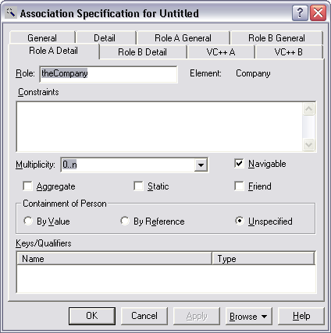

Naming an Association

In addition to role names, it is possible to name the association to aid the readability of the diagram. Generally the association name is a ‘verb’, which indicates how the two connecting classes interact. For example consider the diagram below where each association has been named. Is it more readable?.

The above diagram tells us that there is a Negotiating relationship between customer and Garage, a purchasing Relationship between Customer and Car and a Services and Repairs Relationship between Garage and Car. Does the above generate any code? No. Naming an association is purely to aid readability.

The UML says that a direction arrow can be included on the association to guide to reader in interpreting the direction of the association. For example do Cars purchase Customers or do Customers purchase Cars. In this example it is self evident, but might not be so when the classes are more abstract and do not reflect obvious real world objects.

Unfortunately, Rational Rose, although it allows you to set the direction for readability, does not put the arrow on the diagram. For this reason, I adopt the approach of putting the association name closest to the source so that it should be read as Source name –>Association Name –> Destination Name. For example, Customer Purchases Car, Customer Negotiates with Garage, Garage Services and Repairs Car.

Setting an Association Name and Direction
To set the association name and its direction, double click on the association link on the class diagram to open its specification. The name can then be entered as shown below.

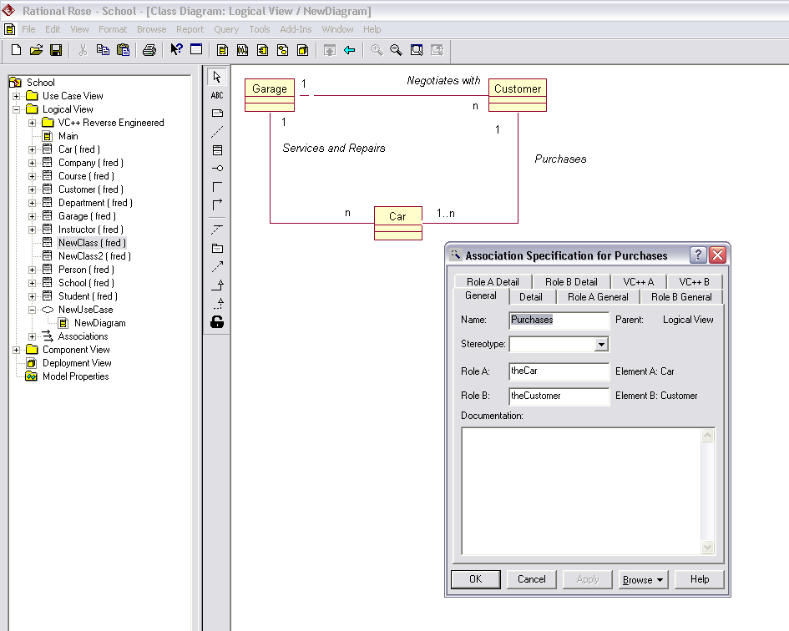

To set the direction (if required), click on the Details Tab and set the direction of the source (see below)

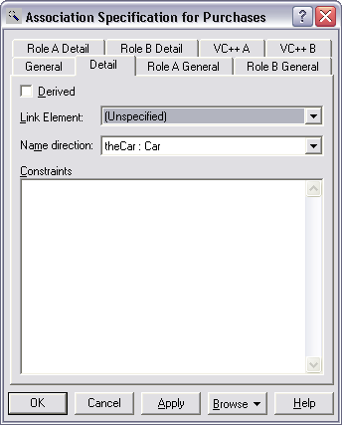

The Role Specifier

When the multiplicity at one end of an association is more than 1 (see example below), it is not sufficient simply to have a single pointer generated within the class to point to the object at the end, since a single pointer can only point to one object.

For example, how is a company object going to keep track of all of its employee objects with just one single pointer?

What we need inside the Company class is a container, to keep track of all the objects in the association. There are many different kinds of containers available ranging from a simple array to complex data structures like Linked Lists and Trees (see the C++ Standard Template Library). So how do we specify the type of container we wish to use? First make sure that the Role Name is visible, and then right mouse click on the association and select the role specifier.

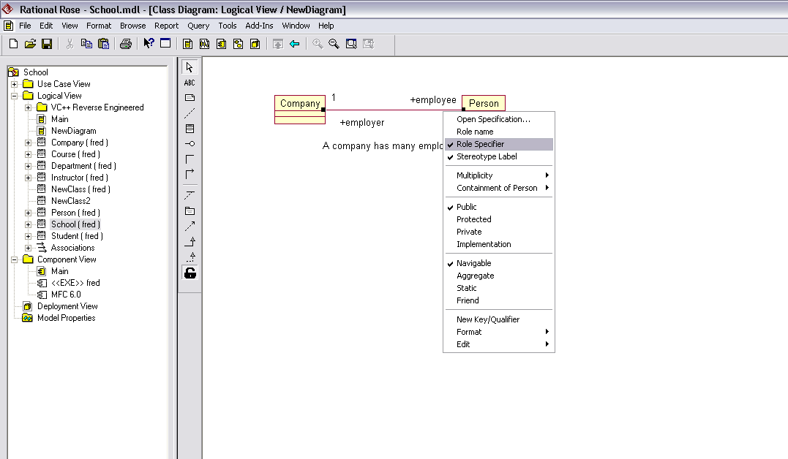
To set the container to a simple array, edit the role name and place a ‘[size]’after the name. (see example below)

Now the code for the Company class will look like this.

class Company
{
public:
Person *employee [ 10 ] ; // array of 10 pointers
Person *Chairman;

};

An array of pointers is fine if there is a ceiling or limit to the number of employees working for a company, but if the upper limit cannot reasonably be predicated, you might like to investigate the use of a dynamically sizeable list, vector or deque (see C++ standard Template Library).

When choosing a container, it is frequently easier to edit the generated code produced by Rose and type in the correct C++ code for the type of container you want and then let Rose ‘Reverse Engineer the code back into the model’. The role name will then be updated accordingly. See example below for the use of a ‘pointer to a list of Company pointer’

Either way around, when you introduce a container, you will have manage with your own code, the creation, inserting, removal and deletion of the employee list/array.

Aggregation and Composition

There are two specialized forms of association that imply increasing levels of ownership and responsibility, called Aggregation and Composition that we may use to model the ‘Has-a’ relationship in UML. The example below demonstrates the concept of aggregation.

The diamond shape at the end of the relationship denotes the owning object, i.e. the Car owns both Engine and Gearbox. However, the engine may or may not belong to a car at any particular point in time, in other words ownership may be transient. This models the real world where engines and cars are often made in different factories at different times and only join together during assembly.

Note that aggregation does not affect navigability i.e. it is still possible for the ‘whole’ or owning object to navigate to the ‘part’ or ‘owned’ object within it and vice-versa, so uni- and bi-directional navigation are still possible.

Likewise multiplicity is unaffected by aggregation, so the ‘whole’ may own ‘0 or more’ instances of the parts at any one point in time and similarly a ‘part’ may belong to ‘0 or more’ wholes. This last point is important because aggregation implies that ‘parts’ can be shared amongst ‘wholes’.

Furthermore, the ‘parts’ may be detached from the ‘whole’ and given to other ‘wholes’ thus the links between ‘whole’ and ‘part’ are transient i.e. not fixed but are likely to change dynamically during program execution.

Finally because aggregation implies possible sharing of the ‘part’ by many ‘wholes’ and given also that a ‘whole’ does not have lasting ownership of its ‘part’, the ‘whole’ does not have to take responsibility for the creation and destruction of the part.

What typically happens is that the ‘part’ is created separately either before or after the whole) and attached at some convenient point later, either during the construction of the ‘whole’ or by calling a member function such as ‘swap()’ to swap out the old part (if it exists) and substitute/insert the new one.

If the ‘part’ is shared by many ‘wholes’ i.e. the multiplicity at the ‘part’ end of the relationship is > 1, then a design decision will have to made as to whether the whole should destroy when the former itself is destroyed. Ultimately, somebody has to destroy the ‘part’.

Creating an Aggregation in Rational Rose

To create an aggregation, draw an association first, showing either a uni- or bi-directional navigation and if required set the multiplicity at each end. Then, to turn the association into an aggregation, right click on the end of the association nearest the ‘owning’ object, i.e. the one that has or owns the other object and select Aggregate from the pop-up menu (see below). Obviously only one end of the relationship can be an aggregate (i.e. they cannot both own each other!!!).

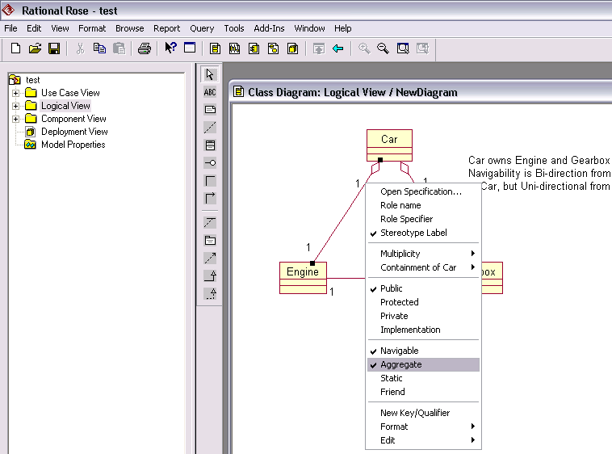

In theory aggregation should generate code identical to association, i.e. a pointer to the ‘part’ is placed inside the ‘whole’ and thus aggregation is indistinguishable from association except for the visual hint or clue on the class diagram. In other words the Engine class should look like this

class Engine
private:
Engine *theEngine ; // aggregation via a pointer
Gearbox *theGearbox ;
} ;

So why bother with aggregation? Jim Rumbaugh, one of the original “gang of three” authors of UML (along with Grady Booch and Ivar Jacobson) described aggregation as a “modeling placebo”, i.e. it doesn’t have any tangible benefits, but using it makes you feel better.

I guess its integration into the UML has more to do with the fact that books on Object Oriented Analysis and Design have always placed great emphasis on the distinction between ownership (implying aggregation) and simply using (implying association) and thus it was deemed appropriate to include some method of modeling aggregation within the UML. (Exercise: Why is association the same as aggregation)

Unfortunately Rational Rose chooses not to implement aggregation in this way and confusingly (despite options within various menus and dialog boxes about type of containment for a part/whole relationship) implements aggregation using plain and simple data elements rather than pointers. If you want aggregation as specified by the UML, then model association in Rose.

For example, given the Car, Engine, Gearbox model presented previously, Rose chooses to generate the following code, which could not possible comply with the definition of aggregation presented by the UML above. How for example would you detach or swap the engine out of the car? What rose does is more like composition (see next)

class Engine
private:
Engine theEngine ; // aggregation via data
Gearbox theGearbox ;
} ;

Composition

Composition is a stronger form of aggregation where the life times of the owner and owned object are the same meaning that the ‘whole’ is responsible for the creation and destruction of its ‘parts’. Furthermore, with composition, the ‘parts’ belong to one and only one whole, i.e. a part cannot be shared amongst several ‘wholes’ and thus the multiplicity at the ‘whole’ end of the relationship is always 1. For this reason, some people do not bother to indicate the multiplicity and leave it to be inferred. An example of composition is shown below.

In this particular example, a Car is composed of one Engine and one Gearbox, as indicated by the filled diamond at the car end and by the multiplicities. Note however that there is nothing to prevent a ‘whole’ from being composed of many parts. For example we could have a Car with two engines if we chose, although this is unlikely in practice (but not impossible!!).

From the above diagram we can infer that whenever a car is created, an Engine and Gearbox are also created and belong to the Car. It will not be possible to separate the Engine or Gearbox from the Car and when the Car is destroyed it must take responsibility for destroying the Engine and Gearbox.

Setting Composition

To set composition, create an aggregate as before, and then right click on the end of the relationship nearest the ‘owned’ object i.e. the Engine or Gearbox in the above example. Select ‘Containment of’ and select ‘By Value’
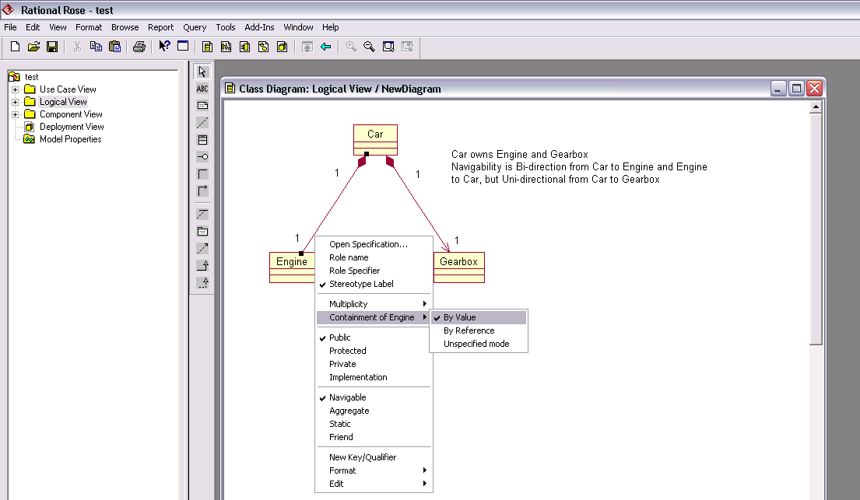

The code for the ‘Car’ class could now be written as shown below

class Car {
private:
Engine e1 ; // an engine is a member attribute of a car
Gearbox g1 ; // a gearbox is a member attribute of a car
} ;

Generalisation

Generalisation is fundamentally a relationship between classes (rather than objects), because it defines a set of common attributes, behaviors, and interfaces for all derived classes. In UML, this is how we create ‘Kind-of’ relationships. In Object oriented Analysis and in UML, generalization implies two things:

- Inheritance
- Substitutability.

Inheritance means that derived or child classes inherit all the attributes and member functions of their base or parent class. In fact they may add their own or even override/modify the ones inherited. Substitutability means that a derived or child class can be used or substituted anywhere in a program where a base or parent class could have been used.

The UML provides a simple notation for expressing inheritance as shown in the example below.

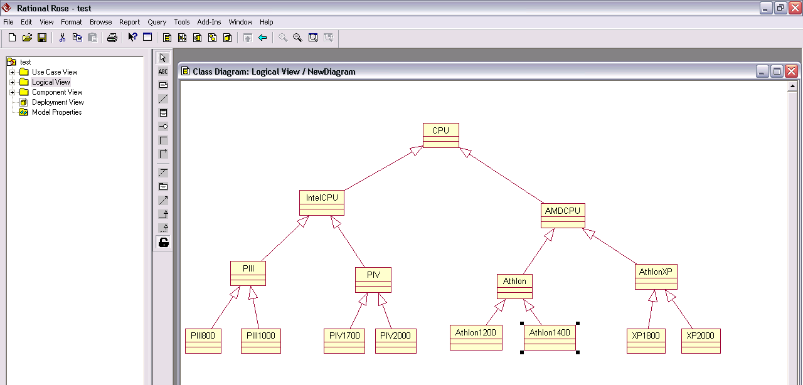

Here the class CPU is the base or root class for all kinds of CPU. We can see that IntelCPU and AMDCPU are both kinds of CPU and that they in tern have their own derived classes, PIII, PIV and Athlon, AthlonXP etc.

Inheritance means that the attributes and member functions for all classes higher up the tree are inherited by those lower down that branch of the tree.

Substitutability means that all classes lower down a tree are a substitute for their parent. So for example, an AXP2000 can be used wherever an AthlonXP, or an AthlonCPU or even a CPU could be used.

The type of inheritance is controlled using the right mouse button, as shown below, private, public, protected and where necessary virtual inheritance for C++, but don’t worry about the latter as it’s rarely used. A friend setting allows derived classes to be friends of the base class allowing them to access the private parts of a base class directly. Experiment with the code generator to see what code gets produced for each settings.

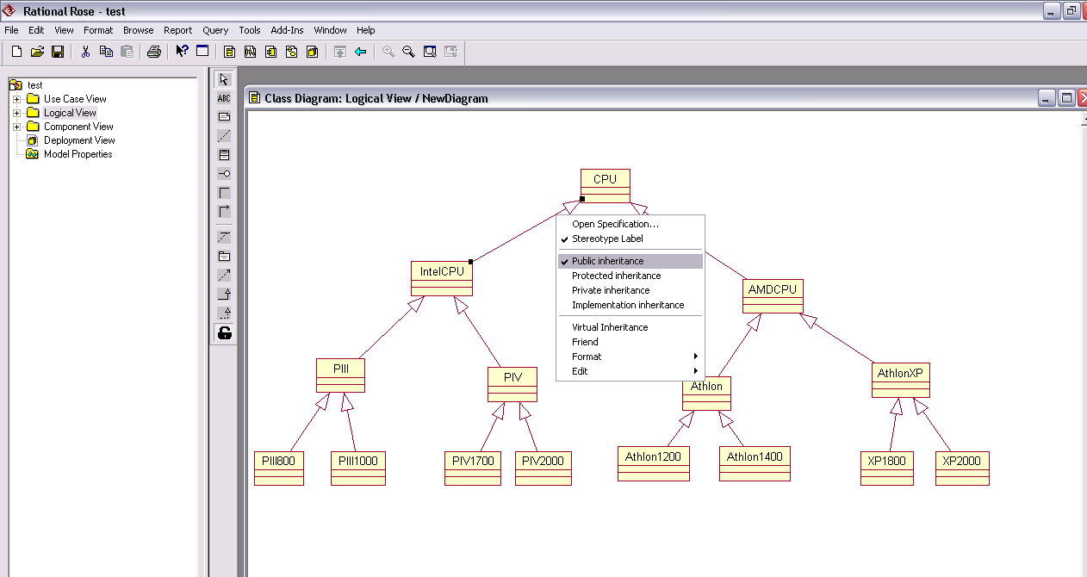

When generating code, the type of inheritance is implemented as shown below

class IntelCPU : public CPU // public inheritance from parent
{
public:
IntelCPU(….) // constructor and its argument
: CPU(….) // call base class constructor
{ }
. . . .
} ;

Abstract Classes

All too often an analyst designs class hierarchies by first collecting attributes and functions common to a range of related and similar objects and then expresses those features within an abstract base class, with the intention that more specialized or derived classes will override some or all of the functionality of that base class to create more concrete classes which represent the real objects in our system. These abstract classes serve no purpose other in our design other than to serve as a base class for others, You would not expect to see instances of abstract classes within a final program, e.g. you wouldn’t see an instance of a CPU, only instances of classes such as XP1800 or PIV2000’s.

It is important then that a facility should exists to prevent the creation of abstract base classes. In C++, classes are made abstract by the inclusion of at least one pure virtual. A C++ virtual function is denoted by the keyword virtual and it is made pure virtual with the peculiar syntax of assigning to the function declaration the value zero. For example,

class shape // an abstract base class
{
public:
virtual void move(…) = 0 ; // pure virtual functions
virtual void rotate(…) = 0 ;
virtual void scale(…) = 0 ;
virtual void move(…) = 0 ;
….
….
virtual shape() = 0 ;
} ;

In UML an abstract class is usually indicated with the class name in italics, as shown below

Setting a class to be abstract is achieved by double clicking on the class and in the details tab, setting the ‘abstract’ checkbox (see below)

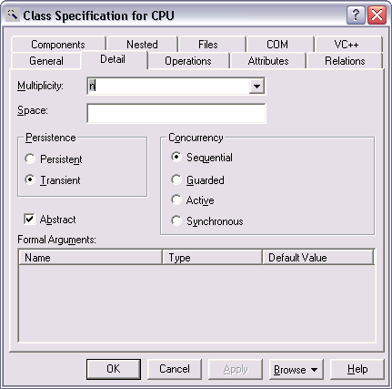

Note however, this is only a UML notation. For a class to be abstract in C++ it must still contain at least one pure virtual function. To create a pure virtual function, open the specification for your class, and on the operations tabs select or create a member function for the class, (see below for the example member function CPU::GetClockSpeed())

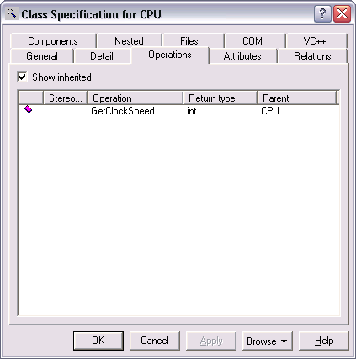
Double click on the function, and in the stereotype entry, select abstract. (There are many others here, including virtual, const etc.)

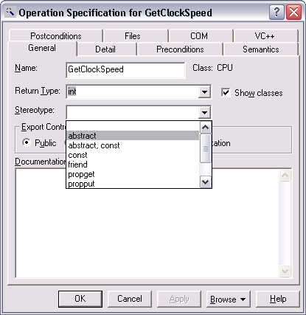

The code that will now be generated for the GetClockSpeed() function will now look like this, where the ‘virtual’ and ‘=0’ specifier have been included

class CPU
{
public:
virtual int GetClockSpeed() = 0; // pure virtual function

};

Note you only get the option to set ‘abstract’ for a class function provided that you assigned the class to a C++ project (see later section on code generation). If you haven’t done this yet, you will not see the ‘abstract’ option appear in the above dialog box/

Abstract Classes, Pure Virtuals and Interface Classes

When a class contains only pure virtual functions, i.e. no data and only pure virtual functions, it is said to be an interface. Java has a special ‘interface’ class to represent this concept but C++ does not and you have to enforce it yourself although it’s simple enough.

Interfaces are important because they provide a useful base class for other classes that conform to the same interface i.e. same member functions taking the same arguments and returning the same results, but which provide their own implementation of those functions through inheritance.

This is important because it allows designers to ‘program to the classes interface’ without regard for the means by which concrete classes will actually carry out that operation. This is known as design by contract. In essence the interface class represents a black box, i.e. one whose external interface is the only thing known to the programmer. It’s implementation is not yet defined. The process of inheritance can then be used to provide an implementation specifically for each and every kind of class derived from the interface.

This makes a lot of sense when you think about it. For example, all IDE disk drives provide the same internal interface to the IDE Controller, both electrical, mechanical and command set. But each IDE disk provides its own implementation or realization of that interface. The same with Cars, they provide a common well understood interface for drivers like you or I, but Vauxhalls and Ford have their own implementations of that standards in the form of the Astra and Focus.

The significance of this cannot be under-estimated. Once an interface is defined, developers can then write their code based upon the existence of that interface and provided concrete example of objects faithfully implement that interface, new derived classes should always work with the developers code

Expressing Interfaces in UML

Another good example of an interface is an operating system device driver, which provides a well-understood external interface for an operating system to drive.

In essence the interface provides a guarantee of particular behaviour to a client (the operating system) that makes use of it, without stating exactly how that interface will be realised. Specific device drivers can then be written by inheriting from the interface and providing the implementations, i.e. the means by which that functionality is carried out.

An example of this is shown below, where an operating system client is shown which has been designed to work with a well defined graphical interface (the GraphicsDriver class) which provides guaranteed facilities for manipulating and drawing graphical objects. The concrete classes (or servers) are the Windows and Motif classes, which realize that interface.

Using this approach, the operating system does not need to know whether it is talking to a Windows or Motif driver, both should work without modifications to the operating system code.

