Class Responsibility Collaboration (CRC) Cards

Although it is relatively easy to identify many of the objects that will eventually exist within our system, and even identify the classes that will eventually represent them, one of the major difficulties facing developers is trying to identify how those classes/objects collaborate with each other to realize or implement a ‘use-case’.

We already know that ‘use-cases’ tell us what needs to be done, but our identified objects represent, initially at least, a set of unconnected building blocks without form or structure. It is that structure which we seek to uncover, so that we can identify which objects do what (their responsibilities) and who with (their collaborations).

The technique of using CRC cards has proven particularly useful during early analysis as an attempt to identify such responsibilities and collaborations. Ward Cunningham and Kent Beck were two of the first proponents of the CRC card, (see their paper at http://c2.com/doc/oopsla89/paper.html).

The technique sounds simple enough. Take a piece of 6” by 4”cardboard for each object/class and attempt to identify and document in high level terms, what the object does and who it collaborated with, i.e. what messages does it send to other objects to realize this responsibility. An example CRC card is shown below, but written in human terms rather than computer object terms.

Name: Purchasing Dept

Responsibilities Collaborations
Raise Order Finance Dept
Purchasing Manager
Accept Goods Stores
Deal with Invoice Finance Dept
Financial Director

The responsibilities come directly and indirectly from the Use-cases, while the collaborations represent identified objects.
An except from Cunningham and Beck’s Paper on CRC is given below as a guide to using the technique effectively.

“We suggest driving a design toward completion with the aid of execution scenarios. We start with only one or two obvious cards and start playing "what-if" games. If the situation calls for a responsibility not already covered by one of the objects we either add the responsibility to one of the objects, or create a new object to address that responsibility. If one of the objects becomes too cluttered during this process we copy the information on its card to a new card, searching for more concise and powerful ways of saying what the object does. If it is not possible to shrink the information further, but the object is still too complex, we create a new object to assume some of the responsibilities.

We encourage learners to pick up the card whose role they are assuming while "executing" a scenario. It is not unusual to see a designer with a card in each hand, waving them about, making a strong identification with the objects while describing their collaboration.

We stress the importance of creating objects not to meet mythical future needs, but only under the demands of the moment. This ensures that a design contains only as much information as the designer has directly experienced, and avoids premature complexity. Working in teams helps here because a concerned designer can influence team members by suggesting scenarios aimed specifically at suspected weaknesses or omissions.”

Once a number of object responsibilities have been identified and we have walked through the use-case scenarios to make sure that we can realize the use-case via collaborations of objects, we can take the responsibilities of those objects and make a preliminary stab at creating the classes, member functions and attributes to represent them.

Identifying Class Structure

The next stage in analysis is to identify classes that define their behaviour and attributes and from which actual objects can then be created (or instantiated).

One of the most important aspects of class analysis is attempting to identify commonality within objects, in terms of their structure and/or behaviour. This allows us to build class hierarchies or ‘Kind-of’ relationships and, through the process of inheritance, re-use are much common code as possible.

In the elevator case study, for example, there are eight separate elevators, all the same, with identical behaviour and identical attributes. Common sense dictates that we need only design one class to encapsulate these features and all eight elevator objects could be created as instances of that class. For example

class Elevator { // an elevator class
public: behaviour functions;
private: attributes;
} ;

Elevator theElevators[8] ; // an array of 8 elevator objects

Similarly, there are lots of buttons, but they all appear to be structurally identical. Each is activated by depression, acknowledges with a backlight, and so forth. However, although these buttons have much in common, some of them differ slightly in their behaviour. For example

- Floor request buttons request a destination for that specific elevator.
- Elevator request buttons request any elevator to come to the floor and take passengers in a specific direction.

Given that these buttons have so much in common, it would useful to try to re-use that commonality and express it within a ‘Button’ base-class. Derived classes could then be created that override or include additional behaviour or attributes inherited from the base class.
In other words, we are attempting to group related objects into a class hierarchy with the root class containing all things common to a button. For example.

class Button { // base class for all buttons
public: common behaviour functions
private: common attributes
} ;

class FloorRequestButton : public Button { // derived class
public: New of modified functions
private: New attributes
} ;

class ElevatorRequestButton : public Button { // derived class
public: New of modified functions
private: New attributes
} ;

Class Diagrams

Class diagrams are the most important diagrams in object-oriented analysis and design. They represent an attempt to realize the physical structure of a use-case via a set of collaborating objects thus a class diagram should be associated with a particular use-case realization. We’ll come back to this later. Class Diagrams represent the structure of a system in terms of collaborating classes and objects. An example is shown below.

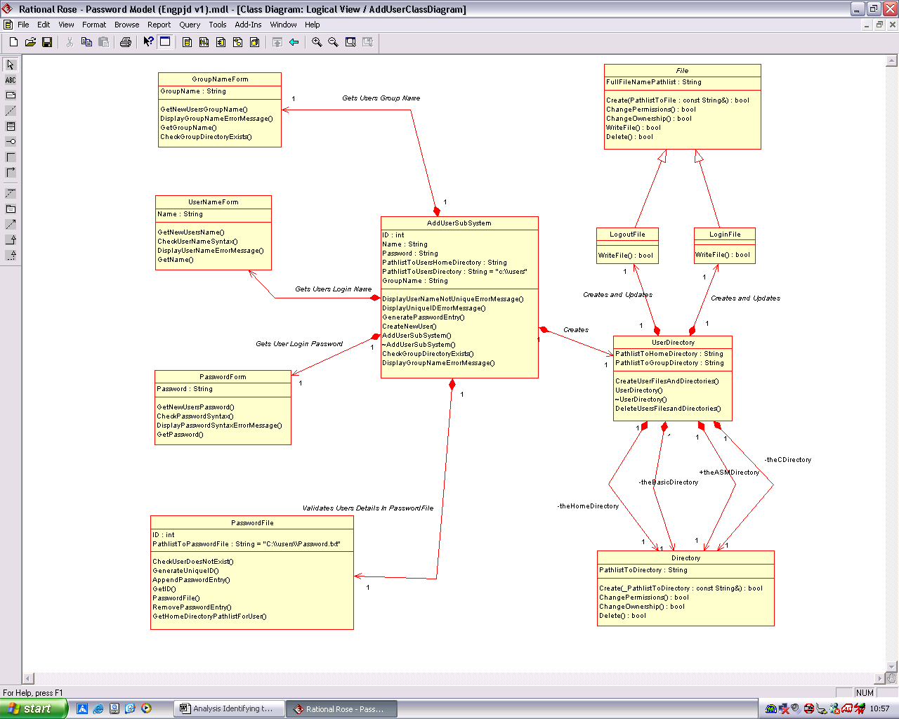

The most important components shown on a class diagram are the classes themselves and their relationship to other classes. An example of a UML class is shown below. It is split into three compartments: Class Name, Attributes and Functions

The attributes record the data held internally by the class (and thus by all objects instantiated from this class) while the functions define the behaviour of those objects. Both attributes and functions can be public, private or protected (Note: an icon is usually placed next to each attribute to indicate this, or alternatively, +, - and ‘#’ can be used in place of the icon).

Creating a Class Diagram

Classes can be created in Rational Rose by adding new classes to a class diagram as shown below. Right mouse click on ‘Logical View’ in the browser, select New->Class Diagram, then name the class diagram, ‘ClassDiagram1’ or some such suitable name. Note that by default there is already a class diagram that has been created for you called ‘Main’, you can use that if required and/or create others to capture your class relationships (see below)

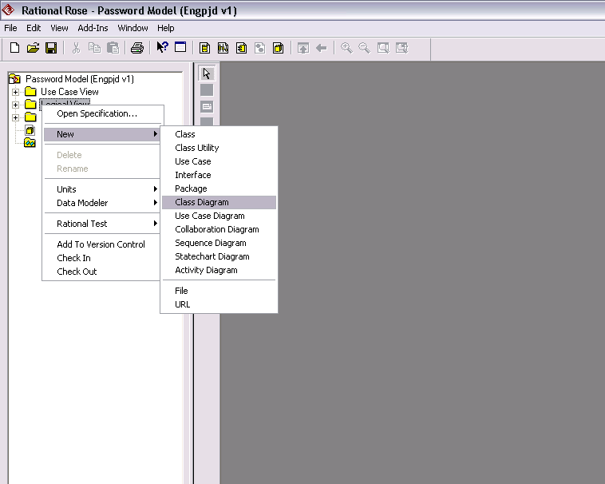

Associating a Class Diagram with a Use Case.

As stated earlier, the design of a system is driven by the need to realize use-cases. Remember use-case analysis is the first stage in any design and attempts to capture the requirements of a system from the point of view of the actors who use it. A class diagram then is an attempt to design a system of co-operating classes whose combined functionality will realize one or more use-cases. If you already have a use-case, then you can associate a class diagram with it in one of two ways.

- Either drag an existing class diagram that you created earlier and drop it on top of one of your use-cases in the logical view.

The example below shows a logical view with three use cases. In the case of the Withdraw Cash Use-case, an existing, or perhaps at this stage a new or empty class diagram has been dragged to it

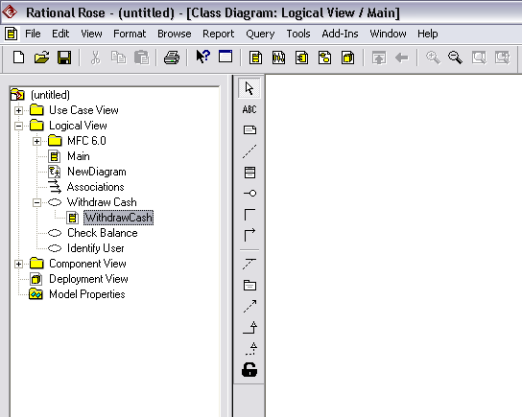

- You can right mouse click on the use case for which a class diagram is being created and select New from the pop-up menu (see Below)

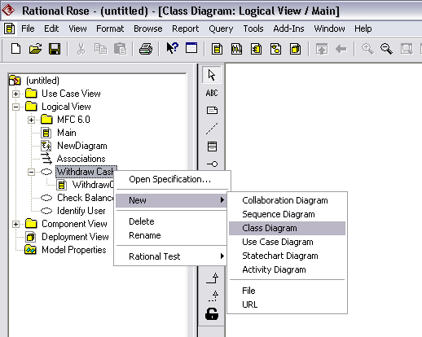

Creating Classes on your Class Diagrams

To create a new class, open the new diagram by double clicking on it in the browser and, using the tool bar, select the class button and then click on your class diagram. See below.

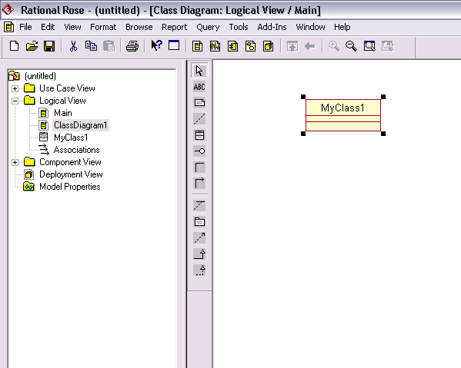

In this instance the new class is called MyClass1. Notice how it appears in the browser. Initially at least, there are no member attributes of functions for the new class.

Once your class has been created, you can play around with its design and its appearance on the class diagram in one of two ways

- By right clicking on the class, a pop up menu appears giving you access to most of the frequently accessed features (see below). Notice the options to include new attributes and new operations, and also the options menu to allow you control over which parts of the class design appear in the diagram (e.g. don’t show attributes, functions etc.)

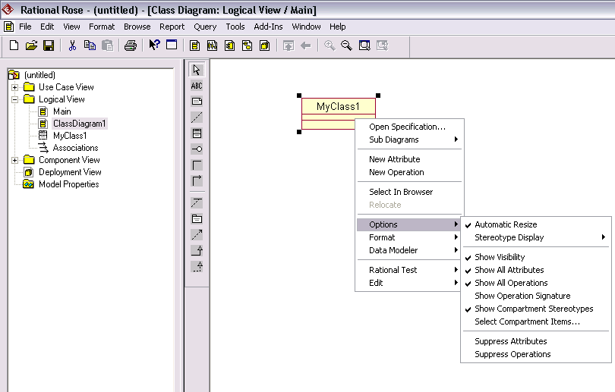

- By double clicking on the class, you open its specification. You should get a more detailed tabbed dialog box (see below). Don’t be intimidated by the detail here. A lot of it is optional or advanced stuff. Notice you can document your class here as well as control its export i.e. is the class available (public) to other components outside the source file where the class will reside (note this has no meaning in C++, but does in Java).

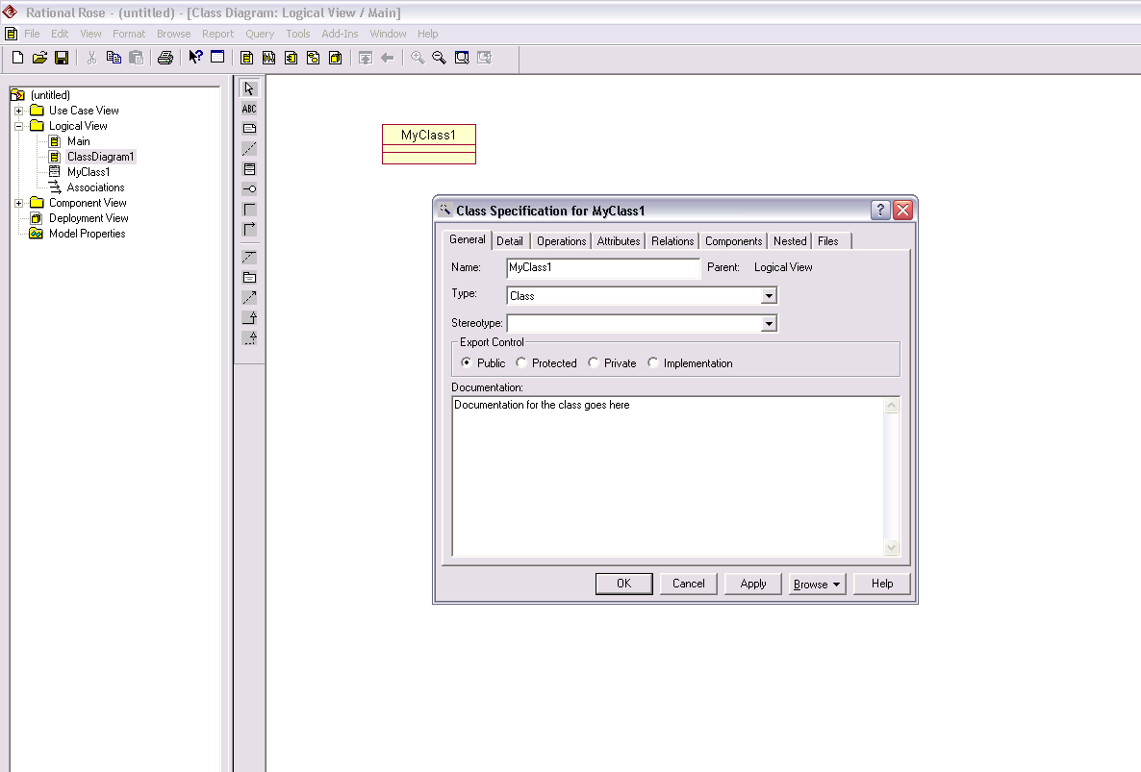

Creating a new Attribute

Open the specification for the class as above and click the attributes tab, then right click in the list box and select insert, as shown below.

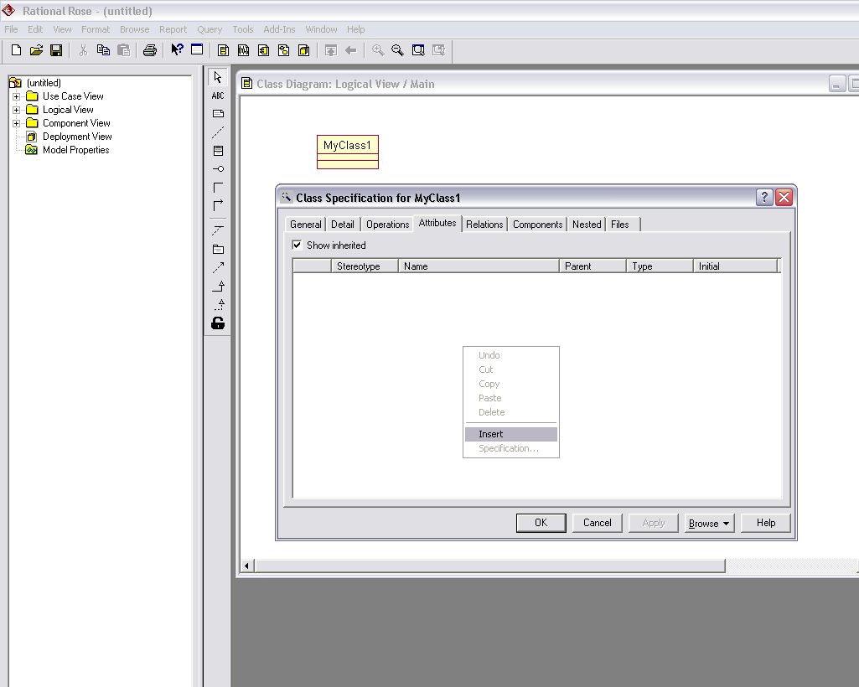

Type in a name for the new attribute. The dialog box below shows what it might look like after 3 entries have been inserted. To delete it, just right click on the attribute and select delete.

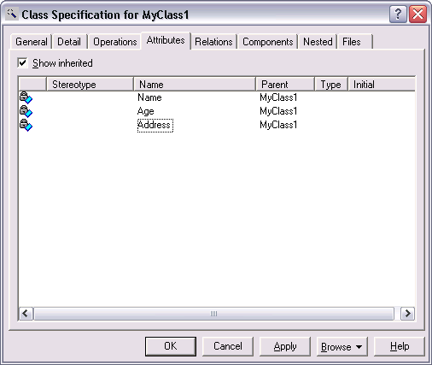

This method only allows us to create named attributes; the type of the attribute has yet to be set. This can be done by double clicking on the attribute in the above dialogue box and entering the details in the new pop-up dialog box, as shown below, where the type of the attribute has been set to ‘string’ (you could of course have specified any built in C++ type, e.g. ‘float’, ‘int’ or any user created class name).

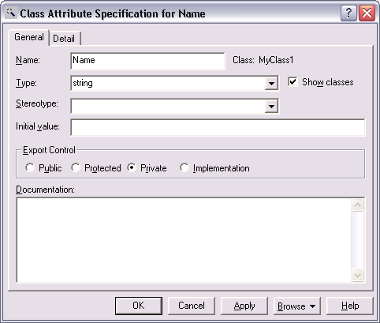

Notice you also get to control the access of the attribute here (public, private, protected). You can also document the attribute if required, i.e. what is its purpose.

Creating a new Member Function

This is similar to adding a new attribute, i.e. either

- Right mouse click the class and select new operation, (see below)

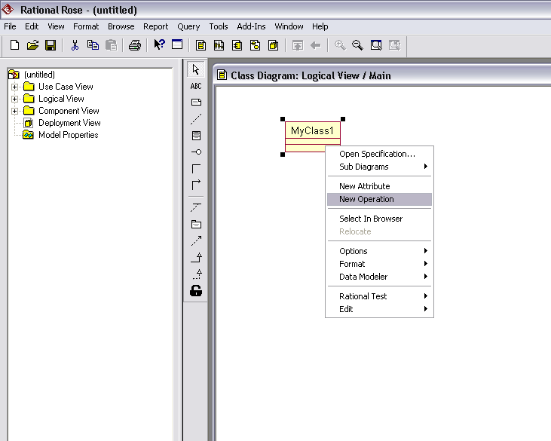

- Or, double mouse click the class and open its specification. Select the Operations tab in the dialog box, then right mouse click in the list box and select ‘insert’ (see below).

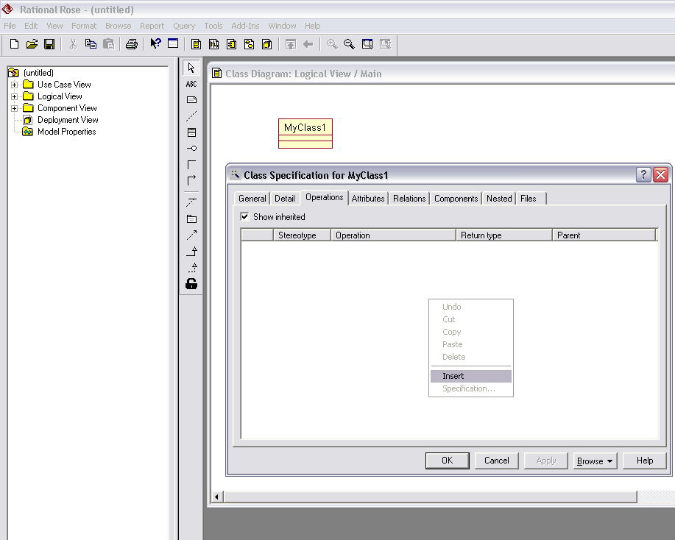

Setting the functions return type and argument list

Double mouse click the class to open the specification and then select the operations tab, as we did previously.

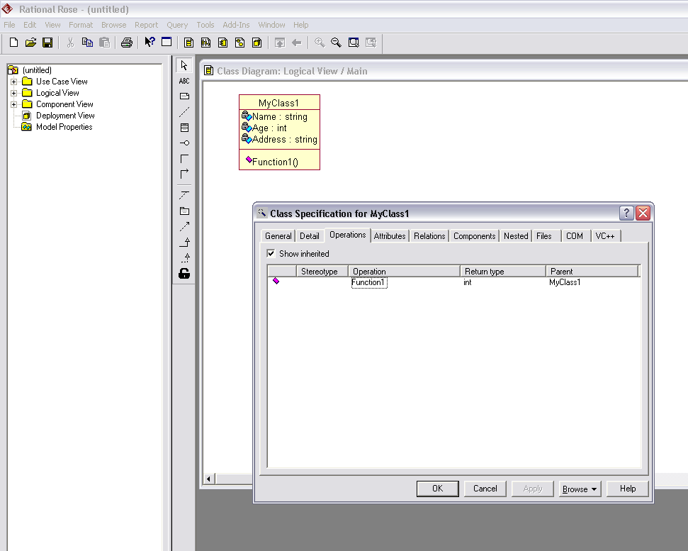

To set the argument list and return type for any function, double click that function. A new pop-up dialog box appears (see below). With the General tab selected, enter the return type, access and documentation

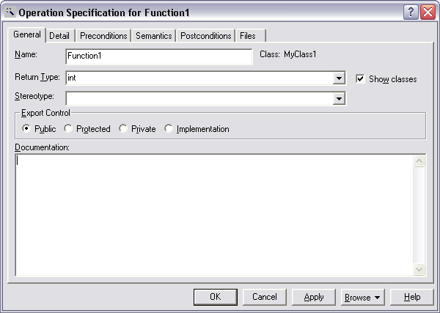

Now click on the ‘Detail’ tab in the pop-up dialog box. Right click in the list box of the dialog box to insert however many arguments you expect the function to take (see below). You may also set the type of each argument (be careful to select or create a type which is recognized by your language e.g. ‘int’ instead of ‘Integer’ etc, and, for those languages such as C++ that support default arguments, you may optionally set a default value for each of the functions argument.

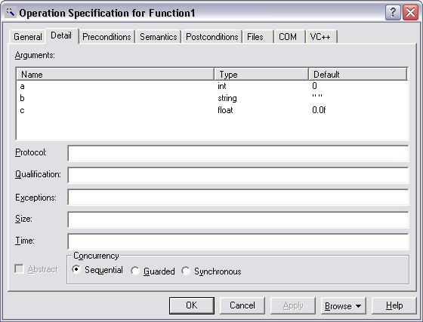

Note you can also double click on each argument to set its details as shown below for argument ‘a’

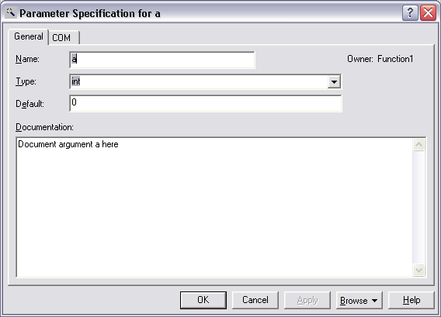

When you have completed, close the dialog boxes and return to the class diagram, right click on the class and if required, you can select the ‘options->show operation signature’ menu as shown below.

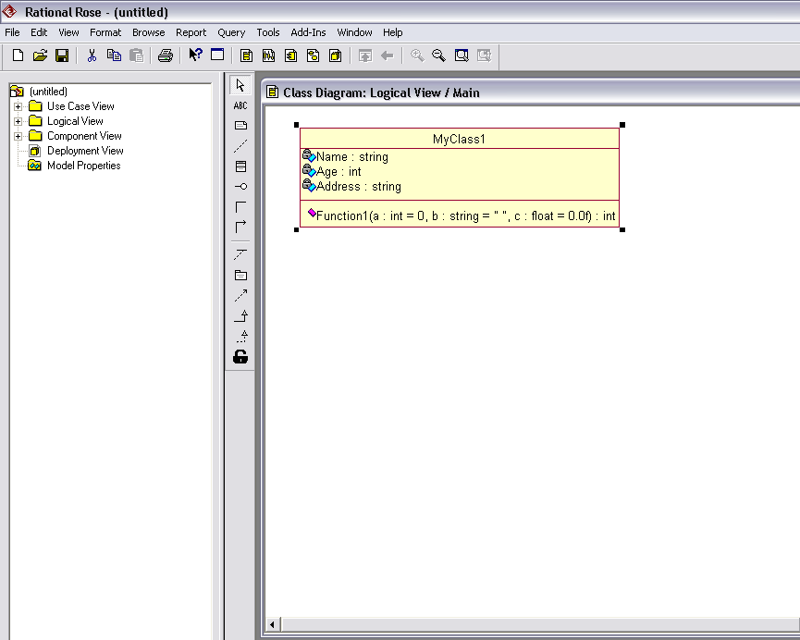

If code for the above class were now generated, it would look like this

class MyClass1
{
private:
string Name;
int Age;
string Address;

public:
int Function1(int a = 0, string b = " ", float c = 0.0f);

};

The Visual C++ Class Wizard.

You can use a wizard if required to guide you through the steps of creating new classes and adding attributes and member functions. To select this feature, choose Tools->Visual C++->Class Wizard. (see below). Just follow the steps and prompts to create whatever class you require
