The Object Discovery Process

In the last section we discovered how use cases and context diagrams provided an initial starting point for object-oriented analysis. During that process we were attempting to discover the functionality the system will provide to its users by uncovering typical ‘user-interactions’ or transactions that exist between user and system. As we saw, for each major use-case, there were a number of scenarios or alternatives that could be played out during the execution of that use-case.

The purpose of Object Oriented Analysis (OOA) as opposed to Object Oriented Design (OOD) and Programming (OOP) is to generate a structural model of the system that can be given to the developer to build. Such a model should include:

- The objects from which the system will be composed of. That is, in just the same way that a car is constructed from engine, gearbox, wheels etc. and a computer is constructed from CPU, memory, disk etc a system is composed of objects collaborating with each other through the process of message passing to achieve a higher order goal.
- The classes that represent the attributes/characteristics, (e.g. the speed of our CPU, the size of its cache, the number of valves and cylinders in an engine) and the functionality/interfaces (e.g. what operations can be performed on that object? What can the object do?) that is, the class model of the system.
- The relationships that exist between objects and classes. For example, how many ‘gearboxes’ are there for each ‘engine’ or how many engines are required to make a car?

This structural model will be complemented by the behavioral model, which attempts to model the dynamic behavior of interesting objects within the system, i.e. their state, and can be captured/modeled using state transition diagrams or state charts.

In essence the dynamic behavior of an object shows how it responds to events and messages that are sent to it and thus how it will respond in the future. i.e. it models the time-dependent behavior of an object.

Generating the Analysis Models

The diagram below illustrates the typical stages involved in generating the OOA models discussed previously. The order in which these stages are performed is not particularly significant. This is because OOA is a process of discovery that proceeds as much by free association as by any sequential processes. Performing the steps in a different order may be better for some problems or some analysts. For example, it may sometimes be more profitable to first identify the object behaviors and then the class relationships rather than the other way around.

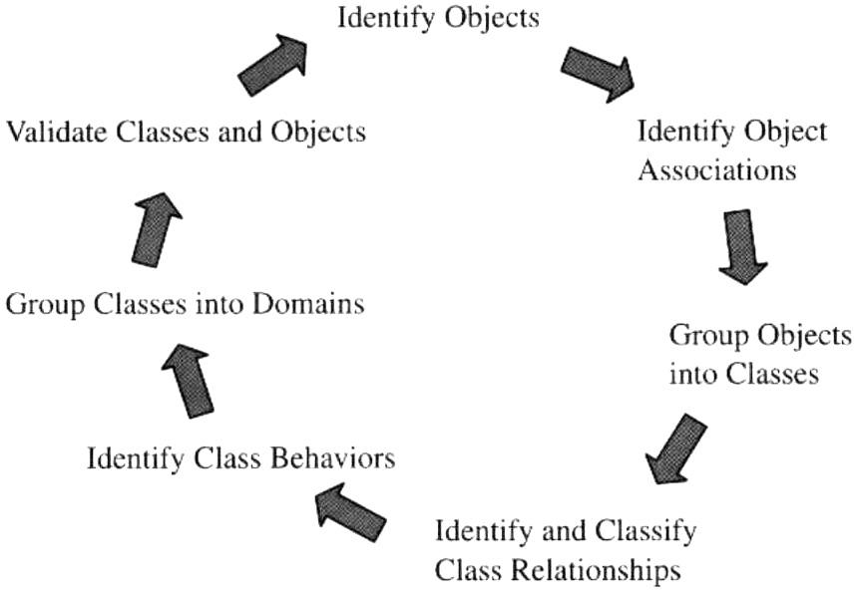

Connecting the Object Model with the Use Case Model

In the following section, we will present a number of strategies for identifying the objects and, subsequently, the classes inherent in a system. However, it is important to realize at this stage, that any object model you create has to be based closely upon the preceding use case model for the following reason.
“The use case model captures the essential user-interaction and functional requirements of the system, that is, it represents a statement of systems objectives and operation. Attempting to build an unrelated object model amounts simply to building the wrong model !!.”

Realizing Use-Cases

Within the use-case model, we have previously identified a number of use-cases (along with their alternative scenarios), each of which will need to be implemented by code in some way.

In UML terminology, each use case is physically implemented or “realized” by a collection of objects “collaborating”, or working together by sending each other messages to implement the higher order functionality identified by that use-case. Our job during OOA then, is to identify the objects that we need and delegate responsibility to them for implementing some aspect of a use-case.
As a model element, this collaboration of objects representing a use-case realization is represented as an oval, similar to a use case, but with a dashed line (see below). It usually has the same name as the use-case itself. Here we see a number of objects, devices, users and their relationships to each other. Each of these will collaborate (in ways that are not shown on this diagram) to implement or realize the use-case.

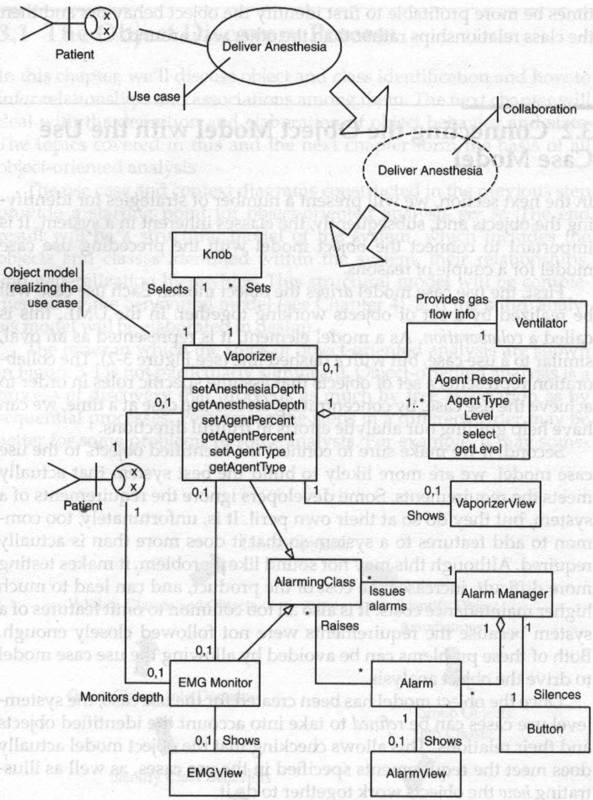

Key Strategies for Object Identification

This section introduces a number of proven techniques for identifying the objects we need to realize our use-cases. The best approach involves selecting three or four of these techniques and applying them to a project. As with all modeling strategies use those that work well for you and discard the ones that do not or are not appropriate. Note that these techniques do overlap to a significant degree, meaning that two or more strategies often uncover exactly the same set of objects.

Technique 1: Underline the Nouns

The first strategy works directly with the written problem or mission statement that has been documented in the use-case model and is one of the most powerful and simple to apply techniques. It starts with the analyst studying the written specification of each use-case/scenario and identifying within it, nouns or noun phrases, each of which is treated as a potential object. Objects identified in this way can usually be put into four categories.

- Objects of interest. These are highly relevant and need to be modeled as objects within our system. For example, Invoice, Receipt, Data Sample, book,
- Actors, i.e. users outside the system that initiate or participate in a use-case and do not need to be modeled by software
- Uninteresting objects, these can be discarded as outside the scope of the software e.g. rope, spark plug lead, desk
- Attributes of objects i.e. not objects themselves, but data stored within an object e.g. name, age, height, clock speed, baud rate etc.

The point of the exercise is clearly to find objects of interest. Actors have usually already been identified in the use case model and uninteresting objects are objects that have no direct relevance to your system.

Attributes e.g. name, date, colour etc. can also show up as nouns and most of the time it is obvious that these should be represented by data within an object rather than an object itself, particularly when you consider that a simple int or float is all that might be required to represent it, or when it has no ‘behaviour’ of significant interest.

However, when in doubt, tentatively classify the noun as an object. If subsequent analysis shows the object is sufficiently interesting, it can then be included as an object in its own right, with data and interface functions to manipulate it.

Technique 1: Underline the Nouns – A Case Study

An elevator is a real-time system familiar to everyone. Below is a problem statement for an elevator system with the noun phrases in italics.

A software system must control a set of 8 Acme elevators for a building with 20 floors. Each elevator contains a set of buttons, each corresponding to a desired floor. These are called floor request buttons, because they indicate a request to go to a specific floor. Each elevator, as well, has a current floor indicator above the door. Each floor has two buttons for requesting elevators, called elevator request buttons, because they request an elevator.

Each floor has a sliding door for each shaft arranged so that two door halves meet in the center when closed. When the elevator arrives at the floor, the door opens at the same time the door on the elevator opens. The floor does have both pressure and optical sensors to prevent closing when an obstacle is between the two door halves. If either sensor detects an obstruction, the door shall open. The door shall automatically close after a timeout period of five seconds after the door opens. The detection of an obstruction shall restart the door closure time after an obstruction is removed. There is a speaker on each floor that "pings" in response to the arrival of an elevator.

On each floor (except the highest and lowest), there is an elevator UP request and an elevator DOWN request button. On each floor, above each elevator door, there is an indicator that specifies the floor the elevator is currently at and another indicator for its current direction. The system shall respond to an elevator request by sending the nearest elevator that is either idle or already going in the requested direction.

If no elevators are currently available, the request shall pend until an elevator meets the above criterion. Once pressed, the request buttons are backlit to indicate that a request is pending. Pressing an elevator request button when a request for that direction is already pending shall have no effect. When an elevator arrives to handle the request, the backlight shall be removed. If the button is pressed when an elevator is on the floor to handle the request (that is, it is already going in the selected direction), then the door shall stop closing and the door closure timer shall be reset.

To enhance safety, a cable tension sensor monitors the tension on the cable that controls the elevator. In the event of a failure in which the measured tension falls below a critical value, then four external locking clamps connected to running tracks in the shaft stop the elevator and hold it in place.

Many of these identified nouns are clearly redundant references to the same object. Others are not of interest. The elevator cable, for example, is not nearly as interesting to the safety system as the cable tension sensor. Likewise, the passengers (clearly actors) are not as interesting as the buttons they push and the indicators they read, which are likely to be inside the scope of the system under development. Other objects clearly need not be modeled at all.

A list can be constructed from the underlined noun phrases of the likely candidate objects along with a few probable attributes of some of these objects, you can see that this strategy quickly identified many objects but also identified nouns that are clearly not interesting to the analyst.

system (1) floor (20) floor request buttons (8*20)
building (1) current floor elevator door
door (20+8 + 8) elevator control panel switch
pressure sensor door half elevator (8)
request button elevator request
button (20+2) optical sensor speaker
indicator (8) obstruction UP button
DOWN button floor door electrical power source
internal door set Open button Close button
alarm central station elevator request
door closure timer electrical power emergency locks
telephone elevator occupants alarm area tracks
message mechanical locking clamp
Once objects have been uncovered, we can consider their attributes, i.e. their status, data etc that make them unique, some examples are shown below.

Object | Attribute
Elevator | Direction, Status, Location
Button | Backlight
Alarm | Status
Cable Tension Sensor | Cable Tension, Critical Value

Technique 2: Identify the Active Objects
Once the potential objects are identified, look for the most behaviorally active ones as these will eventually become active objects i.e. objects that run concurrently with other objects (i.e. in parallel) with each having it’s own thread. Some of the most behaviorally active objects from the lift are listed below.

- Elevator
- Door
- Button
- Request
- Indicator
- Cable tension sensor

Technique 3: Identify the Passive Objects

Passive objects are less obvious than active objects. A simple switch is a passive object. It provides a service to the active objects (it turns the light on or off upon request), but it does not initiate actions by itself.

Simple sensors are passive data objects. An A/D converter might acquire data on command and return it to an actor, or as the result of an event initiated by an active object. Printers and chart recorders are common passive service providers as they print text and graphics on command. Examples of passive objects in the lift include,

- Pressure sensor
- Speaker
- Indicator(s)
- Floor door
- Alarm
- Emergency locks

Technique 4: Identify the Real-World Items

Object-oriented systems often need to model the information or behavior of real-world objects, even though they are not part of the system as such. A bank account system for example must clearly model the relevant properties of customers, even though customers are clearly outside the accounting system.

These objects are important because they usually represent data or information objects that are passed around the system from one object to another. A typical customer object will contain attributes such as:

- Name
- Social Security number
- Address
- Phone number

An Account Transaction object might record such things as

- Date and time of transaction
- Debit or credit
- Amount

A waveform object might represent a sample taken from an A/D converter and might record such things as

- A table of sampled values
- Number of Samples
- Frequency of sampling

A lift request object might record such things as

- Floor Number
- Direction
- Internal or external request

In other words, identify the objects using the terminology of the domain expert.

Technique 5: Identify Physical Devices

Real-time systems interact with their environment using sensors and actuators. These devices, in turn, communicate through other devices, which interface these sensors and actuators to the software. For example, A/D converters are often used to sample continuous data streams from pressure and temperature sensors. Digital I/O ports can be used to control single bit devices such as switches, relays or when monitoring the state of simple on/off switch.

These sensors and actuators can be modeled using objects, which encapsulate the complete behavior of both the sensor/actuator and the device with which it interfaces. For example, an object could exist whose purpose is to obtain a temperature reading. This object, could provide the following functionality:

- Upon creation, initialize the A/D through which it communicates with the sensor, provide a power-on check and calibrate the sensor.
- When asked, samples a temperature reading from the sensor and returns it to the caller.

The object itself could record the following attributes:
- Address of the A/D chip in the systems memory map.
- Size of sample produced by the A/D.
- Number of channels in the A/D.
- Most recent sample.

The complete functionality of the device/interface is therefore encapsulated within the object itself making it easy and transparent to use in much the same way that a device driver does for an operating system. In other words identify objects that can provide a simple well-defined interface between program and I/O device.

Technique 6: Identify Transaction Objects

Transactions occur whenever one or more objects interact or collaborate to achieve some predetermined goal or operation, e.g. realize a use-case. Such collaborations often give rise to transaction objects, which are generally just data objects that persist for a finite period of time and represent the result of the interactions or transaction between those objects.

For example, a Data Acquisition System might collaborate with a Temperature Sensing object in order to obtain a Temperature Reading. This Temperature Reading represents the result of the transaction between the two objects and although it only contains data, it should be encapsulated into an object, which provides the functionality/interfaces to enable other objects to access that data.

Such objects can then freely be passed around the system during message passing in much the same way that ‘int’ and ‘float’ type arguments can be passed between functions in ‘C’. Some example transactions and resultant transaction objects are outlined below.

Object1 | Object2 | Transaction | Transaction Object
Customer | Bank | Withdraw Money | Account Transaction  · Time and Date  · Value of Transaction  · Account details
Request button | Lift controller | Place Request | Floor Request  · Floor Number  · Request Type
System | Temperature sensor | Get Sample | Temperature sample  · Value  · Date and time
Woman | Man | Get Marriage | Marriage Details  · Wedding date  · Wedding location  · Prenuptial agreement  · Witnesses

Technique 7: Identify Persistent Data

Persistent Data represents information whose life often exceeds that of the system itself, and as such will need to be saved/stored somewhere, so that it can be recovered in the future.

In information systems, the most common type of storage medium for persistent data is a data base where records (i.e. objects representing persistent data) are stored to disk before the system is shut down, and can be accessed again the following day when power is re-applied.

In real-time system, persistent data is often stored in volatile memory (RAM or SRAM) or long-term storage such as Battery Backed CMOS Ram, Flash Eprom or E²PROM although disks too can be used where the operating environment is not too harsh.

Persistent data can be represented by objects, which encapsulate their data and provide the necessary interfaces to allow access or modifications to be made to it.

In some ways persistent objects are similar to transaction objects in that they almost always arise as a result of a collaboration between two objects, however the lifetime of persistent objects could be infinite, whereas transaction objects often have a momentary life.

Exercise: Think about persistent information recorded about you by the Inland Revenue, the NHS, your University, your local council and think about how this information is generated and stored.

In a Data acquisition system, think about what system information might be regarded as persistent.

Now think about you might create objects to represent this data and what interfaces you may need to access and/or manipulate it.

Technique 8: Identify Visual Elements

Many real-time and information systems interact directly or indirectly with human users through human interaction devices. In a Real-time system, such devices may range from a simple on/off LED to indicate status or error information, to full blown Windows-like GUI with Dialog Boxes, buttons, windows, scroll bars, icons, and text.

Each of these visual objects, particularly dialog boxes, should be represented by objects that encapsulate the storage and functionality required for it to work. For example, consider the following Word 2000 dialog box.
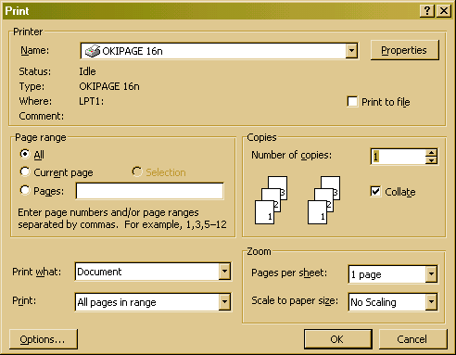

This dialog box is represented by an object that encapsulates a number of other visual objects (buttons, edit boxes etc) and ultimately captures the whole user interaction process. For example the ‘form or dialog’ object above has data members to record

- name of the default printer,
- number of copies to print,
- print range,
- zoom etc.

It also encapsulates the following functionality

- Display and closure (via OK and Cancel) of the dialog box,
- Deal with user interaction, such as changing the number of copies or printer,
- Retrieving the information entered by the user through the dialog control and transferring it to data members within the class.
- Provide interface functions to allow retrieval of the information entered by the users (whose life exceeds that of the visual aspect of the dialog box which disappears when the dialog box is closed).

As an analyst/designer, your task is to identify the visual/human interaction that takes place within the system, design the best method of achieving it and then encapsulate all of its operations and human interaction within an object.

Technique 9: Identify Control Elements

Control elements are objects that exists mostly to co-ordinate the actions and activities of other objects. A good example of this is a use-case controller.

Whenever we realize a use-case, it is implemented as a set of collaborating objects each of which has a well-defined role to play in achieving that use-case. However, objects need to know when to perform their processing and actions and the data objects arising from such processing (i.e. transaction objects) often need to saved before being passed to other objects.

Therefore, in order to fully realize a use-case, we would introduce a use-case controller to coordinate the actions of the objects identified as participating in its realization.

As another example, some objects, called composites, often orchestrate the behaviors of their component objects. These may be simple objects or may be elaborate control systems, such as:

- PID control loops
- Fuzzy logic inference engines
- Expert system inference engines
- Neural network simulators
Some control elements are physical interface devices that allow users to enter commands into the system. The elevator case study has only a few.

- Button (elevator and floor)
- Switch (elevator and floor)
- Keyboard (central station only)
- Mouse (central station only)

Identify Object Relationships/Associations

Early in the analysis, some of the identified objects clearly seem to relate to others in obvious ways. For example

- A request button is related to a lift. When the button is pressed, a message is sent from the button to the lift.
- Likewise, the floor indicator within the lift is also related to the lift. When the lift changes floor a message is sent from the lift to the display to indicate the current floor number.
These sorts of relationships or associations between objects are relatively easy to identify since the mirror the relationships that exist between physical real world objects, i.e. just by looking at a real lift these relationships are immediately apparent.

Exercise: See if you can identify some object relationships between components in
i) a car and ii) a computer.

Concentrate at this stage on two things,
i) Message passing i.e. what components/objects send messages to other components in the system.
ii)Ownership, i.e. which components ‘own’ or are part of others.

With other objects, the relationships are not so obvious, for example, what relationships exist (if any) between lift, floor request and cable tension sensor. One of the most important parts of OOA is to identify these relationships and capture them, since a relationship implies communication between objects, i.e. objects passing messages to each other.

A number of strategies exist to assist in the identification of object relationships, with each relying on the fact that communications takes place between them as shown below

Object Identification Strategies

Strategy | Description
Identify messages. | Each message implies an association between the participating objects. That is, if one object sends a message to another there must be an association or relationship between the objects.
Identify External event generators | Try to identify which object interact with the real world, e.g. push button in a lift, a throttle in a car etc. and ask yourself what are the messages generated by these objects and where to they go.
Identify whole/part structures | Try to identify which components form part of others in your system i.e. the ‘has a’ or ‘part of’ relationships. For example, an Engine and Gearbox are part of a car; a Motherboard has a CPU and memory etc.  Whole/part relationships are modeled using aggregation relationships among objects. Wholes often coordinate their parts by sending messages. For example a ‘reset’ to a motherboard would lead to reset messages propagating to the CPU, IDE Controller, Graphics card etc., which are part of the motherboard.
Apply scenarios | Walk through your use-case scenarios using your identified objects. See if you can trace the propagation of messages that ‘ripple’ through the system in response to an external event. Check that your objects and their associations realize the resulting functionality implied by the use case. If you find you ‘can’t get there from here’ then something is missing, either an intermediate object or an object association.

In our elevator example, there are a number of associations identifiable by the messages that pass between them. Some of these are shown in the table below.

Message Source | Message Target | Message
Elevator request button | Elevator Controller | Request an elevator
Elevator Controller | Elevator | Request status
Elevator Controller | Elevator | Add destination for elevator
Elevator | Elevator Controller | Accept destination
Elevator | Floor speaker | Arrival event beep
Elevator floor sensor | Elevator | Location
Cable tension sensor | Locking clamps | Engage
Central station | Locking clamps | Release
Cable tension sensor | Central station | Alarm condition
Elevator | Central station | Status
Floor request button | Elevator | Add destination
Run-Stop switch | Elevator | Stop/Run
Run-Stop switch | Central station | Stop/Run
Alarm button | Central station | Alarm condition
Elevator | Door | Open/Close

Class diagrams can be used to capture these associations or relationships between objects (an object is an instance of a class). A line drawn between two classes represents a link (instance of an association) between instances of those classes (i.e. objects) that supports the transmission of a message from one to the other.

Exercise: See if you can identify some whole/part relationships between

The components of a lift.

The components of a car.

The components of a PC.

Object Attributes

When discovering the objects that exist within your system, it is natural to ask what characteristics or state the object should record. In UML, and in Object oriented programming in general, such data is recorded by the attributes of an object. For example

- A sensor object might include attributes such as a calibration constant and a measured value.
- An engine might include the capacity of the cylinders, the number of valves, maximum revs etc.
- A CPU might record its clock speed and size of cache etc.
- A lift might record the status of its lift doors (open/closed)

Attributes such as these are almost always primitive and can be recorded with simple built in data types such as ‘int’s, ‘floats’ and ‘string’s and cannot productively be broken down into sub properties.

If you find attributes to be structurally non-primitive (i.e. complex objects that cannot be modeled by primitive types), then they should be modeled as objects owned by or aggregated into the main object rather than as simple data attributes of that main object. For example, if a sensor has a simple scalar calibration constant, then it would be appropriate to model it as an attribute of the sensor object.

Sometimes, the primary attributes of an object are obvious, but not always. Developers can ask themselves some key questions to identify the most important attributes of objects, such as:

- What information defines the object?
- Upon what information do the object's operations act?
- Take the object's viewpoint and ask yourself, "What do I know!"
- What are the responsibilities of the object? That is, what part or role does it play in implementing a use-case and thus what information is necessary to fulfill its role?

It is rare to find that all of an object’s attributes can be stated right at the outset of a design. New attributes will be included and existing ones deleted or changed as the object, system or use-case design evolves.

The Elevator class provides a good example of a real-time class with attributes. Let's ask these questions about this class.

- What information defines the object?

The Elevator is a physical thing that must be controlled. To fulfill its function, it must know where it is, where it is going (destination list), and its current direction.

- Upon what information do the object's operations act?

It has a goto() operation which must act on where it is, its current direction, and its state (moving, stopped, and so forth).

- Take the object's viewpoint and ask yourself, "What do I know?"

I know where I am, where I am going, and what I am doing right now.

- What are the responsibilities of the object? What information is necessary to fulfill these responsibilities?

The Elevator's primary responsibility is to transport passengers from one floor to another. It needs to record where it is, which direction it is traveling, a list of current destinations, and its current state.

(Exercise: Using the ideas presented above, attempt to identify attributes within a PC and a Car.)

