Introduction to UML

What is UML ?

UML or the Unified Modelling language is not a language in the same way that we view programming languages such as ‘C++’, Java or Basic. Rather, UML represents a collection of 8 essentially graphical (i.e. drawing) notations supplemented by textual descriptions designed to capture requirements and design alternatives. It is, to Object oriented systems what Yourdan is to Structured system

What are the 8 diagram types?

- Use Case Diagrams: A simple but very effective analysis technique for exploring typical user interactions with the system. That is, what information is fed into the system and what information comes out.
- Class Diagrams: A powerful tool for exploring and relationships between instances of classes in our system. Such relationship includes using, i.e. one class makes use of another, aggregation, i.e. one class ‘has’ another one as part of it and inheritance, i.e. one class ‘is’ a kind of another one.
- Sequence and collaboration diagrams: These model the interaction of objects (i.e instances of classes) within a system. They represent the passing of messages from one object to another in order to achieve some high level functionality; usually the functionality expressed in one or more use cases. In essence they model the behaviour of the system in response to inputs from the external world.
- State charts.
- Deployment diagrams.
- Package diagrams.
- Activity diagrams. Used during analysis to explore areas of parallelism or concurrency in the customer business model. Only useful in area of business where many processes or activities within the business are carried out in parallel, e.g. simultaneously raising an invoice while at the same time producing a delivery note and shipping the goods or order.

The Software Life Cycle

During the development of any complex software system, there are a number of steps that have to be taken in order to arrive at a successful conclusion. These steps are typified by the classic waterfall model shown below.

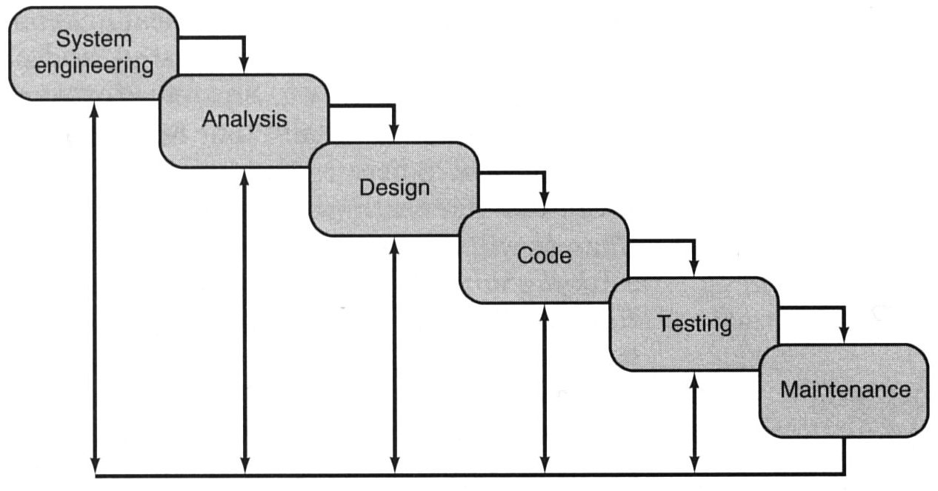

The illustration highlights the various phases of the classic life-cycle paradigm for software engineering. Sometimes called the "waterfall model," the life-cycle paradigm implies a systematic, sequential approach (rarely achieved in practice) to software development that begins at the system level and progresses through requirement analysis, more formal analysis, design, coding, testing and maintenance.

One of the major problems with this approach, and one of the primary reasons why some many large scale projects fail, is that the waterfall model assumes a once-only delivery of the finished project, that is, it assumes that you are attempting to build a monolithic monster of a program all in one go with all analysis being performed before all design before all coding and finally all testing.

Furthermore, it does address the element of ‘risk’, it assumes that all requirements are equally important and are tackled in the same way, in other words the process does not ask the user to prioritise requirements based upon the perceived risk involved in delivering them. Thus potentially high risk activities (e.g. interfacing the system to an unknown database, using unknown tools with staff that are not familiar with them) are not addressed early enough leading to slipping time scales and massive delays and problems towards the end of the project, just when they are not needed.

Spiral Model – An Alternative Model for Software Development

The spiral model for software engineering has been developed to encompass the best features of the classic life cycle, while at the same time adding a new element, risk analysis. The model, represented by the spiral below, defines four major activities represented by the four quadrants:

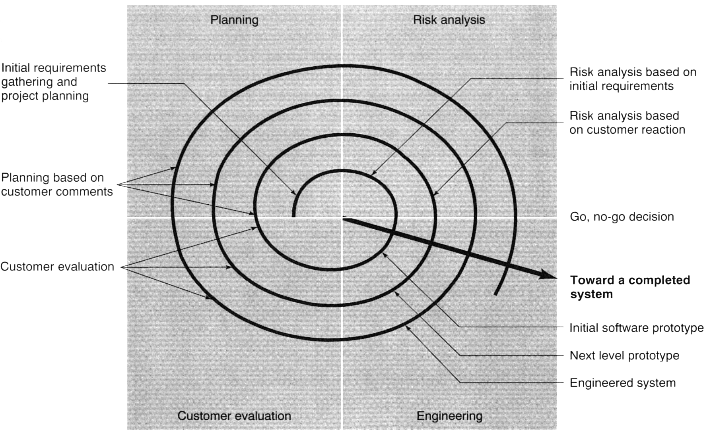

- Planning-- determination of objectives, alternatives and constraints
- Risk analysis--analysis of alternatives and identification/resolution of risks
- Engineering-- development of the "next-iteration/level" of the product
- Customer evaluation -- assessment of the results of engineering

With each iteration of the spiral (beginning at the center and working outward), progressively more complete versions of the software are built. In other words, the product is delivered not as one great monolithic monster, but as a series of iterative developments each of which delivers to the customer an executable program comprising progressively more functionality than the previous iteration. Thus each revolution of the model represents a complete iteration of the classic waterfall model.

The model can be explained as followed. During the first circuit around the spiral, objectives, alternatives, and constraints are defined and risks are identified and analysed. If risk analysis indicates that there is uncertainty in requirements, prototyping may be used in the engineering quadrant to assist both the developer and the customer. Simulations and other models may be used to further define the problem and refine requirements.

The customer evaluates the engineering work (the customer evaluation quadrant) and makes suggestions for modifications. Based on customer input, the next phase of planning and risk analysis occur. At each loop around the spiral, the culmination of risk analysis results in a "go, no-go" decision. If risks are too great, the project can be terminated.

Analysis and the Role of the Domain Expert

During the early stages of any project development, much of your time will be spent in the analysis phase, attempting to understand ‘what’ the system must do. That is, what functionality and behaviour it should provide for your customer.

Such analysis is often conducted in the presence of one or more ‘domain experts’, i.e. somebody who is intimately familiar with the business process or procedures that you are trying to automate (i.e. the problem domain) and can describe them to somebody else, often in a non-technical way. In simple terms, a domain expert is somebody who knows how to do the job before it has been automated.

For example an accountant, could be considered to be a domain expert in the sense that he/she knows intimately the procedures, forms, rules and regulations to be followed when dealing with the Inland Revenue. Likewise, Architects and Electricians are domain experts when it comes to obtaining advice on building and planning regulations and electrical installations.

In a much simpler vein, Mary sat at a supermarket checkout, or Fred assembling engines for Toyota are also domain experts since their experience makes them uniquely qualified to comment on the processes involved. In fact their experience makes them especially useful, since they may well have evolved new tips-and-techniques for ‘getting the job done’ that may only exist inside their head (as opposed to a procedures manual) as such, it is very important to get the domain expert working alongside you.

User Interaction Analysis – Use Cases

There are a number of different techniques that can be used to uncover this expertise or functionality, but one of the most powerful is to concentrate on user interactions that will take place within the system.

For example, consider the process of automating an antiquated library where all books, membership and loan details are stored on a card indexing system that is maintained manually.

The librarian behind the desk represents one particular kind of domain expert because he/she has expertise in the following processes and procedures that you might have been asked to automate.

- Checking out a book for loan.
- Checking in a returned book.
- Checking if a book is available and where to find it.
- Reserving a book that is currently out on loan.
- Dealing with payment of overdue fines.
- Adding new members to the library
- Deleting old members from the library
- Dealing with changes of members details e.g. name address etc.

Likewise a head librarian might handle the following processes and procedures and therefore the head librarian represents another instance of a domain expert but from a different perspective.

- Adding new copies of a book to the library.
- Deleting old copies of a book from the library.
- Issuing overdue letters.

Each of the above bulleted points represents, in UML terminolgy, a specific ‘Use-Case’. That is, it identifies a process or procedure, involving a user interaction with the system for a specified identifiable purpose (e.g. borrowing a book) and as such, each Use-Case involves a step-by-step sequence of operations or events that describe the interaction taking place and the measurable benefits each gets from the interaction are (i.e. what does the user get out of it and what changes takes place within the system).
For example, let’s consider one of the ‘Use-Cases’ above: Borrowing a book, and describe the step-by-step interaction that takes place between a user (the library member or person wishing to borrow the book) and the System (in this case the librarian with his/her card indexing system). A simple description of the overall objective of this use-case is given below.

Statement of Objective - Use-Case “Borrow Book”

The customer identifies himself or herself to the librarian and indicates which books they wish to borrow. If it is acceptable for them to borrow these books, i.e. they are not marked “for library use only”, or the number of books on loan to the customer is less than some predetermined maximum, then the books are loaned to the customer for a specified loan period and the customers loan record is updated to reflect the loaned books.

Of course once the overall objective of the use-case has been stated, one could elaborate on it in an attempt to analyse the interactions involved. Such analysis would generally be conducted in the presence of the domain expert and may well use the terminology and processes of the system “as-it-currently-implemented”. For example.

Detailed Description - Use-Case “Borrow Book”

Start-Of-Transaction/Use-Case
- The borrower/member identifies himself or herself to the librarian using their membership card.
- The borrower/member presents one or more books to the Librarian.
- The Librarian checks the membership card to make sure it is valid.
- The librarian looks up the member’s records in his/her card indexing system.
- Each book is stamped with the appropriate return date.
- Each book has its identifying card removed.
- The librarian updates the member’s loan details by placing all removed book identifying cards into that borrower/members record maintained by the library.
End-Of-Transaction/Use-Case

Exercise: See if you can describe overall objectives and details use-case descriptions for the other use cases associated with the library system..

Example 2. A Cash Dispenser.

As another example of use-case analysis, let’s attempt to identify the user interaction with a cash dispenser. In essence, this system (a completely automated system, as opposed to a manual one) provides the following functionality

- Request Cash
- Request Balance
- Request Statement
- Request Cheque book

Let’s take the ‘Request Cash’ use-case and identify the interaction that takes place between user (a person with an ID card wishing to borrow money) and the system (the cash dispenser). The overall statement of objective of this use-case might be

The user identifies themselves to the system and requests to withdraw an amount of cash. The bank checks to make sure their account would remain in credit after the withdrawal and if so, there are dispensed the cash and their account is debited accordingly.

Detailed Description - Use-case “Request Cash”

- The user inserts their ID card into the systems.
- The system reads the magnetic strip from the card.
- The system contacts the banks central computer to request the PIN number for the card and their account details.
- The system prompts the user for their PIN.
- The user enters their PIN.
- If PIN is authenticated, the user is prompted for the amount of the withdrawal. If not, the card is returned to the user.
- The user enters the amount of withdrawal.
- The system checks with the banks central computer to ensure that the user has sufficient funds to make the withdrawal.
- If there are sufficient funds, the cash is dispensed and the customer’s account at the Bank Central Computer is debited accordingly.
- The card is returned to the user and a receipt issued.

Exercise: See if you can describe the other use cases

Use Case Diagrams

Once the analysts and domain experts have uncovered the important use-cases and explored the interactions they involve, these use cases can be captured in UML using a ‘Use-Case Diagram’ such as the one below for the cash dispenser. You will notice that is very simple, involving just two symbols, a stick figure referred to as an ‘actor’, and a named oval representing each of the identified use-cases.

What is an Actor?

An actor represents an external entity outside of the domain of the system we are modelling. Most commonly these represent the people or users that interact with the system, but do not be mislead by the fact the symbol for an actor resembles a person; actors could in fact be hardware devices such as computers, disk drives, A/D converters, printers or whatever. In other words, a use-case diagram could be used to represent a context diagram showing the system software and the devices/people with which it interacts. In fact there may well be several actors shown on a use-case diagram.

What does the Oval represent?

The oval represents a unique use-case and therefore must interact with (and hence there must be a connection) to the actor that ‘uses’ it. In this case four uses case have been represented, interacting with a ‘Customer’ actor.

What about the bank central computer, should it be shown?

It depends upon your perspective. You might consider that the banks central computer, although a distinct piece of hardware, quite separate from the cash dispenser itself, is in fact ‘part of the overall system’ that services the customer and therefore does not need modelling separately.

On the other hand you might like to record the fact that a use case does in fact interact with this separate computer (and indeed a printer for issuing receipts etc) and thus you could represent your use-case diagram like this. Note a rectangle is sometimes drawn on a use-case diagram to delimit the system boundary although it’s purely optional.
Which one is the best? It depends. You might start off with the first diagram during preliminary analysis with the domain expert and gradually, as the systems operation unfolds and you move towards a more detailed design, it may evolve into the second or indeed vice versa.

However, if the process you are trying to model is currently a manual i.e. human activity that is to be automated, and then the domain expert might not appreciate the second diagram. So it’s a case of horses for courses, that is you might have different use-case diagrams depending upon whom you are showing them to.

Remember, a use case diagram is supposed to represent the functionality of the system “from a users perspective”, that is, from the perspective of somebody or something that initiates a transaction with the system and obtains value from it. Therefore it is important to identify who the principle actors are, i.e. those who initiate the use-case rather than those who are simply involved as a result of its use.

The only actor that meets that criterion is the customer since it is the customer that initiates each use-case and will receive identifiable value from it. The Bank Central Computer and printer may well be actors, but their role is essentially passive or collaborative and therefore you could argue that they should not appear on any first-cut analysis model.

Looked at in another way, the only reason for introducing actors into the scheme in the first place is to allow us to consider their interaction with the system and thus expose more use-cases. If an actor does not contribute to this process of discovery then perhaps it is not of interest during analysis and might be better left out.

What if the computer was a principle user?

Let’s suppose that there was another use-case that was of significance to our modelling, one whereby the bank central computer was responsible for initiating a request to the cash dispenser to download to it, details of all the transactions that had taken place that day.

Now our Bank Central computer might well have to be modelled since it is now responsible for initiating a transaction rather than simply taking part in one, and thus we might draw our use-case diagram as shown below, illustrating a new use case ‘Upload Transactions’ which can only be run or initiated by the Bank Central Computer. Likewise we could also imagine a new use case called ‘Diagnostic Check’ which is run by a new actor called Technician, which involves the use of the Bank Central Computer

Exercise: See if you can draw a Use-Case Diagram for the Manual library modelling system discussed earlier.

A Use case diagram looks so simple, why bother with it?

- Firstly it shows the BIG-PICTURE without getting bogged down in the details of design and implementation.
- Secondly, the customer can easily relate to a use-case diagram and identify the objectives of their business within it. This means that any major or miss-understood functionality required from the system is less likely to be overlooked during analysis

- From a developer point of view they can immediately assess the functionality required and assess the risk involved in implementing each use case. High-risk use-cases can be identified and resources and training allocated appropriately.

- Because software development follows an iterative approach, each new release of the software can be based around the implementation of one or more use-cases. Thus it is easy to identify what functionality is required with each new release. It fact the customer should be actively involved in the planning and release process by prioritising the use cases in terms of must-haves and nice-to-haves, thus they get to chose the functionality of each new release.

Use-Case Scenarios

When we talk about use-cases, we almost inevitably end up discussing the concept of scenarios. In essence, a scenario is a specific instance or usage of a use case that is played out between actor and system. What does this mean? Well take for example the cash dispenser use-case Request Cash. What could happen when a particular customer comes to make a withdrawal, i.e. they interact with the systems ‘Request-Cash’ use-case?

Well ideally, we would like the user to enter the correct PIN and have sufficient money in their account to make the requested withdrawal. This is certainly one particular scenario that could be played out between user and system and is probably the primary or most commonly acted out scenario for this use case.

However, it is easy to envisage a different scenario whereby the customer incorrectly enters their PIN number and the transaction would obviously be aborted. This is a different use-case scenario since the outcome is not the same as someone who interacts with the use-case and obtains money.

Put simply, you will probably have a scenario for every ‘what-if’ question that can be posed during analysis. For example

- What if the users PIN is incorrectly entered?
- What if the user has insufficient funds in their account?
- What if the cash dispenser cannot read the cards magnetic strip?
- What if the cash dispenser is out of money?
- What if the bank central computer is off-line?

Thus when any particular customer interacts with a use-case, he or she may find themselves taking part in one of perhaps many alternative scenarios that could be acted out under different circumstances. A scenario then is a particular run through or execution of a use-case.

Use-case scenarios are best explored between analysts and domain-expert. The important thing however, is they must be identified and catered for within each use-case. Scenarios play a key role in designing and testing use-cases since they are a key feature of the use-case’s functionality.

Documenting Scenarios in a Use Case

There are many ways to document each possible scenario in a use-case. The important thing obviously is to document all those ‘what-happens-when’ type situations, that could arise, so don’t get hung up trying to evolve a clever form or procedure for documenting them. Ask yourself one simple question. Is my description unambiguous and understandable by others? If so, then it’s good enough.

One simple way is use structured pseudo-code in your use-case description as shown below for the cash dispenser ‘Request Cash’ use-case.

Use-Case Request Cash
Start of Primary scenario/transaction
- The user inserts their ID card into the systems.
- The system reads the magnetic strip from the card.
- If the system cannot read the card then <<Scenario 1>>
- The system contacts the banks central computer to request the PIN number for the card and their account details.
- If bank central computer cannot access users account then <<Scenario 2>>
- The system prompts the user for their PIN.
- The user enters their PIN.
- If PIN cannot be authenticated <<Scenario 3>>
- The user is prompted for the amount of the withdrawal.
- The user enters the amount of withdrawal.
- The system checks with the banks central computer
- If the user has insufficient funds <<Scenario 4>>
- The cash is dispensed and the customer’s account at the Bank Central Computer is debited with the withdrawal amount.
- The card is returned to the user and a receipt issued.
End-Of-Transaction

Scenario 1: The users card is returned. End of Transaction
Scenario 2: The users card is returned. End of Transaction
Scenario 3: The user is given two more attempts to enter a correct PIN.
If this fails the card is kept and the transaction ends.
Otherwise resume primary scenario.
Scenario 4: The user is given the opportunity to enter a lesser amount or cancel the transaction. If cancel is chosen, the card is returned and the transaction ends. If the lesser amount is acceptable then resume primary scenario.

Use Case Relationships – Includes

When designing use-cases it is sometimes apparent (or even obvious) that there exists some commonality or replication between one or more use cases.

For example take the cash dispenser once again. In each one of the four use cases (that a customer could be involved with) i.e. ‘Request Cash’, ‘Request Balance’, ‘Request Statement’ and ‘Request Cheque Book’, the user is required to insert their ID card and enter their PIN, which is verified by the bank central computer.

Rather than duplicate this common user interaction within four separate use-cases, we might extract it and chose to represent it with a mini-use-case called ‘identify user’ whose functionality is included as part of all four use-cases. Such an includes relationship is shown in the simplified diagram below. The dashed line indicates a dependency relationship i.e. one use-case depending upon another. The arrow points to the use-case that will be included, thus
(Exercise: See if you could document this new mini use-case. What changes would be made to the other use cases?).

Given the include relationship now shown, we could document the ‘Request Cash’ use-case in the manner shown below. Note the reference to the included use-case.

Use-Case Request Cash
Start of Primary scenario/transaction
- Include (Identify User)
- If identification fails << Scenario 1>>
- The system contacts the banks central computer to request the PIN number for the card and their account details.
- If bank central computer cannot access users account then <<Scenario 2>>
- The system prompts the user for their PIN.
- The user enters their PIN.
- If PIN cannot be authenticated <<Scenario 3>>
- The user is prompted for the amount of the withdrawal.
- The user enters the amount of withdrawal.
- The system checks with the banks central computer
- If the user has insufficient funds <<Scenario 4>>
- The cash is dispensed and the customer’s account at the Bank Central Computer is debited with the withdrawal amount.
- The card is returned to the user and a receipt issued.
End-Of-Transaction

Scenario 1: The users card is returned. End of Transaction
Scenario 2: The users card is returned. End of Transaction
Scenario 3: The user is given two more attempts to enter a correct PIN.
If this fails the card is kept and the transaction ends.
Otherwise resume primary scenario.
Scenario 4: The user is given the opportunity to enter a lesser amount or cancel the transaction. If cancel is chosen, the card is returned and the transaction ends. If the lesser amount is acceptable then resume primary scenario.

Use Case Relationships – Generalisation

Another useful relationship that can may between use-cases is one of generalisation. This occurs when two of more use-cases attempt to achieve the same goal but have different ways of achieving it. For example, let’s suppose that that an ID card with magnetic strip is not the only way that you could identify yourself to a cash dispenser. Let’s suppose than a fingerprint and retina scan are also acceptable.

Obviously the user would get to choose which method of identification to use when they arrive at the cash dispenser, and thus their interaction with the system would vary; PIN numbers for example would not be required for a retina or fingerprint scan but the system might put up different prompts to the user and the user would interact with the system in a different way, depending upon the method of identification chosen.

It is therefore possible to identify three different use-cases here, bound together by the common goal of identifying the user. We would represent these three use-cases using a generalisation relationship, which is shown below (this can be related to the previous diagram).

This can be interpreted, as meaning that there are three possible methods of identifying a user, thus there is a use case drawn for each.

The four major use cases i.e. ‘Request Cash’, ‘Request Balance’, ‘Request Statement’ and ‘Request Cheque Book’ will obviously call upon (i.e. include) one or other of these three methods of identification. However, the diagram says nothing about which one the customer will actually choose, that will obviously depend upon the user at the time they interact with the system.

When documenting these generalisation use cases. The base or root use-case (i.e. Identify User) should be documented in very general terms, i.e. it should just list the objectives of the use-case. For instance the following should suffice.

“Identify the user and obtain their account details from the bank central computer”

The three specific or derived use-cases can be documented in far more detail, they are after all specific examples of identifying the user and thus you could list the specific interactions that take place during that interaction.

Remember, generalisation is about isolating common user objectives and expressing that commonality in the base use-case. The various methods of achieving that can be documented in the derived use-cases.

(Exercise: See if you can document the three derived identification use-cases. One has already been done; check that the overall objectives of your use-case are consistent with the description given above for the more general case).
Use Case Relationships – Extends

The final use-case relationship is one that allows extensions to be made to a use-case. This can be used to model optional behaviour, particularly scenarios within a use-case. For example, take the case of the cash dispenser once again. In the use-case ‘Request Cash’, we identified a number of different scenarios that could be acted out by a customer when requesting cash.

We noted previously that one way to document these use-case scenarios was through a carefully chosen textual description placed within the use-case documentation itself, identifying the circumstances under which some additional or extended behaviour would be executed.

The use-case description below illustrates this and takes into account the fact that there are now three methods of identifying the user and thus includes the use-case “Identify User” which could in fact be either ‘Card and PIN’, ‘finger print scan’ or ‘retina scan’ methods of identification. Notice that the scenario dealing with a failed PIN has effectively been delegated to the use-case “Card and PIN” so we are now left with three scenarios.

Use-Case Request Cash
Start of Primary scenario/transaction
- Include (Identify User)
- If identification fails << Scenario 1>>
- The system contacts the banks central computer to obtain their account details.
- If bank central computer cannot access users account then <<Scenario 2>>
- The user is prompted for the amount of the withdrawal.
- The user enters the amount of withdrawal.
- The system checks with the banks central computer
- If the user has insufficient funds <<Scenario 3>>
- The cash is dispensed and the customer’s account at the Bank Central Computer is debited with the withdrawal amount.
- The card is returned to the user and a receipt issued.
End-Of-Transaction

Scenario 1: The users card is returned. End of Transaction
Scenario 2: The user is given two more attempts to enter a correct PIN.
If this fails the card is kept and the transaction ends.
Otherwise resume primary scenario.
Scenario 3: The user is given the opportunity to enter a lesser amount or cancel the transaction. If cancel is chosen, the card is returned and the transaction ends. If the lesser amount is acceptable then resume primary scenario.
In other words, we documented the primary or principle scenario along with any additional or extended behaviour that dealt with unusual or exceptional situations i.e. scenarios.

Now when these scenarios are simple, there is nothing wrong in documenting them this way. However, some exceptional situations/scenarios are less than trivial in operation and we might chose to document them more formally with their own mini use-cases. To illustrate this, the diagram below shows how we could use the “extends” relationship to document all possible scenarios within a base or primary use-case.

Here, we see three separate mini use-cases that extend their base use-case. These use cases deal with exceptional scenarios that could (that is they may or may not) occur when their parent or base use case is executing. Note the direction of the arrow from extended use-case to base use-case. In other words “Deal with Insufficient Balance” extends “Request Cash”. The base use case can now be described along the following lines.

Use-Case Request Cash
Start of Primary scenario/transaction
- Include (Identify User)
- If identification fails (Failed Identification)
- The system contacts the banks central computer to obtain their account details.
- If bank central computer cannot access users account then (Account Access Failure)
- The user is prompted for the amount of the withdrawal.
- The user enters the amount of withdrawal.
- The system checks with the banks central computer
- If the user has insufficient funds (Insufficient Balance)
- The cash is dispensed and the customer’s account at the Bank Central Computer is debited with the withdrawal amount.
- The card is returned to the user and a receipt issued.
End-Of-Transaction

Notice how the extended use case is called just by referring to the extended use-case. Thus in step 2 above, if identification fails, then the extended use-case “Failed Identification” is invoked.

One way to think of extended use-cases is to think of functions or subroutines that may or may not call the extended use-case based upon events that occur during its execution.

Creating Use Case Diagrams with Rational Rose:

- Make sure the browser is visible. This is the left hand window which shows a hierarchical view of your diagrams and components. If it is not shown, choose View->Browser from the menu
- Select File->New to create a new workspace.
- Expand either the Use-case View or the Logical View by clicking on the ‘+’ to the left of it. To keep it simple, we will use the logical view throughout this example. You will see a main entry for the main class diagram and that’s about all of any interest.
- Right mouse click on the Logical View and the pop-up menu shown below appears, select new and then chose the type of diagram you wish to create, in this case choose Use Case Diagram (see below)

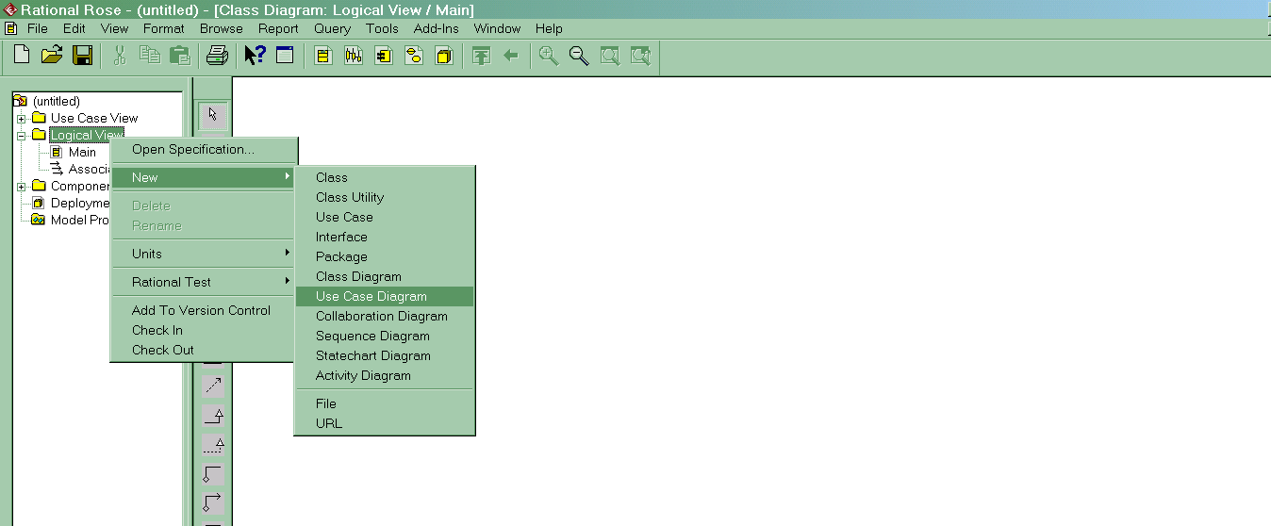

A new use case diagram appears in the browser (the left hand pane). Give your new diagram a name, e.g. Use Case Dagram1 as shown below. If required your model can contain as many use-case diagram as are necessary to capture the requirements of the system

Notice how the vertical tool bar has changed to show the tools applicable for a use-case diagram. By default your tool bar will not contain all the tools you will use, but it can be customized by right-mouse clicking the toolbar and choosing customize and then adding the tools you want.

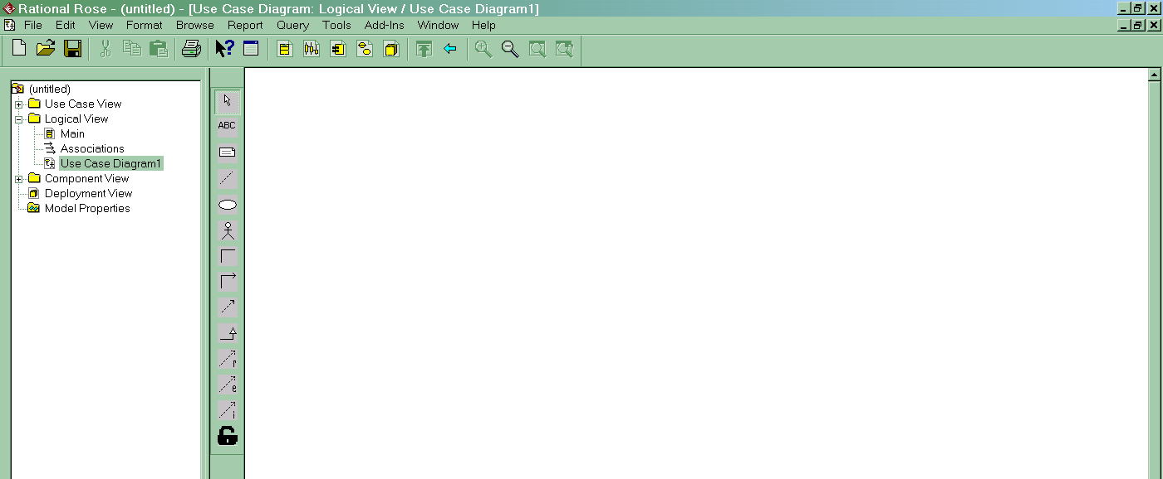

The following use case diagram was created with just six tools from the tool bar and covers most of the things you are likely to use in any use-case diagram.

- Actors People who interact with the system
- Use-case Document the nature of actor interaction with the system
- Generalisation Kind-of relationships between use case and even actors
- Includes One use case included another
- Extends One use case may optional extend another
- Association Connecting actors and use-case to show interaction

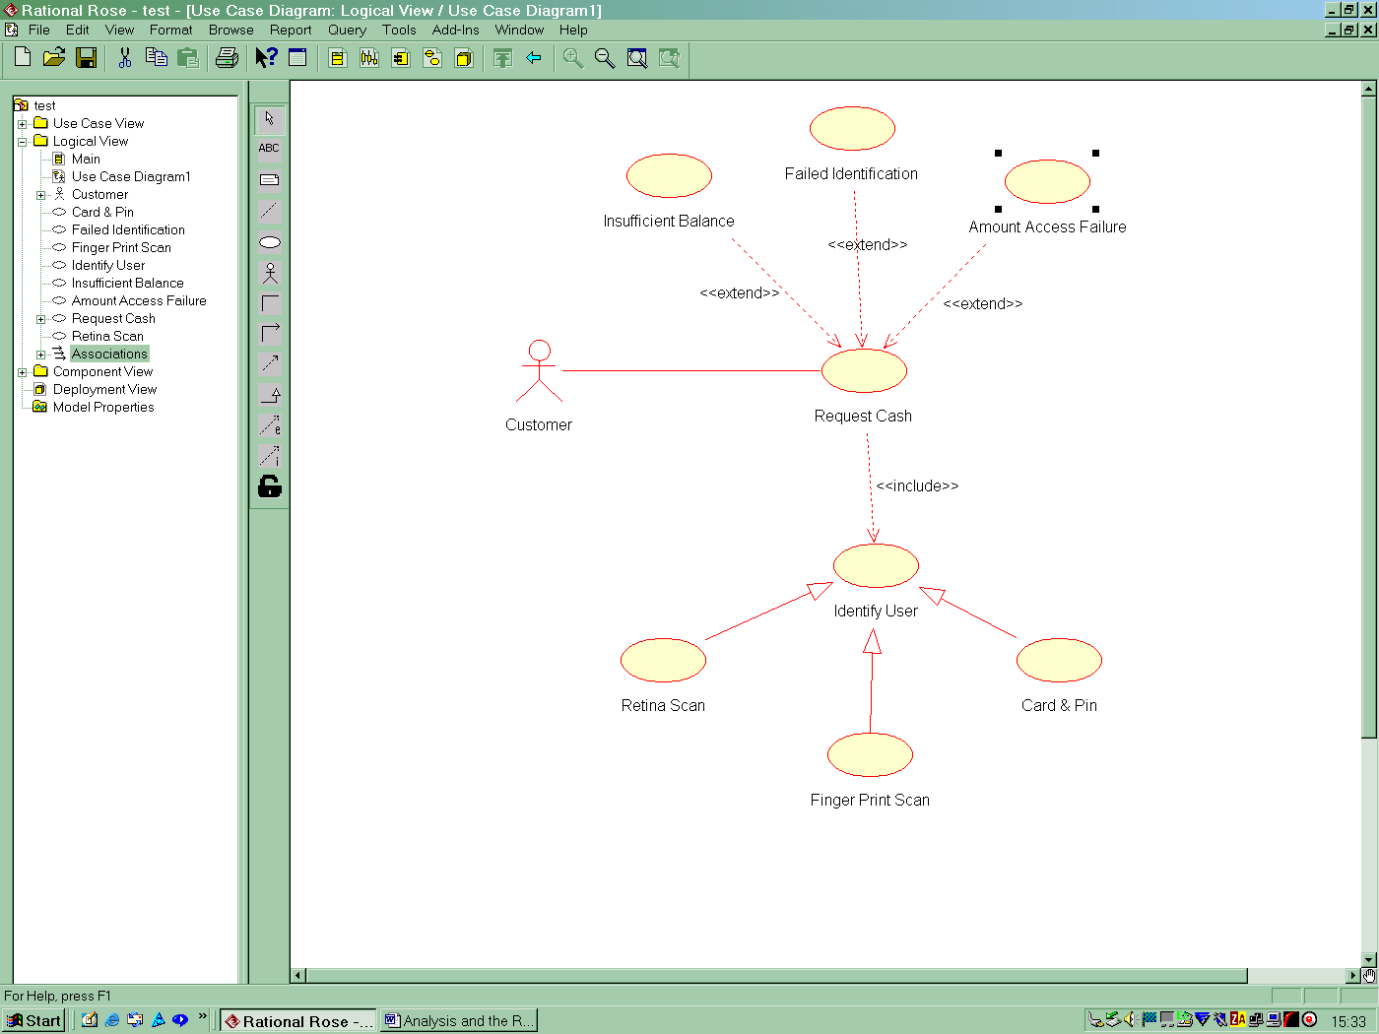

Notice how all the components you create (actors, use-cases etc.) all appear in the browser pane. This can sometimes get a little cluttered (a bit like storing all you files in the root directory of your hard disk). To organise our components a little better, we would create packages (analogous to folders or directories) and put our various components into them. This makes it easier to keep track of things.

Creating a Package to Organise out Components

- Right mouse-click the Logical View and select New->Package

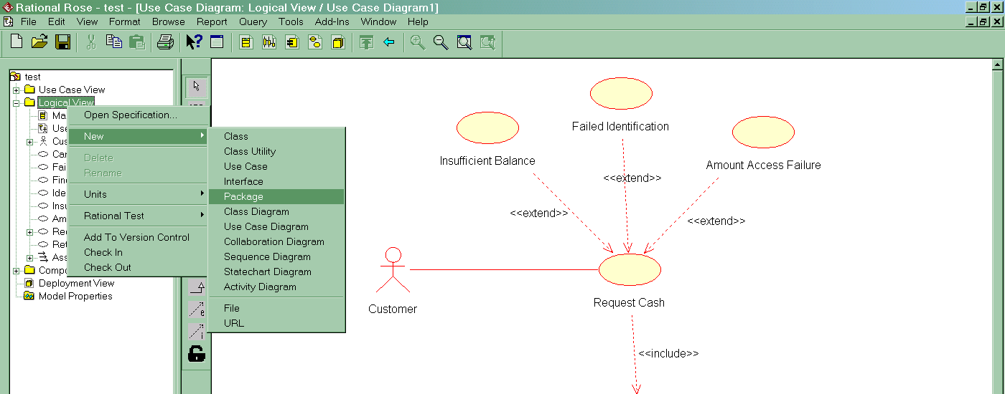

A new package is created and you can type in name for it. In this case create two packages called Use Cases and Actors (see below).

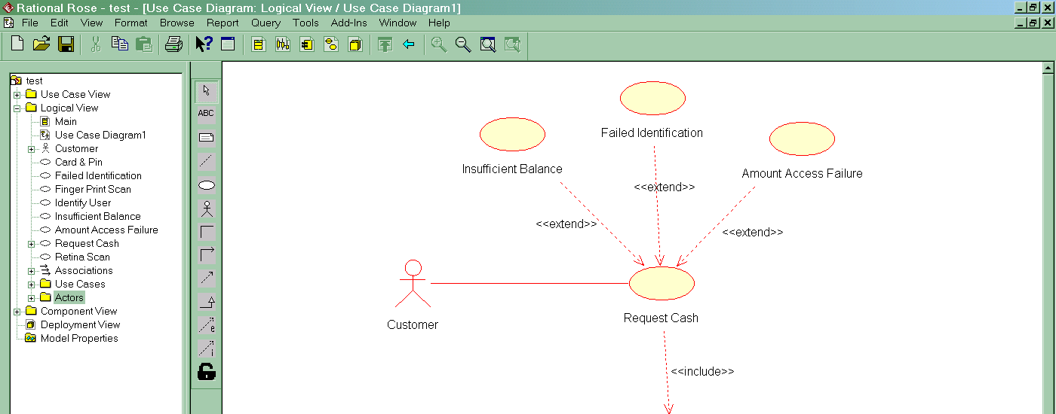

Now drag and drop your various use-case and actors into the appropriate package (see below)

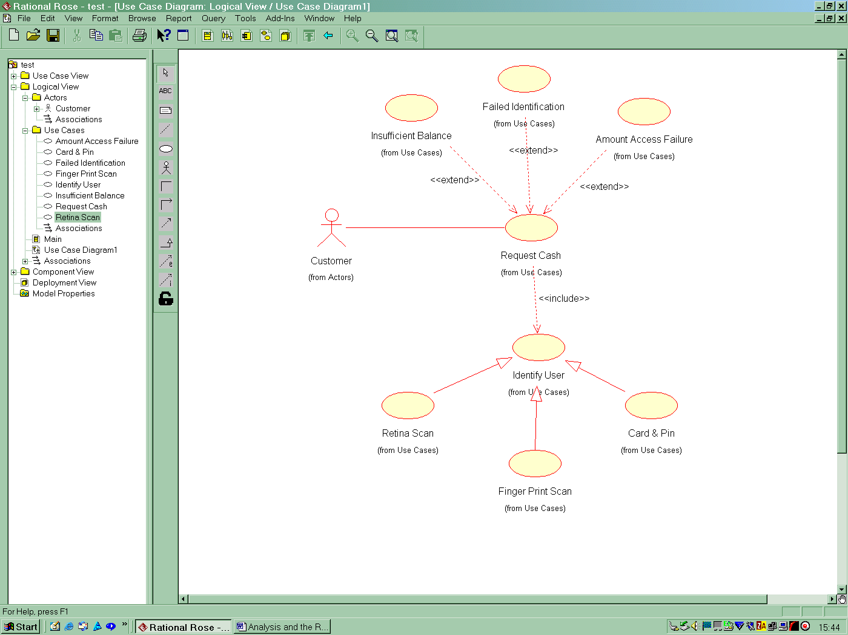

Notice how the diagram changes to show where the components now live in the browser (e.g. from use-case or from actors).

Documenting your Use-Cases and Actors

Obviously the point of using use-case is to capture their functionality and express it in terms of actor-use case interactions. This is easily documented as follows

- Either double click on a user/actor in the diagram and type the requirements into the documentation field on the general tab (see below for the Request-Cash use-case example)

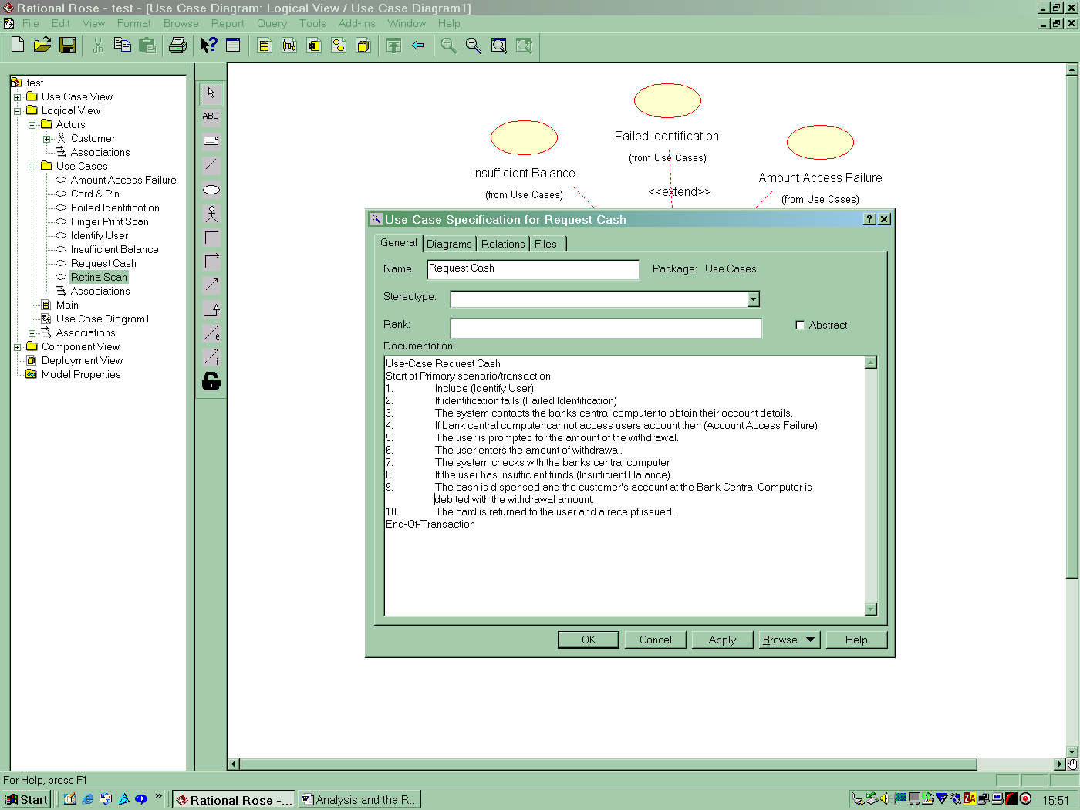

- In the Files Tab, right mouse-click and insert-file to select a file (e.g. a word document) containing the requirements for the use-case/actor.

The rank of a use-case is simply a measure of its important to the customer. Use-case with the highest rank should be given priority during development.

