Introduction to u-Vision

These notes provide a quick introduction to creating your first program with u-Vision. For more complete details read the on-line uVision User Guide, Getting Started and Debug Commands (See the Books tab in the project window)

Very briefly what you will be doing is :-
- Creating a new project for your program.
- Creating one ore more ‘C’ source files. (Most of your early projects will only contain one ‘C’ source file.
- Adding source files to the project
- Building the project
- Running the program using the Debug Simulator.
At various stages you may need to specify/select certain options.

To start u-Vision double-click the icon on the Windows desktop. You should obtain a window similar to the one below.

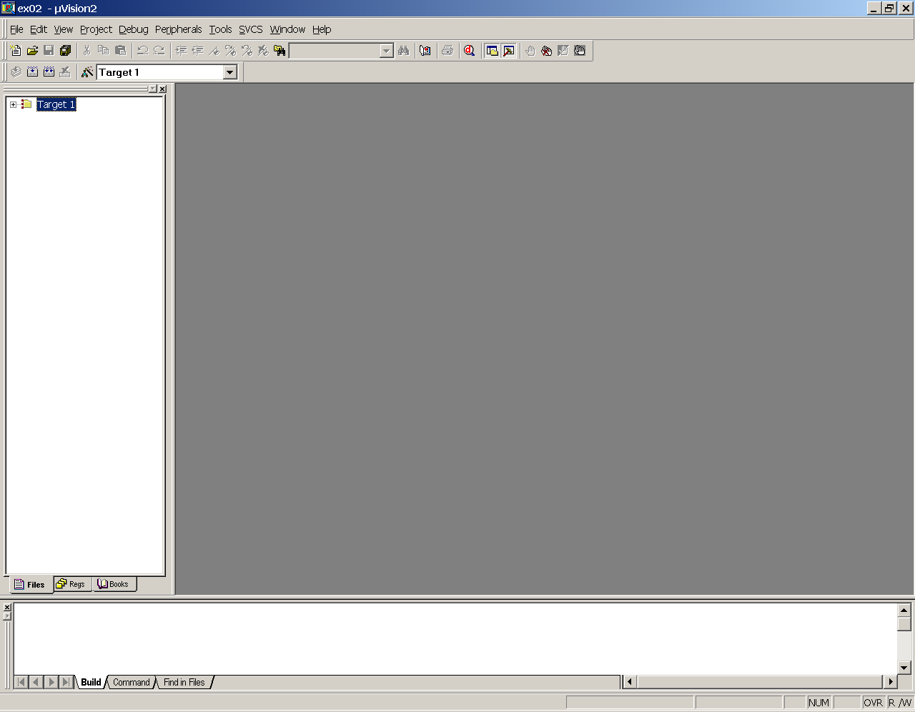

Select New Project from the project menu. You should create all your projects in your homespace in a sub-directory /folder
The project filename, and all filenames should be limited to no more than 8 characters in length. The project is stored as a file with the extension .uv2

Note:. You can use the same project file for all your programs. [A new program can be created by removing the current C file from the project and adding a different C file and rebuilding the project.]

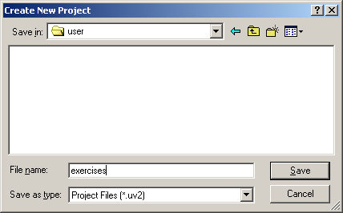
Click on Save

Next you must select the target device (i.e. the microprocessor/microcontroller that you are using). For all our work we will choose the Infineon C167CS-LM.

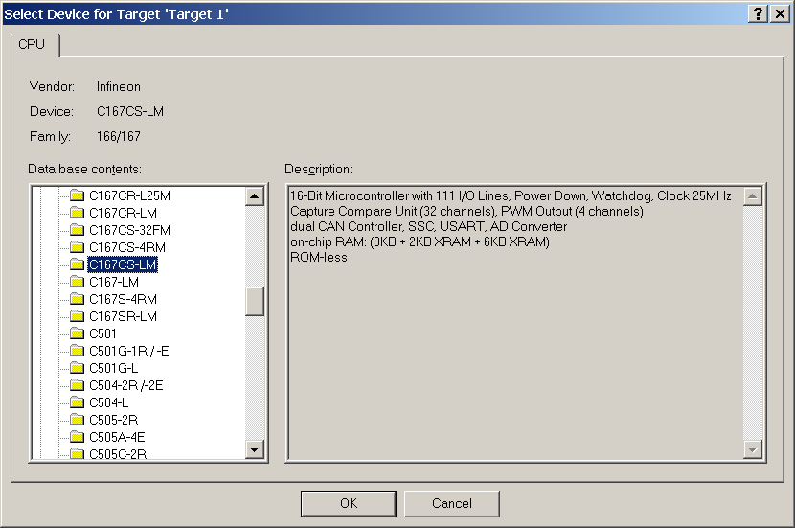

Click on Ok.

This will create a target called Target 1 and within Target1 a Source Group called Source Group1. These names are the default names and can be renamed if you wish (select the name then single click on the name). The Source group 1 is similar to a subdirectory of Target1. It is within Source Group 1 that we will place the ‘C’ source files.
There are many options that we can specify for the target. Let’s look at some of them. Click on the “Magic wand” icon.

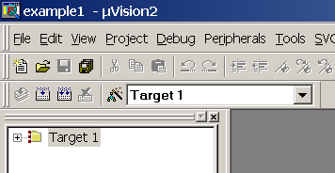
Magic Wand

This displays a tabbed dialog box as shown below. The only things we need to specify initially in these simple programs are the Clock value, which should be set to 20MHz and the start and size of the external memory. The Start and Size values are used to specify the program (i.e.ROM) and the variables(i.e.RAM) address ranges. Set the values as shown below
Start Size
Note: 0x indicates a hexadecimal value.
#1 ROM 0x10000 0x10000
#2 RAM 0x20000 0x20000

DO NOT CHANGE ANY OTHER SETTINGS. We will make use of some of these later. We can also see settings for other aspects of our project (click on some of the tabs but do not make any changes). Click on Ok to close the Options dialog box.

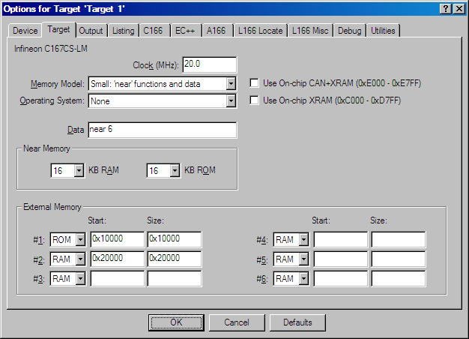

Next we need to create the ‘C’ source file(s).
Select New from the File menu option

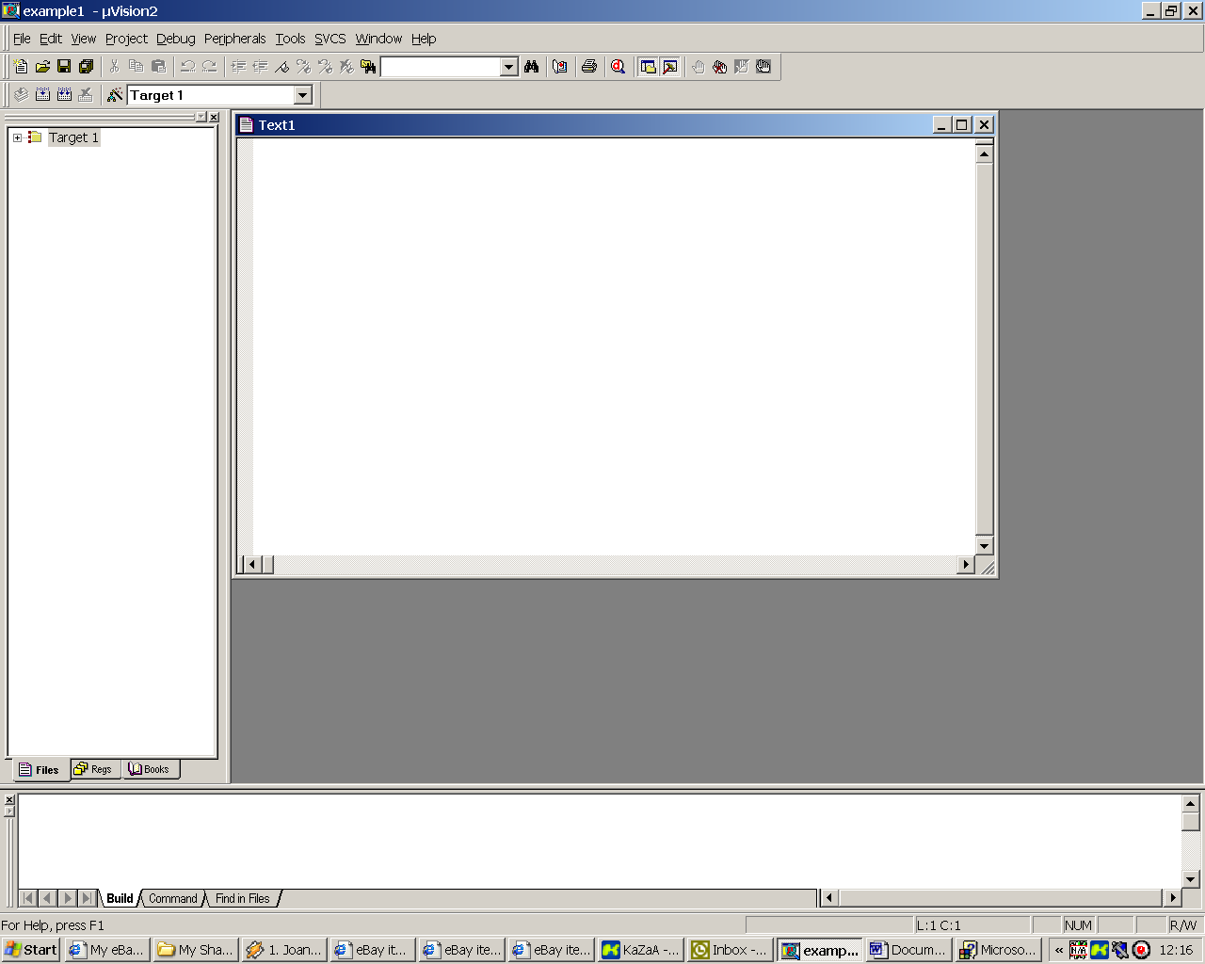

A Text window opens. We edit the ‘C’ program in this window. Type in the C program below, but I suggest saving the file immediately after you have typed in the first line. This is because when we save the file we will save it with the extension .C indicating that this is a ‘C’ source file. From now on as you type the editor will automatically use syntax colouring to highlight the different words and items in your ‘C’ file. So type in the line
#include <c167cs.h>
and use Save or SaveAs from the File menu and save the file with the extension .C in the appropriate directory:-

Notice the filename MUST end with .C Click on Save.

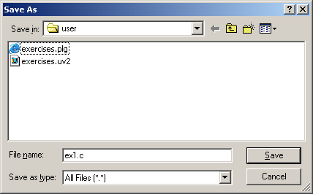

Now type in the rest of the program.

#include <c167cs.h>
/* Filename ex1.c
Author: Alan Goude
Date :
*/
void main()
{
unsigned char y;
//Configure all 8 bits of port 4 as inputs
DP4 = 0x00;
//Configure direction of port 6 as outputs
DP6 = 0xff; //binary 11111111

while(1) //endless loop
{
y = P4; //copy Port4 to Port6
P6 = y;
}
}

When all the ‘C’ source code has been entered save the file.

Next we need to add the source file to the Target Source Group :-
Right mouse click on Source Group 1 and select “Add Files to Group”

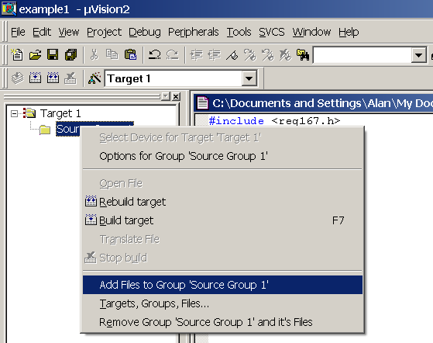

Select the ‘C’ source file(s) and click on Add and then Close
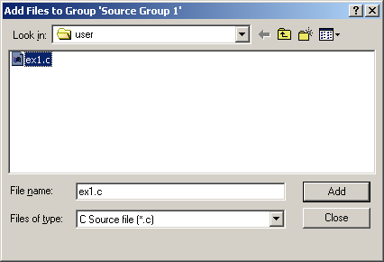

In order for the program to run correctly we need to incorporate a system file called start167.a66 to the project. This may have been already added to the project when the project was created. (Your lecturer will tell where to find the file start167.a66 can be located if this has not been added automatically). If the start 167.a66 file has not been added then select “Add Files to Group” again, but this time alter the “Files of Type” to “Asm Source File”. Navigate to the directory containing start167.a66 (It is a good idea to keep a copy of this file on your homespace and to also put a copy in the folder where your project is located)

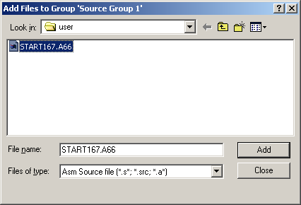

Click Add and then Close.

The project Window should now look like this :-

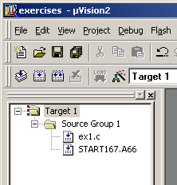

Now we can Build the target program.

Select the Build icon

The Build Icon

If there are no errors you should see the following in the output window at the bottom of the screen.

Build target 'Target 1'
compiling ex1.c...
assembling START167.A66
linking...
"exercises" - 0 Error(s), 0 Warning(s).

If there are any warnings or errors they must be corrected before you can proceed to the simulation.
Warnings can sometimes be ignored but my advice is to investigate the warning to find out why the warning was issued and rectify the problem. Only in very exceptional cases would I ignore a warning.

Example of a common error
If the semicolon is omitted after the declaration of the unsigned char y then the following build messages will be produced.

Build target 'Target 1'
compiling ex1.c...
EX1.C(10): error C25: syntax error near 'DP4'
Target not created

Try it by introducing the error.

Double click on the error line and a cyan coloured arrow will be placed where the system detected a problem. This is usually after the point where the problem is. So in this case the compiler only knew there was a problem when it reached the line
DP4 = 0x00;
Basically it was looking for a semicolon after the y and it skipped over the comment line and stopped when it reached the D in the line DP4 = 0x00;

Don’t forget to correct any errors and re-build the target before proceeding to the simulation.

Notes on managing files and projects

The compilation and build process will create several files. The only ones which should be saved back to your floppy disk are :-

File Type File extension
project file - *.uv2
opt file - *.opt
C source files - *.c

All the other files can be recreated from these files. The start167.a66 is a system file and is permanently stored on the system.

Since creating a project, selecting the various options and entering parameters for your project is a tedious exercise it is often convenient to keep the same project file and simply replace the existing C file with a different one :-

To re-use your project and all its setting withs in a new program simply highlight the current 'C' source file in the project window and click the right mouse button and select the remove option as shown below.
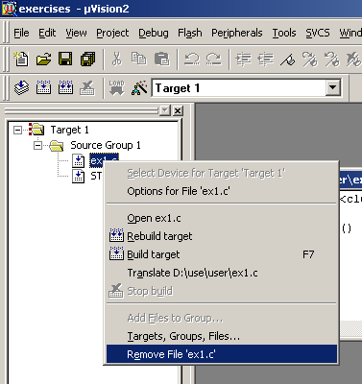

Now highlight the source Group 1 and click the right mouse button and add the new C file. Now build the project with the new C file.

This procedure can be used for all your programs. This means you need only ever create one project and re-use it for all of your programs.

Also look at the notes on creating multiple targets, which is very useful when you come to using the target hardware.
Simulation

The uVision development software can be used to simulate the target device. The simulation is very useful for testing and debugging a program prior to actually loading the program code in the real hardware and executing it. The simulator is a powerful tool that can be used to prove the correct operation of a program. It can also assist in showing where program errors exist. It is therefore vital that you become proficient in using the simulator and will pay significant dividends in the future, particularly when working on your assignments.

To start a Debug Session click on the debug icon in the toolbar (it’s the red ‘d’ to the right of the printer icon) or use the Debug menu. If you are using the evaluation version of uVision you will see a popup window to that effect. Simply click on Ok.

The uVision package will now mimic the Infineon 167 microcontroller. The project window switches to display the internal registers of the 167 microcontroller.
uVision can also simulate to a certain extent the peripherals of the 167. As we are using the ports 4 and 6 in the example program we can display them in the simulator. Use the Peripherals menu and select Port 4 and Port 6 from the I/O Ports option. Position these Port windows out of the way, to the right of the screen
We can also watch the value of ‘C’ variables as a program executes. Select Watch & Call Stack Window from the View menu. Ensure that Periodic Window Update from the View menu is enabled. Select Watch#1 and add variable y to the watch window
Your screen should look like this:- Notice the yellow arrow

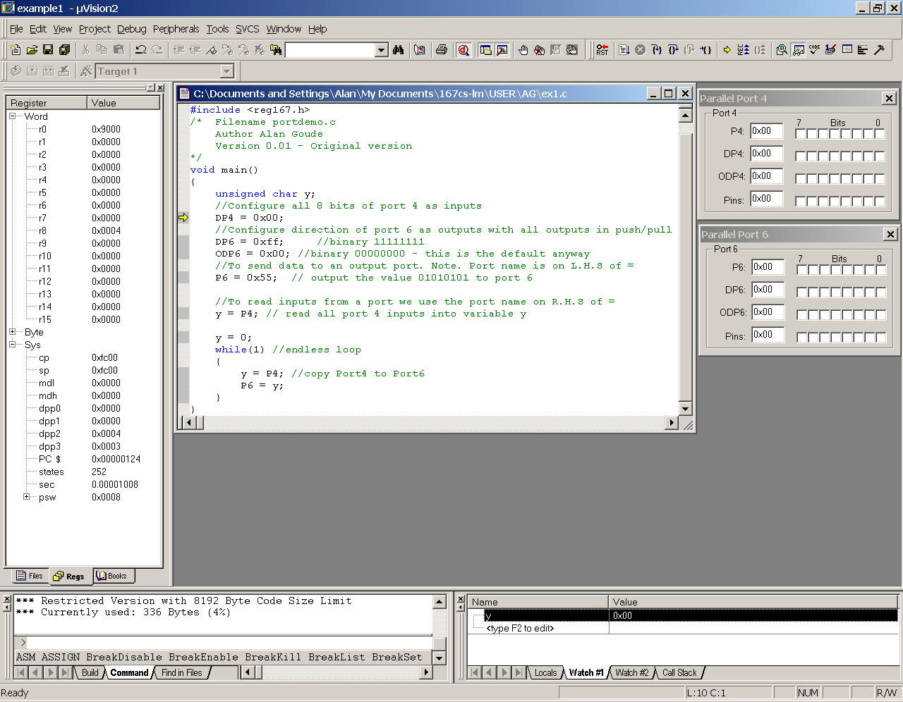
Enter Debug commands here

We now have various ways in which we can use the simulator. We can simply run the program and see what happens or we can step through the ‘C’ program one line at a time.
We can simulate the inputs at Port 4 by clicking on the respective port Pins and observing the output on Port 6. The debugger commands are entered in the command line which is a single line in the Output Window at the bottom left of the screen. The most commonly used debugger commands are available as icons on the toolbar.

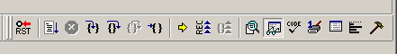
Run to cursor
Step out of function (OSTEP)
Step line (PSTEP)
Step into function (TSTEP)
Stop execution (Esc key)
Run program (GO)
Reset PC (RESET)
Useful commands and their abbreviations
r Reset PC
g , main After a reset runs program up to start of main function
p PSTEP command
t TSTEP command
o OSTEP command

Exercise the program by stepping through line by line and observe the effects.

Modify the program in some way, re-build it and simulate it again. Experiment and become familiar with building and simulating programs.

Find out about Breakpoints – what they do and how to use them in your simulation.

These notes have provided the minimum information to get you started. You should read the uVision 2 User Guide, uVision 2 Getting Started and uVision 2 Debug Commands (See the Books tab) for complete description of uVision and the Debugger Commands.

