Running Visual Basic 2005 at SHU and Home

Note that VB cannot access USB drives, or any drives on your home pc. You must use the F drive at SHU.

0. Create a folder on the F drive at SHU, to hold all your VB programs. Call it something like My VB Programs. Within this folder, each program is in its own folder, consisting of a number of files.

1.
Start
All Programs
Tools and Accessories (or you might find it in: Accessories - Communications...)
Remote Desktop Connection
enter:
vsteaching.ts.shu.ac.uk
click Connect

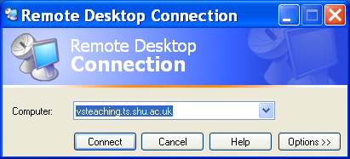

2. enter your user code and password
click Connect

3. click on start
Get:
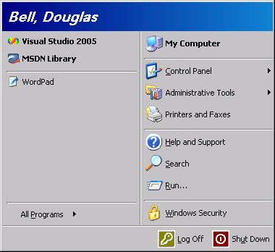

4. Select Visual Studio 2005

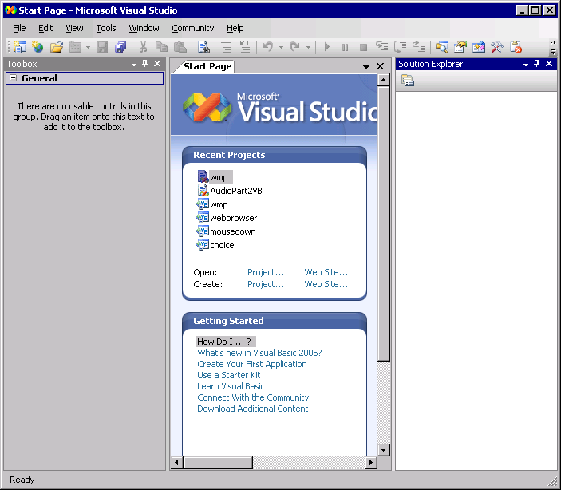

5.
Tools - Options - Projects and Solutions
browse to the folder that you have set up to store your VB projects (step 0)
click OK

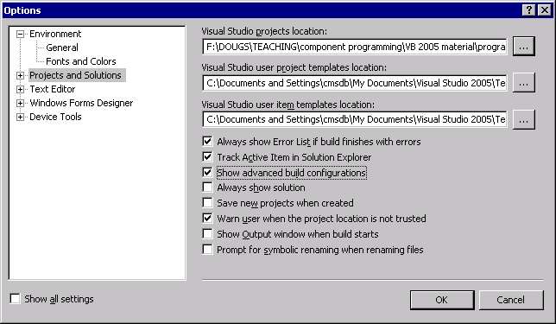

6. To create a new project:
File
New Project
(You will see that Visual Basic is the default language)
Select Windows Application
Type in a name for the program
Click OK

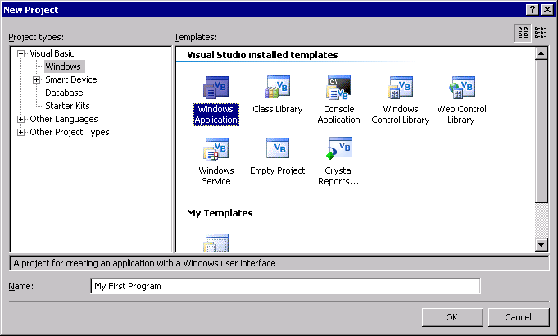

(To open a project that you created earlier - look for its name on the Welcome page, or go to :
File > open project, then browse to its folder - then click on the VB Proj file.)

7. Get following screen.
Can now construct a program, by selecting GUI controls and adding code.

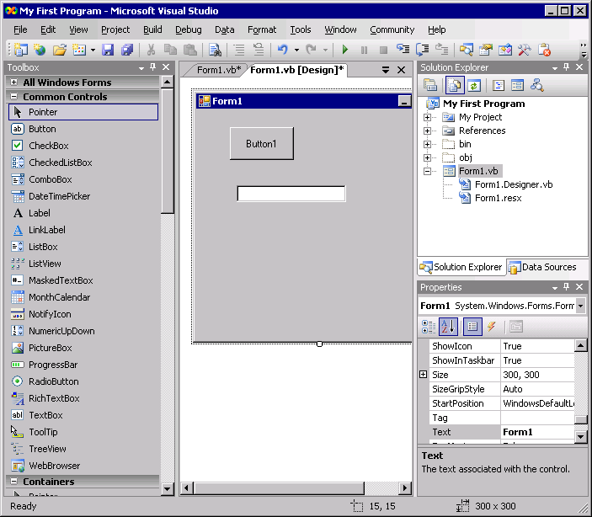

8. Don't forget to save frequently:
File
Save All
and check that the material is being saved in the correct folder.

9. To leave lunaria:
Start
Shutdown

This only logs you off from vb - you are STILL logged to the PC !!

Using the VB development system

When you start VB, you automatically get a blank form on the screen. You use the form to design your program. The form can be any size or colour and you can paste controls (e.g. a button or a text box ) on to it and attach code to it so that it will execute a certain task when it runs.
run program

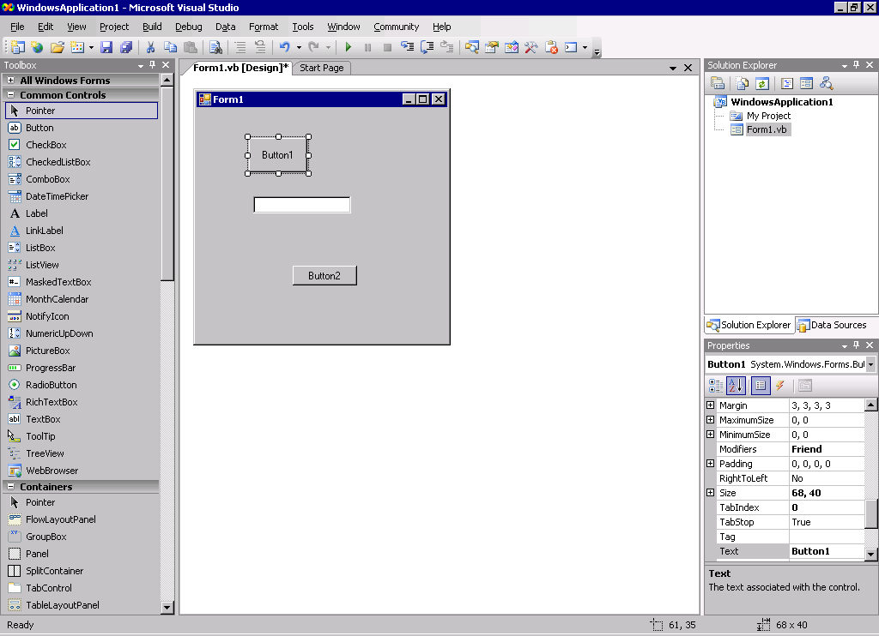
Form

ToolBox
Property window

The Toolbox

The toolbox contains the standard built-in GUI components which we may use to add to our form. To add, say, a button, simply click on the button with the mouse and the click on the form. Then you can use the mouse to move it where exactly you like it to be on the form.

The toolbox tends to slide out of site. You can prevent this by clicking on the Auto-Hide icon at the top right of the toolbox.

pin this window

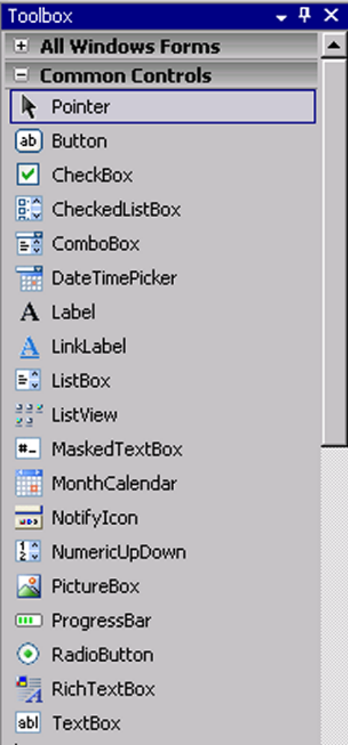
Button
Label
TextBox
PictureBox

Above indicated are some of the most commonly-used controls.

- a Picture Box holds images created, for example, with Paint.
- Label is used mainly to display prompts
- Text Box is used mainly for receiving input from the user, but can be used for display..
- a Button is a way of activating a particular event.

Creating a first Program

- run Visual Basic 2005
- click on File | New Project
- click on Windows Application from the templates on offer
- change the name from WindowsApplication1 to Hello (or something else of your choice as the name of the folder that will contain the program files)
- click on OK button
- click on File | Save All
- click on the Browse button and browse to the name of the folder that will contain all of your VB programs.
- click on the Save button

Remember the slogan:

new program - new folder

The properties window

Click on a button on the form and see the properties window for the button:

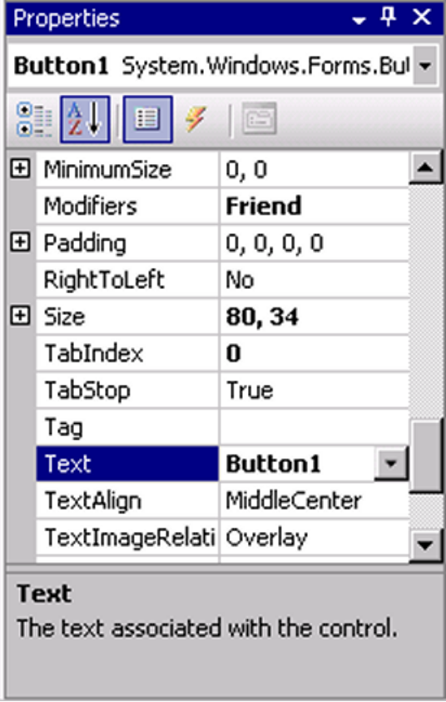

The caption on the button can be changed by changing the Text property, shown above. You can change the position, colour etc of the button and also its name. You can also change the name of a component.

Entering code

1. double click on the Button1 button

2. the code window will open showing:

Private Sub Button1_Click etc (no need to type these 2 lines!)
End Sub

3. Type the following between the Sub heading and footer:

Private Sub Button1_Click etc
MessageBox.Show("Hello!")
End Sub

4. Save your program from time to time by:

Select File | Save All

5. run the program

Exercise

1. Create and run this program.

2. Change the text on the button to something meaningful, such as hi

3. Change the name of the buttons to something meaningful, such as HiButton . Make sure that the program still works.

4. Modify the program. Put a label on the form, and set its text property empty, then put this line underneath the message box line:

Label1.Text = "Hello Sheffield!"

Run the program, note the effect.

5. Now make a spelling error (e,g MessigeBox) and note how VB tells you about the error. Now mis-spell Sheffield, and note that no errors are shown. Now try to retype MessageBox as messagebox. What happens?

6. Add another message box just above the End Sub, which displays Done. Run, note the effect.

What you found...

- You can create pop-up message boxes.

- VB re-formats your typing with capitals in certain places - so you can type faster!

- A label has a text property, which the program can alter as it runs.

- Lines are obeyed - executed - downwards in a sequence.

